Nito: How to guide

Logging in 1
Create new Exam 1
Uploading files 2
Retrieving IDs 3
Editing an exam 3

Logging in
Browse to the Nito URL: https://nito.nwu.ac.za/login
Enter login credentials and click on the Key icon in the top right corner

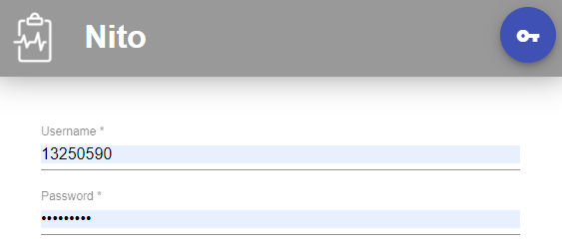

After logging in you will be presented with new options at the top of the page
Clicking the Key icon again will log you out. Clicking the ‘+’ icon will create a new exam.

Create new Exam
To create a new exam, click the ‘+’ icon at the top of the Nito page
You will be presented with the Create page
Complete the required fields relevant to your exam session:
Exam Name | only used for display purposes
Lab | where the exam will be written - this does not book the room
Start time | cannot be less than an hour before the actual start time
End time | logins will be made inactive after this time
Accounts | the number of random IDs to be generated
Internet Access | tick the box to allow Internet Access
USB Access | tick the box to allow USB drive access

Uploading files
Files can be loaded onto the mapped network drives (‘K’ drives) which will be available to students upon login. To do this click on the Add Files (paperclip) icon at the top right of the Create page

This will open the Files page
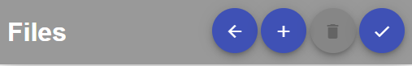
Click the ‘+’ icon at the top of the page to select files to upload. Using the presented File Browser locate the files and click open.
A list is presented of all the uploaded files
To remove a file, select the checkbox corresponding to the file you want to remove.
If you are done uploading files, click the Checkmark icon at the top left of the page to return to the Create page — uploaded files will now also be listed here.
Once all fields have been completed, click the Checkmark icon at the top of the page to complete the exam.
A progress bar is displayed at the bottom of the page
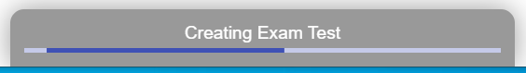

Retrieving IDs
To retrieve the created IDs, click on the exam which was created (and which should be listed under Upcoming)
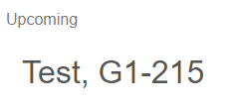
This will open the View page
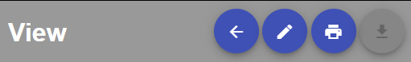

Click on the Print icon at the top of the page to be presented with the option to download in either PDF or CSV format.
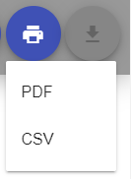

Editing an exam
While still on the View page, click on the Pen icon to edit the exam details.

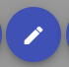
Note - editing an exam will cause a regeneration of new exam IDs, and previous IDs for that exam will not work!

Downloading files
After completion of the exam, clicking on the Download Arrow will download all the contents of the ‘K’ drives (bundled as a Zip file) to your hard drive.
The structure of the zip file is:
Exam-name.zip
|-> Random Exam identifier (folder)
|-> Random login (folder)
|-> file1
|-> file2
|-> Random login (folder)
|-> file1
|-> file2
|-> etc....
|-> Random IDs (csv)
|-> Random IDs (pdf)

Exams (and all related files) will automatically delete after 1 week from exam expiry date.

Updated: 9 March 2020 (LV)

