Financial Processing
Value Added Tax
Document Summary
Product Owner | Andre Fourie
Editor | Chimoné Barends
Date | 2014/12/02
Time | 08:30 AM
Template | Verbose

Lesson Objectives
On completion of this lesson you should be able to:
- Understand the working of VAT on e-docs.

Lesson Scenario
- As an existing staff member you will be able to create e-docs with VAT where applicable.

Lesson Prerequisites
- You need to be a NWU staff member that is registered on KFS as a user.

Table of Contents

- Disbursement Voucher (DV)
- Requisition
- Purchase Order
- Internal Billing
- Non Check Disbursement
- Service Billing
- Customer Invoice
- Customer Credit Memo
- Payment Request
- Vendor Credit Memo
- KMM Customer Return
- Invoice Write Off
- Vendor Creation with VAT Number

1. Disbursement Voucher (DV)

1.1 Handling of VAT on the Accounting Lines

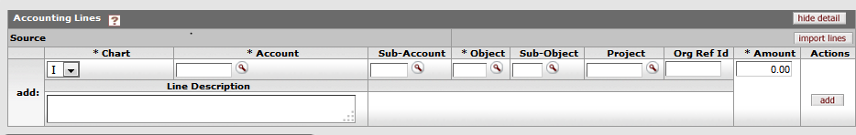
Figure 1

1. | In all instances (always) fill in the total amount (vat inclusive). KFS will handle the vat calculation automatically. It will take in consideration Vendor, Account and Object.

- The Disbursement Voucher is used for payment of certain vendors where purchase orders are not issued. Examples are Budget Rent a Car and cellphone payments to Nashua.
- KFS will automatically verify the vendors VAT status and account and object code to calculate the VAT applicable. The amount including VAT must always be completed on the disbursement voucher.

2. Requisition
2.1 Handling of VAT on the Accounting Lines
- The requisition is used to obtain goods or services from external vendors. Depending on the VAT status of the vendor, VAT will be levied on goods or services invoiced.
- When compiling the requisition, KFS will verify the VAT status of the vendor and if the vendor is registered for VAT, the VAT amount will be added to the purchase price on the requisition.
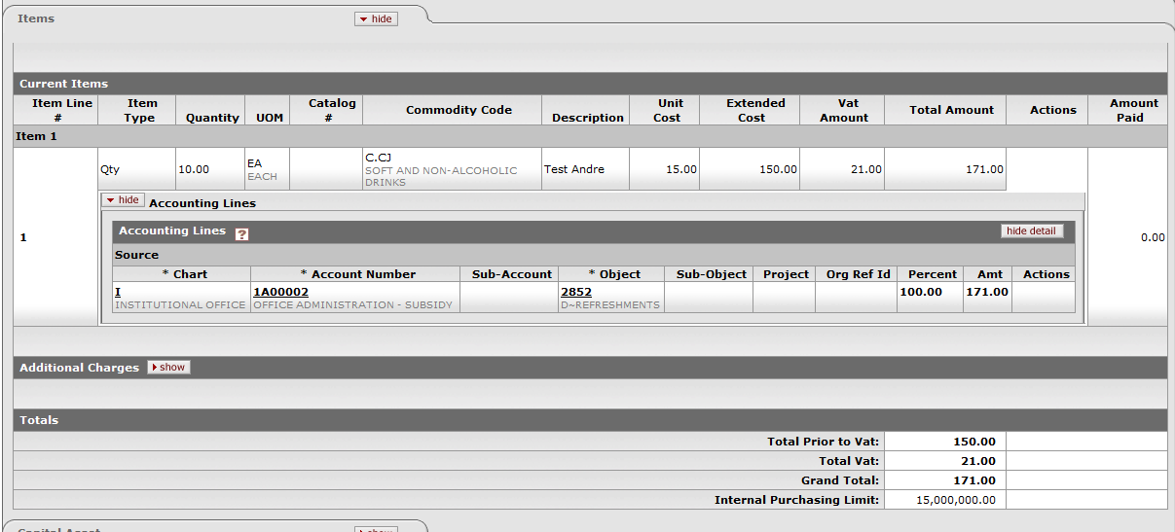
- Where the unit price is entered, it must be entered the amount excluding VAT, as KFS will automatically add the VAT amount to the unit price.

3. Purchase Order
3.1 Handling of VAT on the Accounting Lines
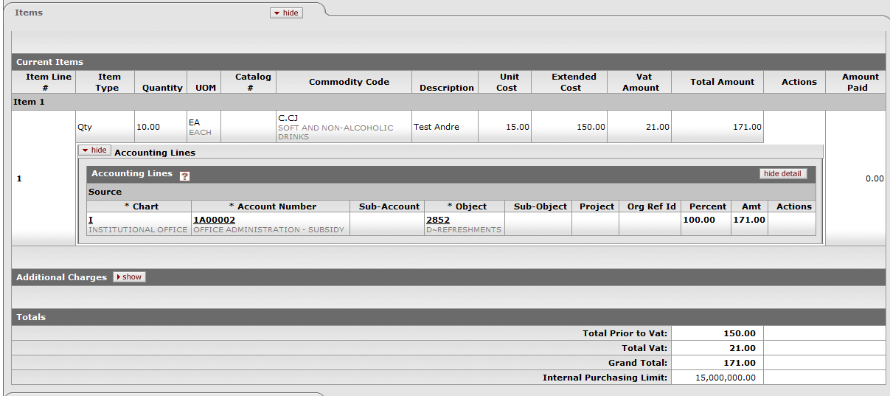
- Once the requisition is approved an order document will be raised with all the particulars relating to the amount of VAT as was calculated on the requisition.

4. Internal Billing
- The Internal Billing document will only generate VAT on transactions between the KMM module and KFS. This is to account for VAT on store items where items will be taken into stock VAT included.

5. Non Check Disbursement
5.1 Handling of VAT on the Accounting Lines
- On completion of the NCD, KFS will automatically calculate the VAT claimable taking into account the Vendor’s VAT status, Account and object code and calculate the recover the VAT based on the set rules.
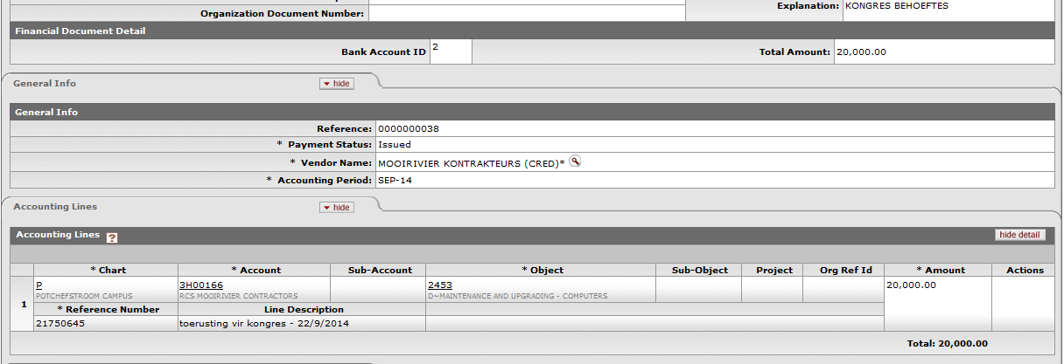

- As can be seen from the above the VAT recovered was posted to the account, object code relevant to the transaction.

6. Service Billing
6.1 Handling of VAT on the Accounting Lines
- Service Billing is used to request services from, example: Technical Services, to perform services to a department. This can be for alterations to buildings or repairs to air conditioners etc.
- In order to correctly allocate the VAT that was paid on purchases of materials or spares, KFS will automatically verify the VAT status of the expense account and object code and claim back the VAT accordingly.

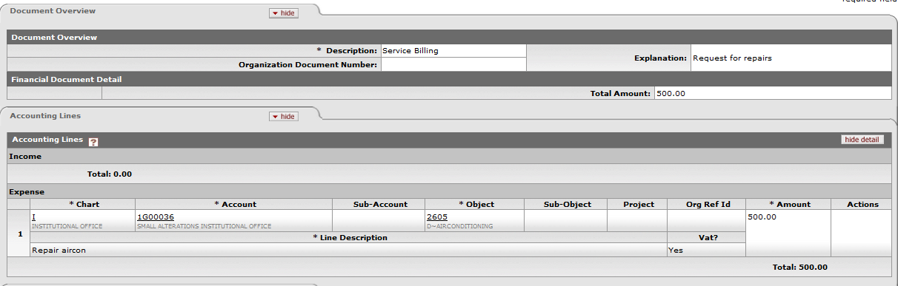

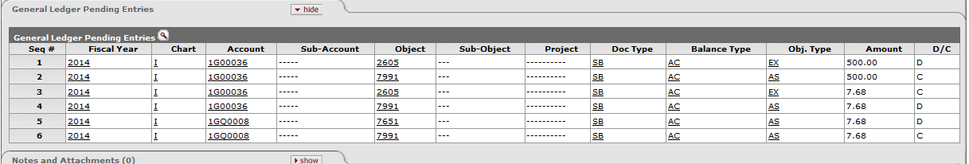

7. Customer Invoice
7.1 Handling of VAT on the Accounting Lines
- A customer invoice is generated when services are rendered to an external customer or sales of commodities are made to external customers.
- Based on the VAT status of the account and object code, KFS will calculate the VAT to be added to the amount on the invoice. If VAT is to be added a Tax Invoice will be generated that reflect the VAT on the invoice and all relevant information as prescribed in the VAT Act.
- VAT in customer invoices will always reflect the full 14% VAT as this is output VAT on income and bears no relevance to the claimable percentage allocated to such an account.
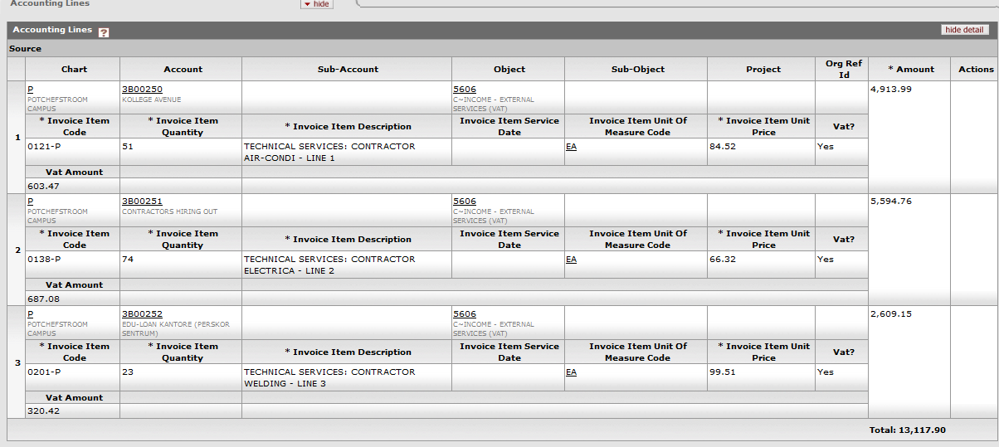
8. Customer Credit Memo
8.1 Handling of VAT on the Accounting Lines
- The customer credit memo is used to make adjustments on invoices for example, alter the amount of items that was actually delivered if less or more than what was invoiced.
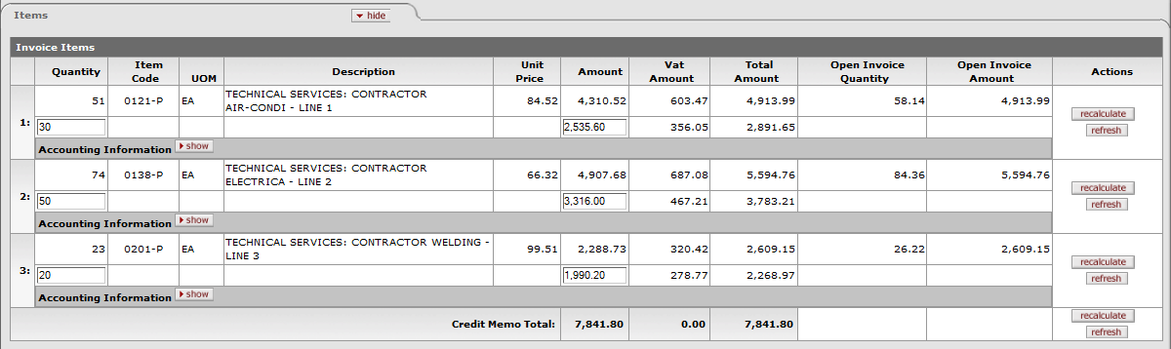
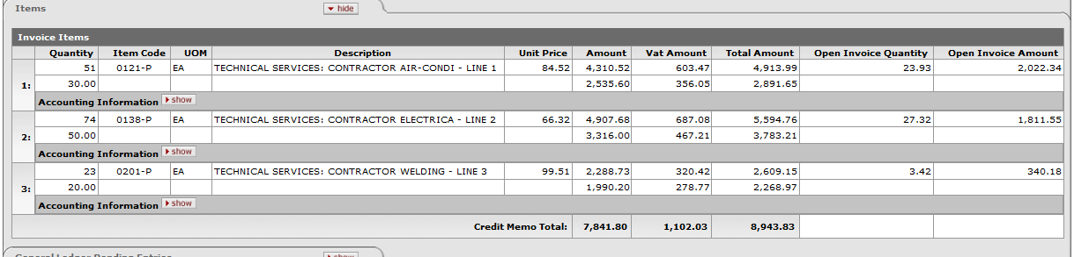
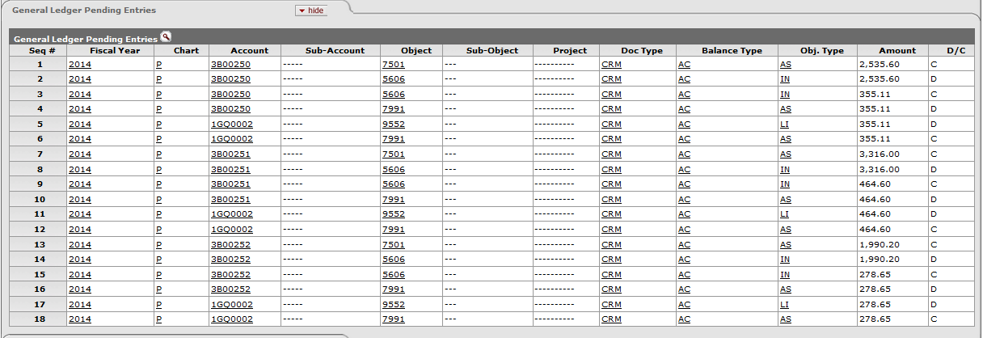
- Once the CCM is approved KFS will make the necessary adjustments to the relevant accounts and object codes and the VAT will also be automatically adjusted according to the relevant adjustments made.

9. Payment Request
9.1 Handling of VAT on the Accounting Lines
- A payment request is processed to effect payment to a vendor for goods or services purchased.
- The payment request is directly linked to an invoice received from the vendor and depending on the VAT status of the vendor; KFS will automatically calculate the VAT applicable on the invoice and reflect it on the payment request.
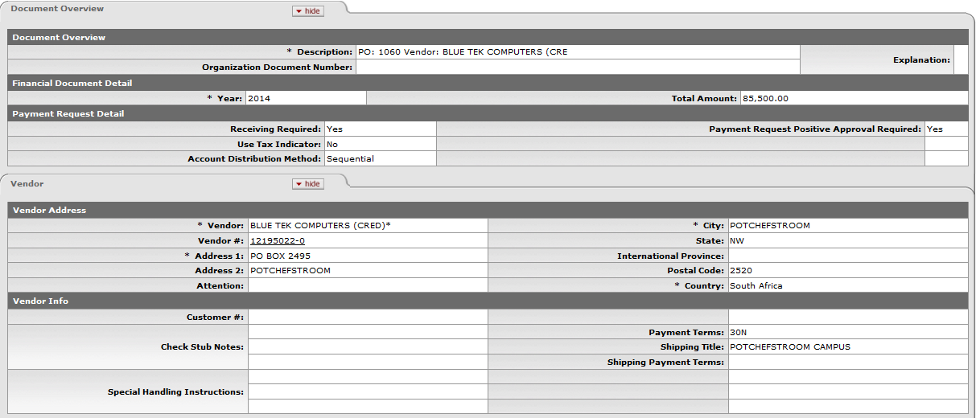
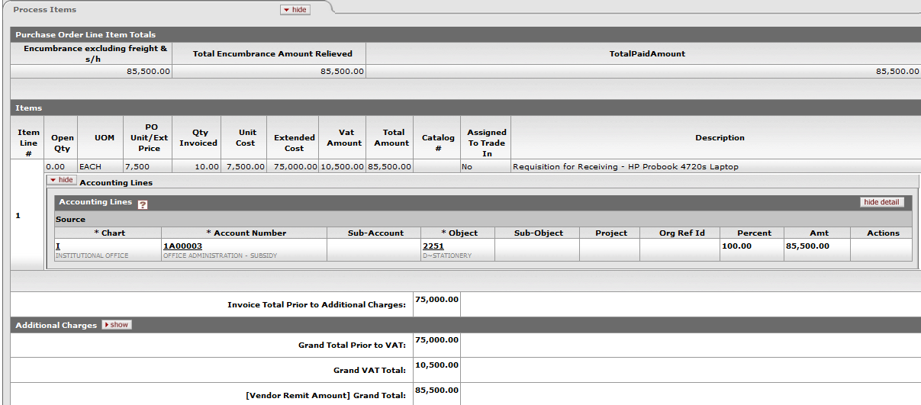

10. Vendor Credit Memo
10.1 Handling of VAT on the Accounting Lines
- A vendor credit memo is generated to make alterations to an invoice that was issued to the university.
- Once approved KFS will automatically account for the VAT on the transaction according to the rules and status of the account and object type.

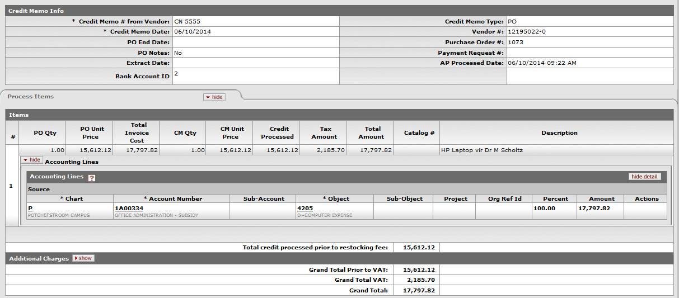
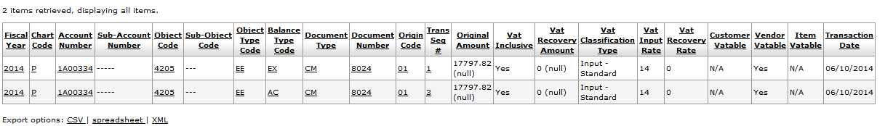

11. KMM Customer Return
11.1 Handling of VAT on the Accounting Lines
- This document is used to take goods back into stock from customers where in was incorrectly issued.
- Upon finalizing this document, KFS will automatically recalculate the VAT on the original transaction according to the rules and VAT status of the account and object code and reverse the entries in the account and object code as well as the VAT Control Object.

12. Invoice Write Off
12.1 Handling of VAT on the Accounting Lines: In proses of development.

13. Vendor Creation with VAT Numbers
13.1 Handling of VAT on the Accounting Lines
- When a new vendor is created and the vendor is registered for VAT, the VAT number must be completed in the space provided for under corporate information.
- Upon submitting the document, KFS will verify the VAT registration number and if incorrect the system will halt and require that the number be verified.
- A VAT number will always begin with a 4 and consists of 10 digits. Within this number a control digit is built in that verifies that the number is authentic.

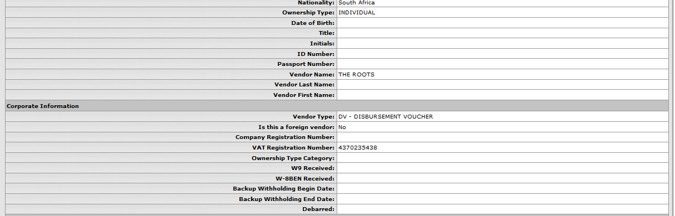

13. E-Docs not discussed in this document
- All other e-docs not discussed in this document either do not account for VAT or has no impact on VAT.
- Where applicable VAT should be calculated by hand as in the case of the General Error Correction.

Lesson Summary
Having completed this lesson you should be able to:
- Understand the process of calculating VAT when certain e-docs are generated. Almost no human intervention is necessary for handling VAT on e-docs.

