

Financial Processing

User Registration in KFS

|  |  |
| --- | --- |
| Document Summary | |
| Product Owner | Elizna Jacobs |
| Author Name | Elizna Jacobs |
| Editor | Chimoné Barends |
| Date | 2015/04/09 |
| Time | 08:00 AM |
| Template | Verbose |

|  |  |
| --- | --- |
| Lesson Objectives | |
|  | On completion of this lesson you should be able to:   * Know the KFS registration procedure for a new KFS user. * Have access to the KFS-system. |

|  |  |
| --- | --- |
| Lesson Scenario | |
|  | * As an existing staff member of the NWU you are required to work through this lesson, make some notes if necessary and print out the documentation as a guideline. |

|  |  |
| --- | --- |
| Lesson Prerequisites | |
|  | * You need to be a NWU staff member that is registered on KFS as a user. |

|  |
| --- |
| Table of Contents |

1. Process Flow
2. User Registration
3. User Registration document
4. Document Overview tab
5. User Registration tab
6. Access to Chart of Accounts and Membership tab
7. Ad Hoc Recipients tab
8. Route Log tab
9. The Action List of the approver
10. Document Search
11. Detailed Search option
12. The Title option

## Process Flow

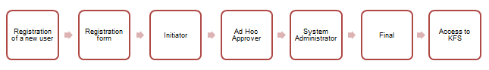

## User Registration

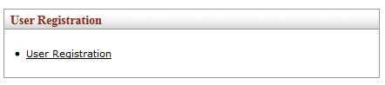

Figure 1

|  |  |
| --- | --- |
| 1. | Click on the **User Registration** option below the **User Registration** link. |

## User Registration document

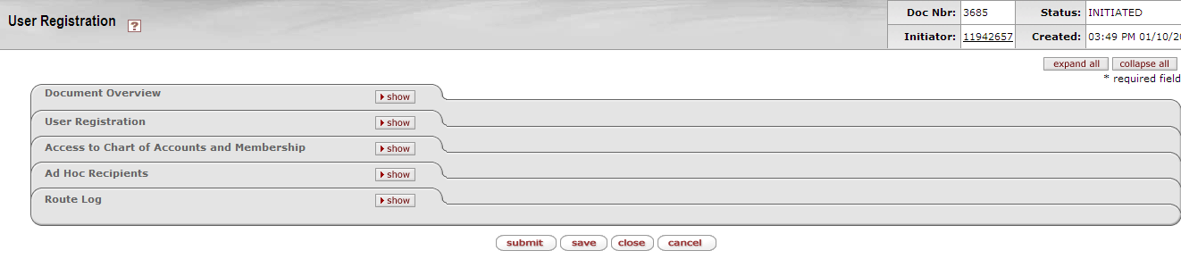

Figure 2

* This screen opens up the **User Registration** document. The tabs of this document in the example are set to **collapse all** to make the discussion easier.

## Document Overview tab

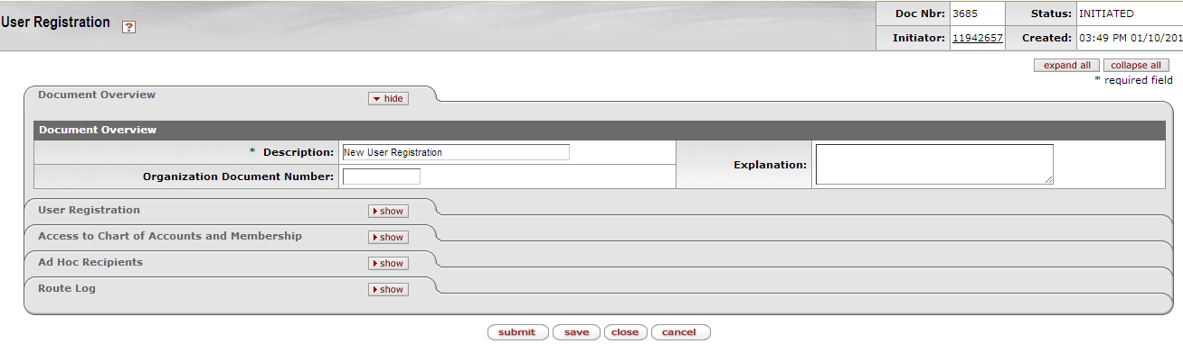

Figure 3

|  |  |
| --- | --- |
| 1. | Click on Show to expand the Document Overview tab. |
| 2. | It is not necessary to fill in this Document Overview tab; this is only a preview of how the screen will look. |
| 3. | Click on Hide to collapse the Document Overview tab again. |

1. **User Registration tab**

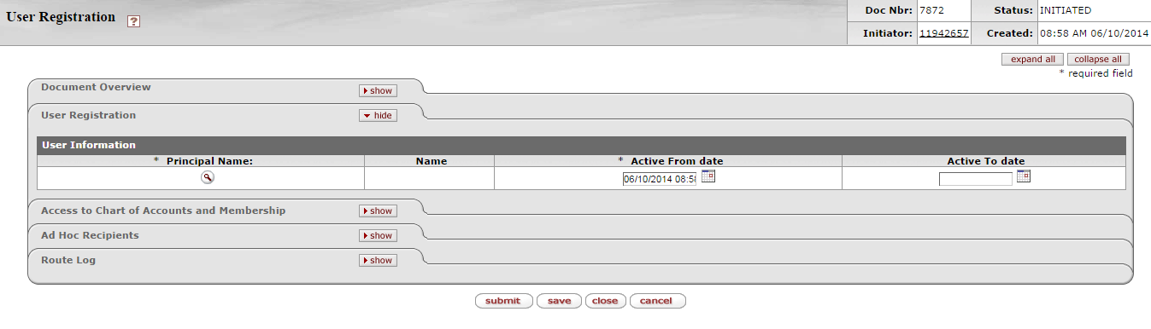

Figure 4

|  |  |
| --- | --- |
| 1. | Click on Showto expand the **User Registration** tab. |
| 2. | This screen explains the **User Information** that must be provided to register a new user. |
| 3. | Click onto **Lookup** the principal name of the new user that must be registered by completing his/her employee number in the Principal Name field or by completing his/her surname in the Surname field. |

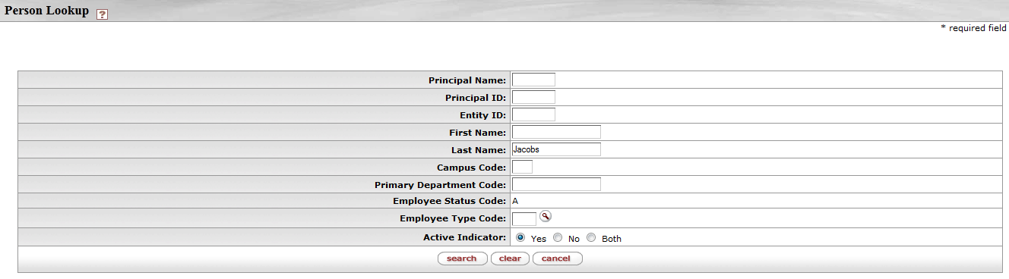

Figure 5

|  |  |
| --- | --- |
| 4. | Click on  to return results |

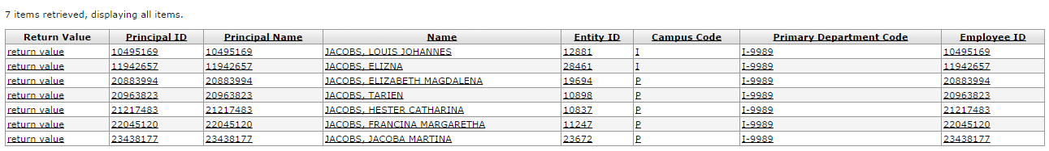

Figure 6

|  |  |
| --- | --- |
| 5. | Choose item that you want to use and click on return value |

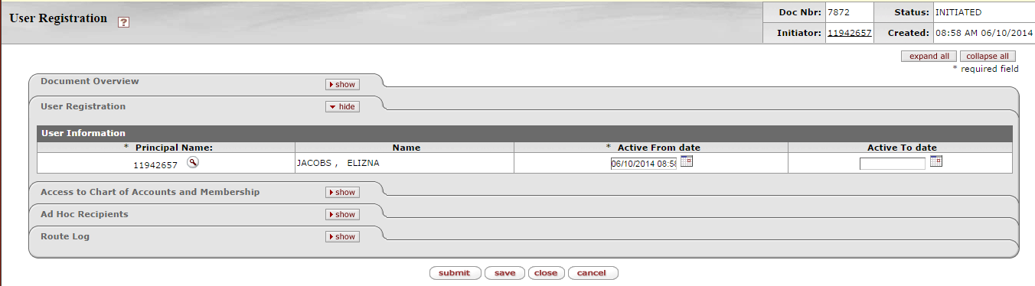

Figure 7

|  |  |
| --- | --- |
| 6. | The employee number and name of the new user will be completed in the Principal Name and Name field |
| 7. | The **Active From date** will be completed automatically as the date when the user registration document is completed. |
| 8. | If the person is on a contract basis, the **Active To date** field must be completed otherwise it can be left blank. |
| 9. | Click on  and then on Hide to collapse the **User Registration** tab again. |

1. **Access to Chart of Accounts and Membership tab**

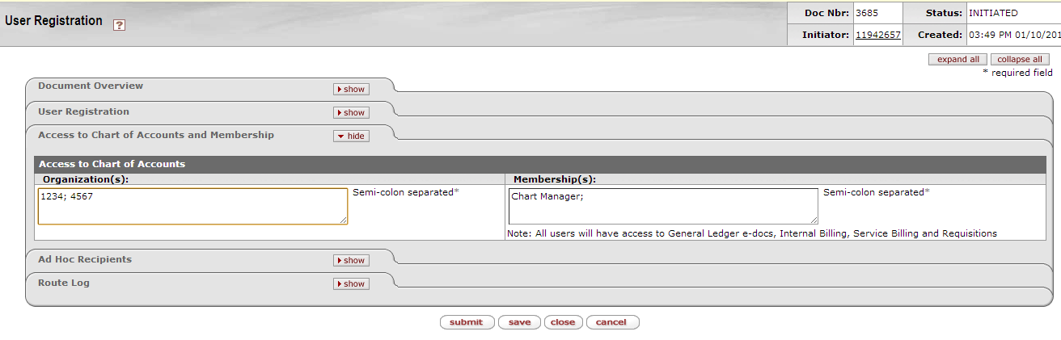

Figure 8

|  |  |
| --- | --- |
| 1. | Click on Show to expand the **Access to Chart of Accounts and Membership** tab. |
| 2. | Type in the **Organization(s)** to which the person must have access to. |
| 3. | If the person must have access to certain specified roles, that roles must be mentioned in the **Membership(s)** field. |
| 4. | Click on Hide to collapse the **Access to Chart of Accounts and Membership** tab again. |

1. **Ad Hoc Recipients tab**

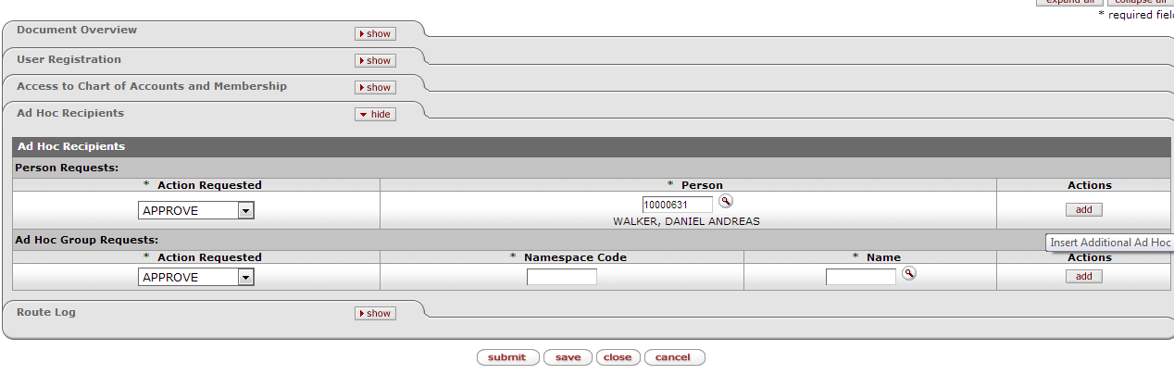

Figure 9

|  |  |
| --- | --- |
| 1. | Click on Show to expand the **Ad Hoc Recipients** tab. |
| 2. | **Complete** or **lookup** the employee number of the person who must authorize the registration of the new user. |
| 3. | That staff member could be the **Director/Head** of the department. |
| 4. | Click on the  button to add that person to the document. If an additional person must authorize the registration of the new user, another person can be added. |

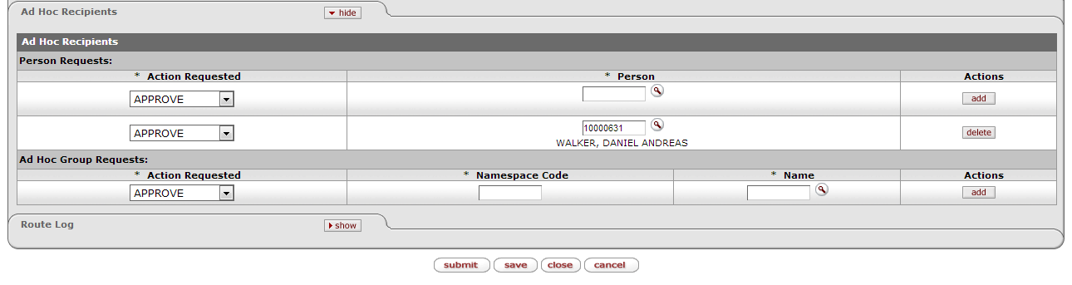

Figure 10

* The adding of an **Ad Hoc Recipients: Person Requests** is a required field – if no person is added, the document will return with an error indication that an Ad Hoc Recipient must be added.

**Please note:** The **Ad Hoc Group Requests** field is for office use only.

* **Approve**: The document is waiting for your action. Review the e-Doc for accuracy and appropriateness. If errors exist, you will need to disapprove the document.
* **FYI**: The document continues routing without any action on your part. Document can be removed directly from your Action List without opening.
* **Complete**: You need to complete your saved document before you can initiate the document. The complete action request usually goes with the “Saved” route status.
* **Acknowledge**: The document continues routing without any action on your part. Document can be removed directly from your Action List without opening.



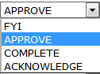

|  |  |
| --- | --- |
| 1. | Click on  so that the document can route to the next person in the workflow. |
| 2. | Click on Hide to collapse the **Ad Hoc Recipients** tab again. |

## Route Log tab

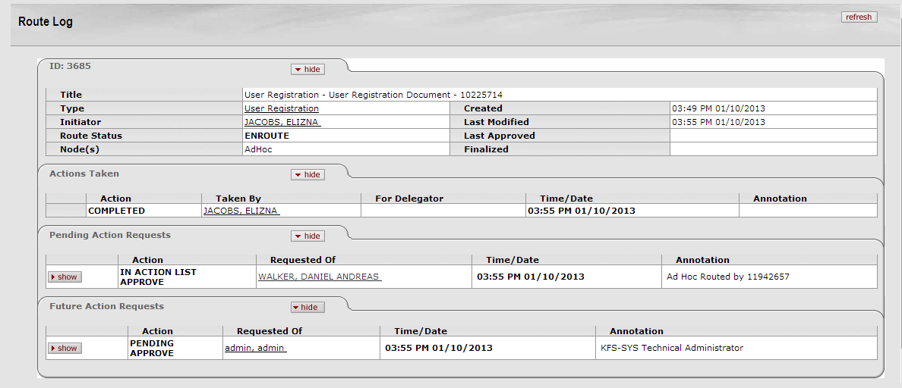

Figure 11

|  |  |
| --- | --- |
| 1. | Click on Show to expand the **Route Log** tab. |
| 2. | This is only a preview of how the **Route Log** screen will look on the user registration document in KFS. |
| 3. | You can therefore see which persons must approve the document as well as where the document is stuck in the process. |
| 4. | The **Actions Taken** tab displays the history of workflow actions on the e-doc. |
| 5. | The **Pending Action Requests** tab displays the next action to be taken and shows more detailed routing information about this request. |
| 6. | The **Future Action Requests** tab shows the action requests that Workflow will generate in the future based on the information currently on the document. |



* **SAVED**: The document has been started but not completed or routed. You can save your work, close the document, and retrieve it from you Action List for completion and routing at a later time.
* **FINAL**: The document is fully approved.
* **ENROUTE**: Approval requests on the Document are pending.
* **PROCESSED**: The document has no pending approval requests but still waiting for acknowledgement.



|  |  |
| --- | --- |
| 1. | Click on Close to close the document and on **YES** to save the document again. |

## The Action list of the approver

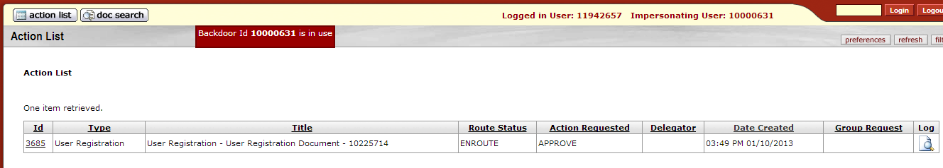

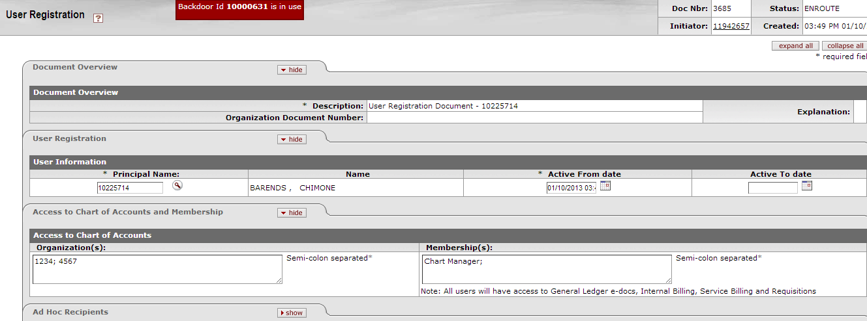

Figure 12

* The **Director/Head** of the department will receive the user registration document in his/her **Action List** for approval. After the **Director/Head** of the department have approved it, the System Administrator will receive the document in his/her Action list for approval and further completion.

## Document Search

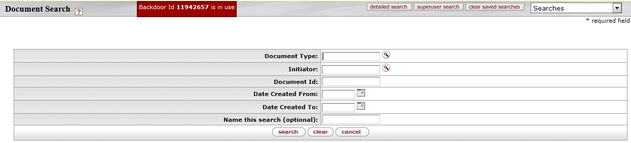

Figure 13

* The initiator can check the status of the registration by doing a **Document Search**.

|  |  |
| --- | --- |
| 1. | Click on  to search for a new KFS user. |

## Detailed Search option

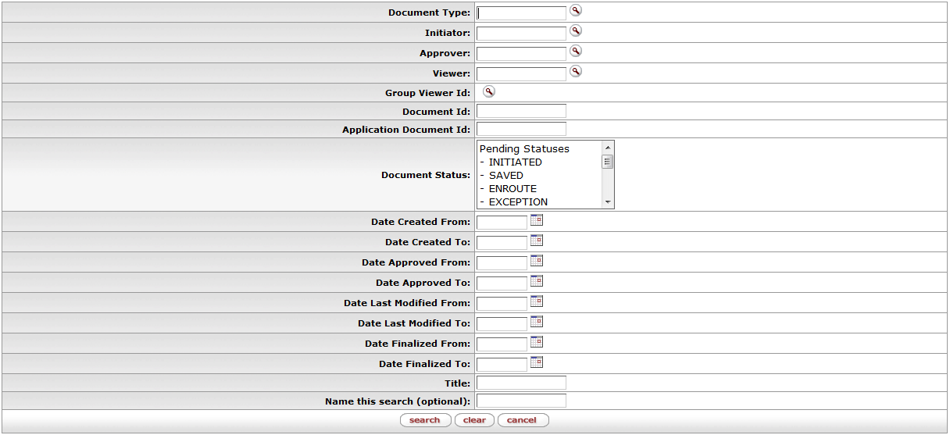

Figure 14

## The Title option

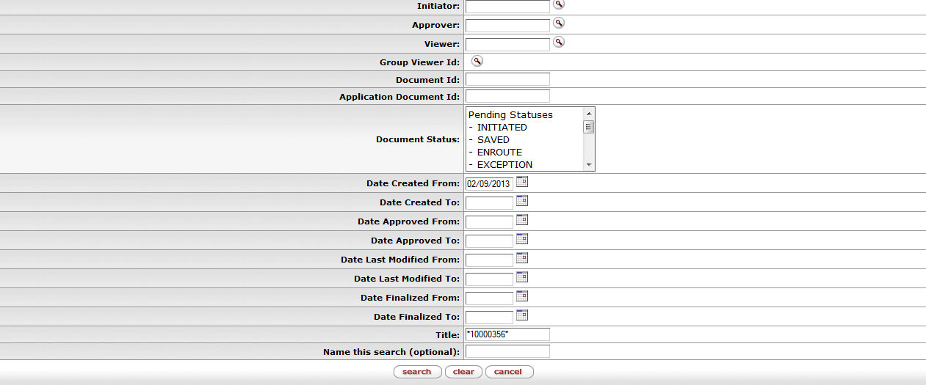

Figure 15

* Fill in the employee number of the new user between asterisk (**\***) at the **Title** field.

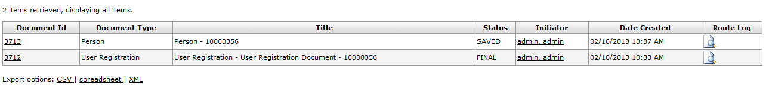

Figure 16

**PLEASE NOTE**:

* If the person’s document is still in **SAVED** status, the user is not registered, yet.
* The person’s document status must be in a **FINAL** status to be a registered KFS-User.

|  |  |
| --- | --- |
| **Lesson Summary** | |
|  | Having completed this lesson you should be able to:   * Know the KFS registration procedure for a new KFS user. |