Organization Review Delegate Global
(ORDG)
Document Summary
Product Owner / Author | Carl Minné
Editor Name | Chimoné Barends
Date | 2015/09/16
Time | 08:00 AM
Template | Verbose

Lesson Objectives
On completion of this lesson you should be able to:
- Create a secondary delegate using the Organization Review Delegate Global document

Lesson Scenario
- As an existing staff member of the NWU you are required to work through this lesson, make some notes if necessary and print out the documentation as a guideline.

Lesson Prerequisites
- You need to be a NWU staff member that is registered on KFS as a user.
- You need to be an existing approver on KFS.

Table of Contents

- Organization review Delegate global
- Organization Review Delegate Global document
- Document Overview tab
- Edit Organization Delegate Global tab
- Edit List of Org Review Roles tab
- Principle Name Lookup
- Organization Code Lookup
- Submit Document
- View Organization review Delegate

- Organization Review Delegate Global
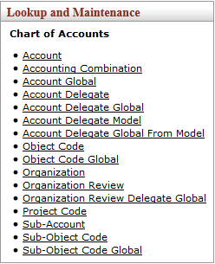
Figure 1

1. | Click on Organization Review Delegate Global option Lookup and Maintenance submenu group in the Chart of Accounts submenu on the Main Menu tab.

- Organization Review Delegate Global document

- This screen opens up the Organization Review Delegate Global document. The tabs of this document in the example are set to to make the discussion easier.
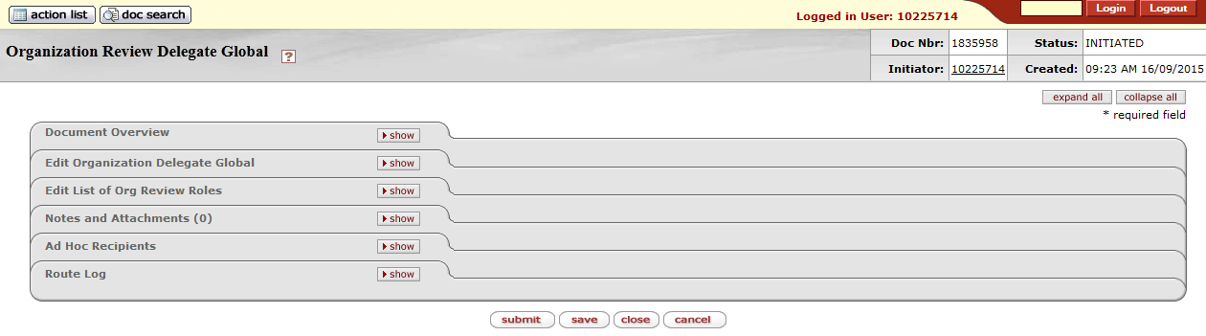
Figure 2

- Document Overview tab
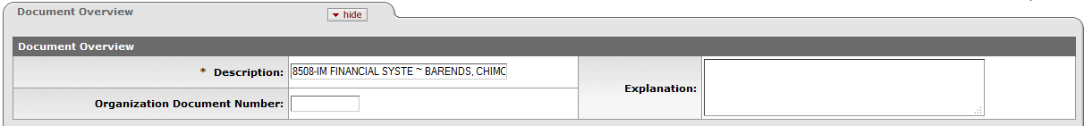
Figure 3

1. | Click on to expand the Document Overview tab.
2. | It is not necessary to fill in this Document Overview tab; this is only a preview of how the screen will look.
3. | Click on to collapse the Document Overview tab.

- Edit Organization Delegate Global tab
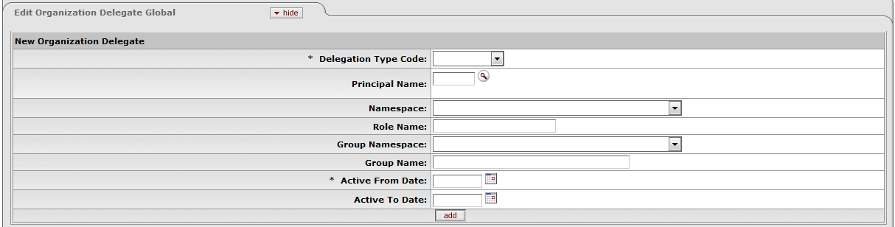
Figure 4

1. | Click on to expand the Edit Organization Delegate Global tab.

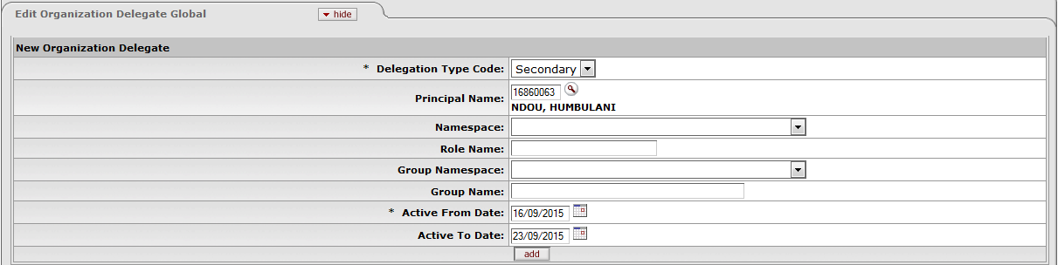
Figure 5

- Please Note: The principal name is the person that need to act as the Delegate of the approver
1. | Delegation Type Code: Select Secondary from the drop-down list.
2. | Principal Name: Type or search for the Principal Name.  Note: Must preferable be a person on the same or higher rank than the approver of the organization.
3. | Type or search in the Active From Date
4. | Type or search in the Active To Date  Note: We prefer that every approver have a permanent delegate that could act during unforseen situation that will avoid transactions from being stuck in the workflow.
5. | Click on to add the person to the Delegate list

- Edit List of Org Review Roles tab
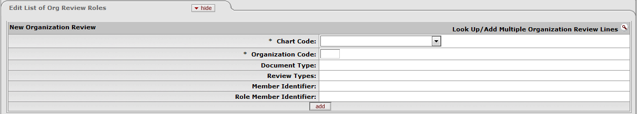
Figure 6

1. | Click on to expand the Edit List of Org Review Roles tab.
2. | Click on to open the

There are two ways to do a lookup:
- On the Principle Name or Organization Code
The Organization Code lookup is preferred over the Principle name lookup unless approver is linked to to many Organizations codes at once. A document will need to be completed for each Organization for which the approver is responsible.

- Principle Name Lookup
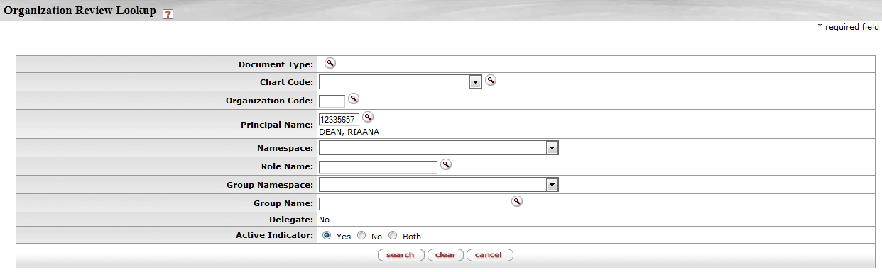
Figure 7

1. | Type or for the Principal Name.
2. | Click on to return the result.

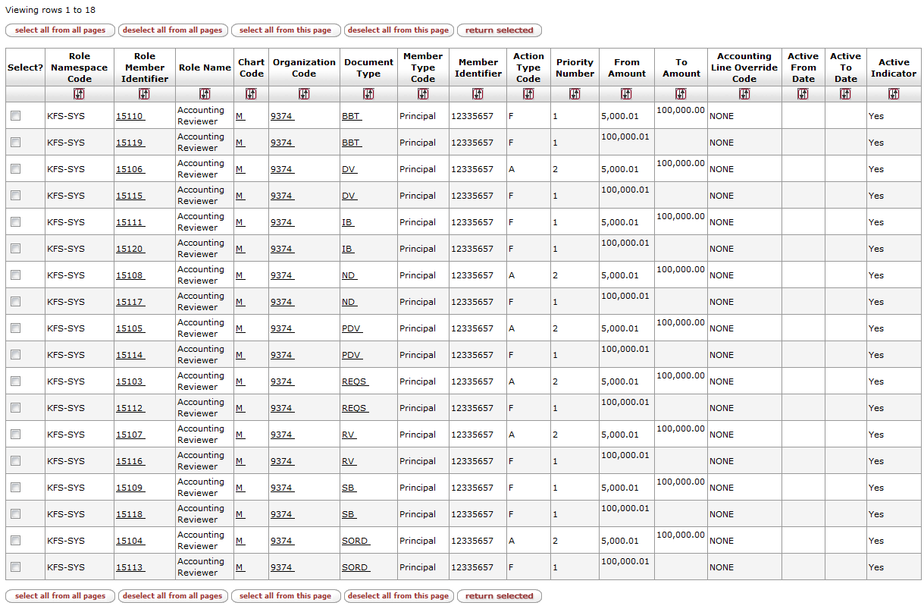
Figure 8

1. | Click on to select all the relevant documents or select only certain lines.
2. | Click on to return the selected documents.

- Organization Code Lookup
Figure 9

1. | Type or for the Organization Code.
2. | Click on to return the result.

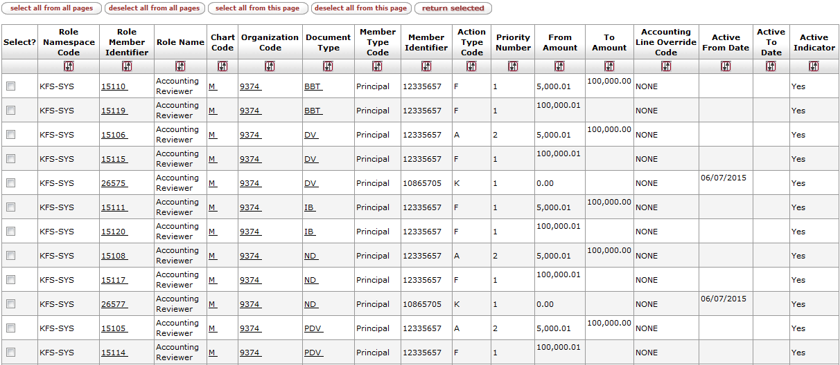
Figure 10

1. | Click on to select all the relevant documents or select only certain lines.
2. | Click on to return the selected documents.

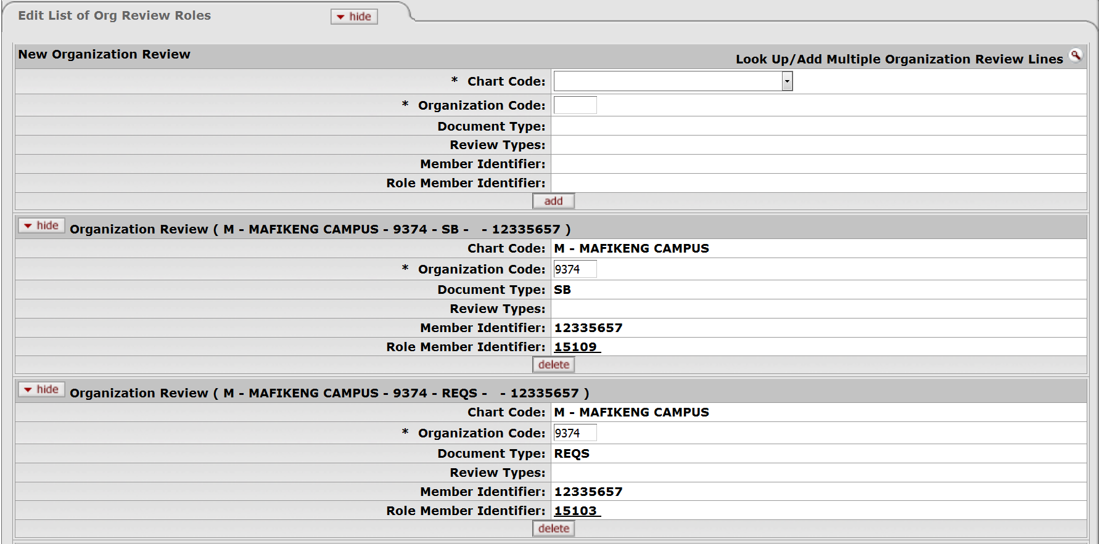
Figure 11

- Submit Document
Figure 12

1. | Click on then the document will be in “Final” status.

- Organization Review Delegate
Figure 13

1. | Click on Organization Review option Lookup and Maintenance submenu group in the Chart of Accounts submenu on the Main Menu tab.

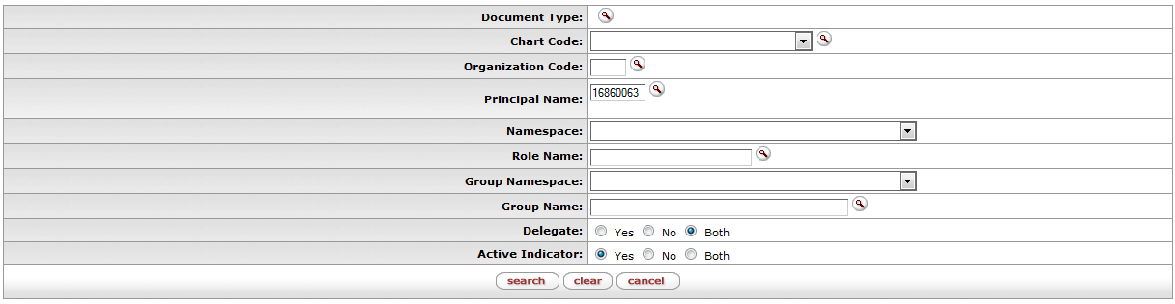
Figure 14

1. | Type or for the Principal Name or
2. | Type or for the Organization Code.
3. | Select both for the Delegate.
3. | Click on to return results.

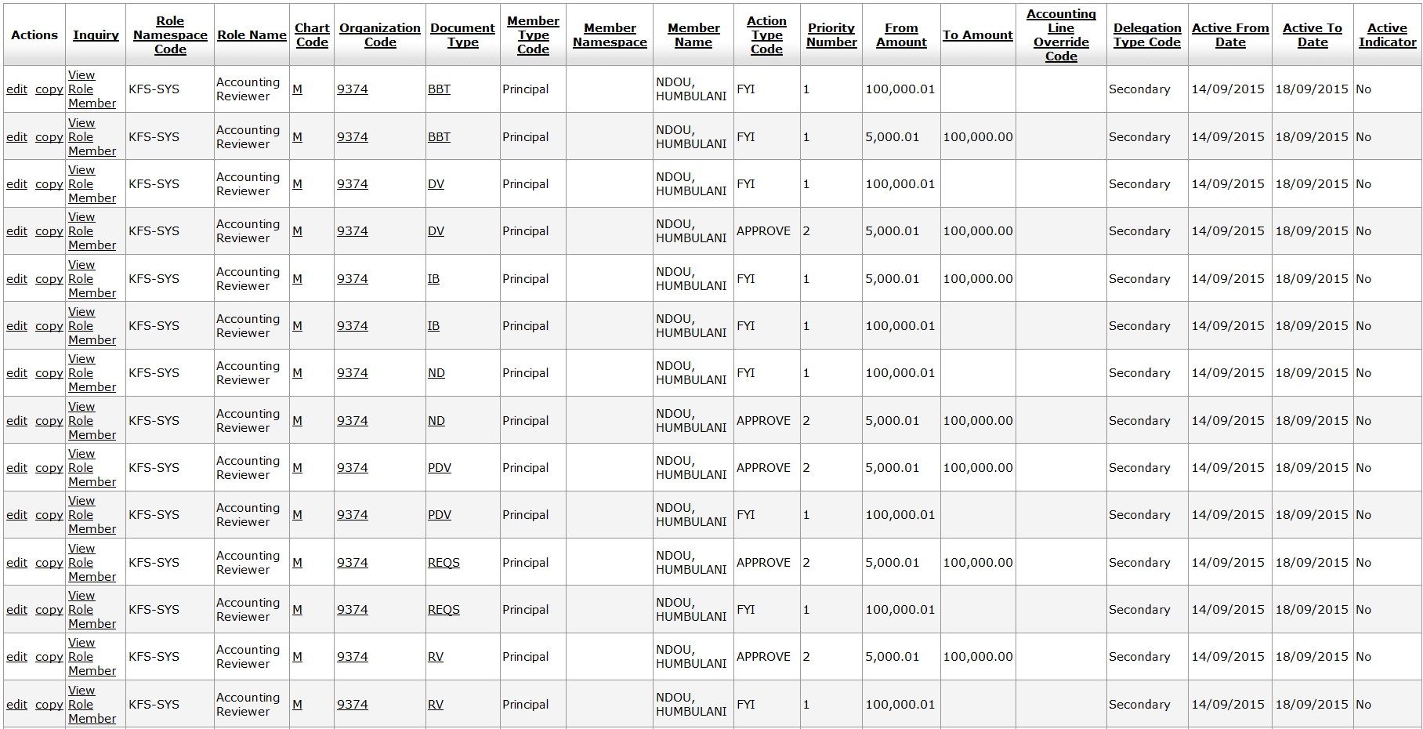
Figure 15

Lesson Summary
Having completed this lesson you should be able to:
- Create a Delegate on Organization for existing user.

