**KFS Training Tip 2: Is the object linked to my Account or not?**

As KFS-user you will be able to search on the system whether an object is linked or not.

Use the following steps:

* 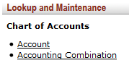Main Menu
* Lookup and Maintenance
* Chart of Accounts
* Accounting Combination
* Enter Account number
* Click 

**For example:**

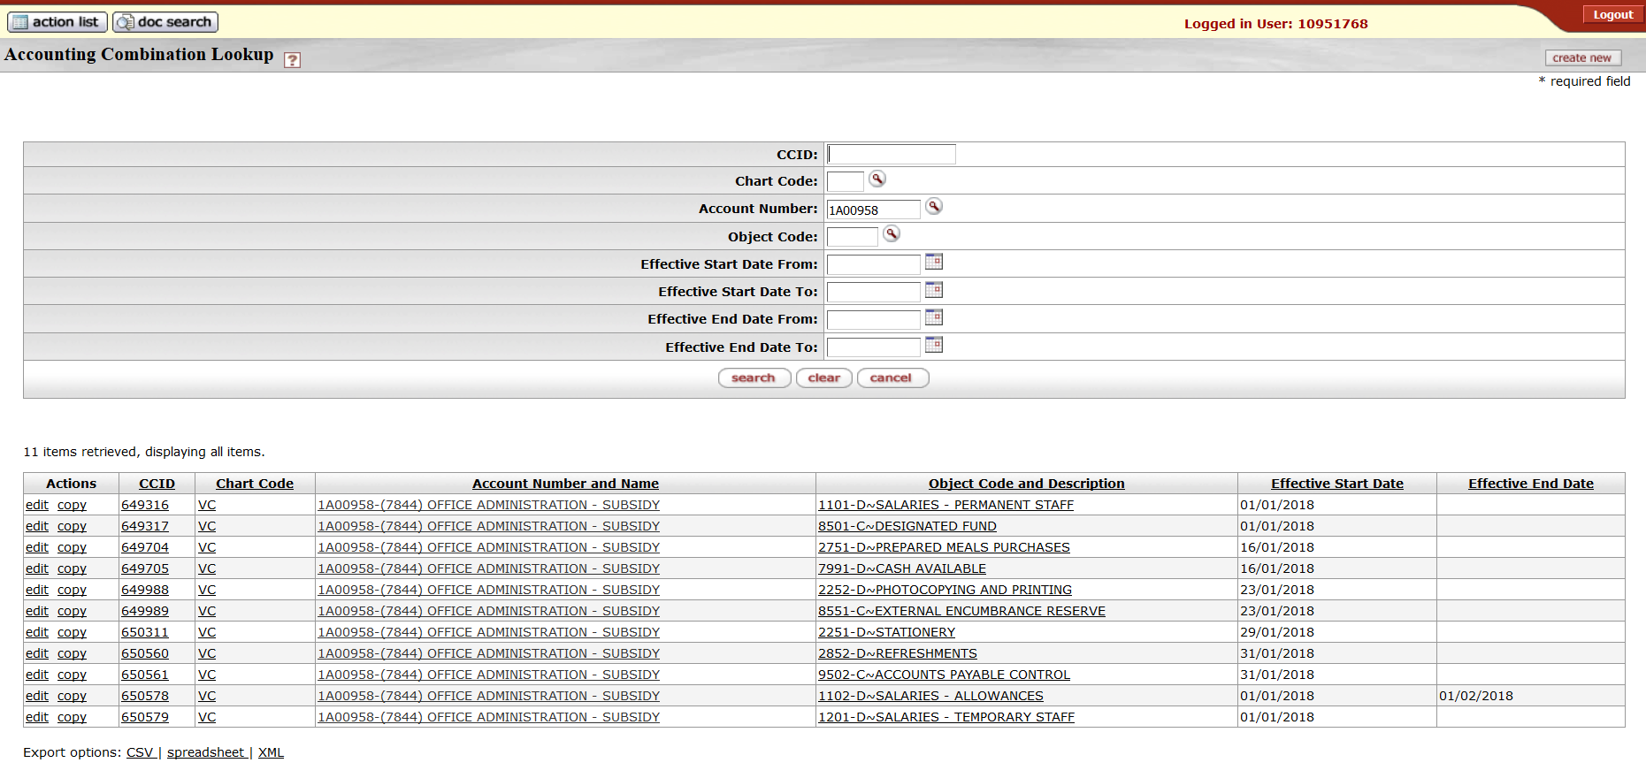

**The search result will indicate:**

* Whether an object is **active** = **Effective Start Date** and
* Whether an object is **closed/inactive** = **Effective Close Date**

**Errors found in a transaction:**



* If you get the following error message: “**Invalid `Accounting Combination`**” - it means that the specific combination does not exist and that you need to contact Finance: Governance, Reporting and Treasury to link the object before you can proceed.
* This will only be necessary for the object types in the range from **5000** upwards.
* For expense object types it will not be necessary to link the objects before they are used, it will automatically generate when used for the first time – according to the rules and parameters that apply to the E-doc and transaction.