Accounts Receivable (AR)
Create a Customer Invoice
Document Summary
Product Owner / Author | Elizna Jacobs
Editor Name | Chimoné Barends
Date | 2019/02/12
Time
Template | Verbose

Lesson Objectives
On completion of this lesson you should be able to:
- Navigate to the Customer Invoice
- Select a Customer
- Select a Shipping Address
- Add an Item Type
- Enter the Invoice Quantity / Description and Unit Price
- Generate a Pro-Forma Invoice
- Generate a Tax Invoice

Lesson Scenario
- As an existing staff member of the NWU you are required to work through this lesson, make some notes if necessary and print out the documentation as a guideline.
- This lesson will teach how to create a Pro-forma Invoice that will need to be accepted by the customer for goods or services that they have requested an actual invoice is generated.

Lesson Prerequisites
- You need to be a NWU staff member that is registered on KFS as a user.
- You need to have access to Accounts Receivable.

Table of Contents

- Main Menu overview for the end user
- Customer Invoice Layout
  - Document Overview Tab
  - Organization
  - General Tab
  - Billing / Shipping Tab
  - Accounting Lines Tab
  - General Ledger Pending Entries Tab
  - Notes and Attachments (0) Tab
  - Pro-Forma Invoice
  - Tax Invoice

Main Menu
KFS Navigation: Transactions > Accounts Receivable > Customer Invoice

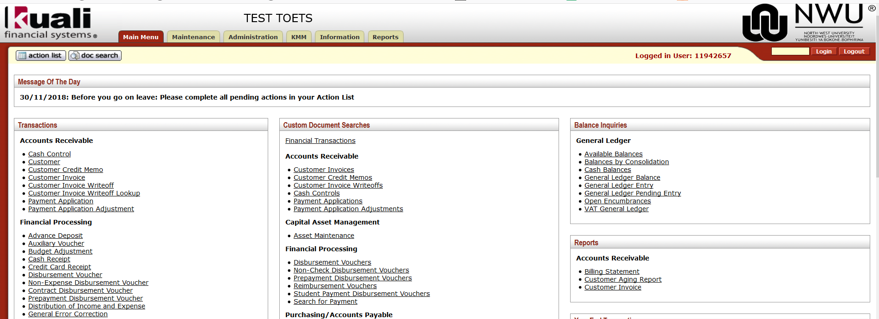
Figure 1

1. | Click on Customer Invoice.

Customer Invoice Layout (tabs to be completed)
Figure 2

2.1 Document Overview Tab

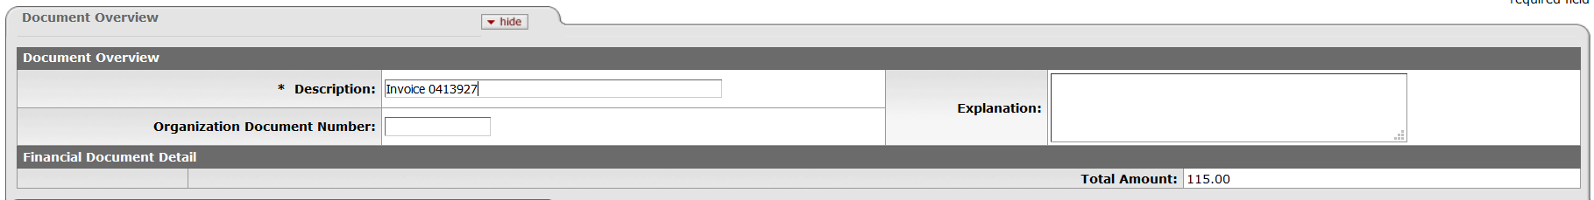
Figure 3

1. | Description: Type “Invoice with invoice number”.

Organization Tab: Processing Chart, Organization and Billing Chart, Organization

Figure 4
1. | Processing Chart Code: Default according to Chart of Initiator
2. | Processing Organization Code: Default according to Organization of Initiator
3. | Billing Chart Code: Chart of the account that is used at the accounting line
4. | Billing Organization Code: Organization of the account that is used at the accounting line

  - General Tab: Customer Information, Detail Information and Statement Information

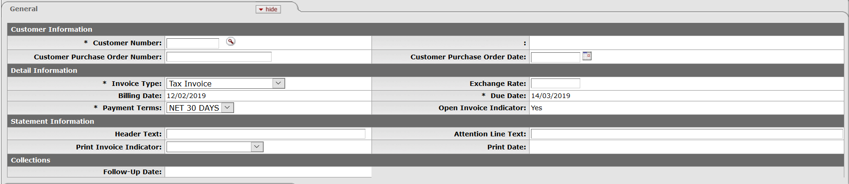
Figure 5

- Please note that the Customer Number must be completed before you can save the transaction.
1. | Customer Number: Click on to complete the customer number.
2. | Customer Purchase Order Date: Click on to specify the Purchase Order date.
3. | Detail Information: Under this heading you will be able to make a choice on what type of Invoice you will be generating.
4. | Invoice Type: Click on and select the invoice type you would like to create.
- Tax Invoice:
Use to create Invoice with VAT. Please take note that this Invoice Type is also used in the case with Foreign Customers when the service or goods are delivered in the foreign country an Invoice is generated in their currency with the exchange rate of the day that it is submitted.
- Non-Tax Invoice: Use to create Invoices which are tax exempt. No VAT will be added on the Invoice.
- Donations: Use to create Donation Invoices. The Invoice it generated without VAT.
- Bursaries:
Use to create Bursary Invoices. Please take note that only certain departments are allowed to create Bursary Invoices. Invoice is generated without VAT.
- Tax Invoice Rand (Foreign):
In regards to the SARS Law when a service or goods are delivered to a foreign customer but the goods or service is delivered within South Africa then the Invoice is created in RAND. The Foreign Customer can claim VAT back upon leaving the borders of South Africa again.

5. | Please note: If the Customer is a Foreign Customer, you should enter the exchange rate for that specific day. The currency used on the invoice, will be the currency specified on the Customer that you are invoicing,  For example, USD 1 = R15.50. Exchange rate that are being used on the invoice, will therefore be 15.50
6. | Payment Terms: Click on and select the payment terms you require.  Please Note: The default term for all invoices set to 30 Days with only a few departments allowed to use the other options.
7. | Attention Line Text: Type a contact person’s name in the text box.

2.4 Billing / Shipping Tab

- When the Customer is selected the Bill to Address (Primary address) automatically gets populated from Customer data.
- The Ship to Address specifies multiple sites for the same customer. This is in the case when you have one customer, but they have different sites which you can bill or different branches (Primary address vs Alternate address).
- The Ship to Address will identify which site of the company you will bill for the service delivered. You will need to search for the correct ship to address if it differs from the bill to address
Please note: This is required fields.

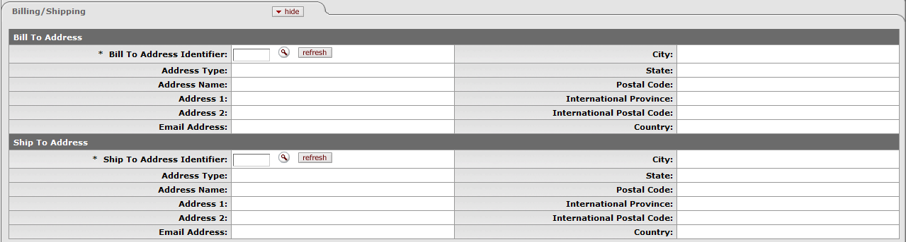
Figure 6

1. | Bill To Address Identifier: Click on and return the value.
2. | Ship To Address Identifier: Click on and return the value.

2.5 Accounting Lines Tab

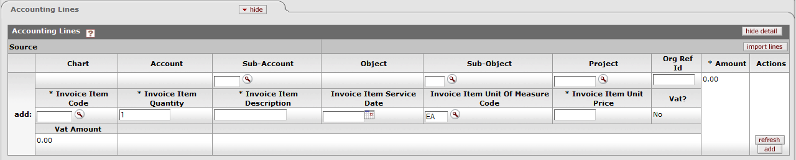
Figure 7

1. | Invoice Item Code: You can or type in the item code.
2. | Invoice Item Quantity: Complete the quantity to be invoiced in the text box.
3. | Invoice Item Description: Complete the description of the service in the text box.
4. | Invoice Item Unit Price: Complete the unit price in the text box.  This amount should be the amount before VAT.  PS: If Foreign Customer is invoiced, the amount should be the amount in the currency of the customer, for example if the currency of the customer is USD, the amount entered should be the USD amount.
5. | Click on - VAT will be added to the amount if applicable
6. | the transaction - this will keep a record of your transaction, will generate GL pending entries and open up the possibility to generate a pro-forma invoice or submit to generate a Tax invoice.
7. | After clicking on , the Organization Invoices Number will generate in the Organization tab. The invoice number can now be entered in the Document Overview Description field.
8. | Click on . At this stage a pro-forma invoice can be generated for the customer first to accept or reject, before a Tax invoice is generated.

2.6 General Ledger Pending Entries
In this tab, you will be able to see which general ledger lines (GLPE’s) will create
If a Foreign Customer were invoiced, the Rand-amount will reflect in the GLPE’s
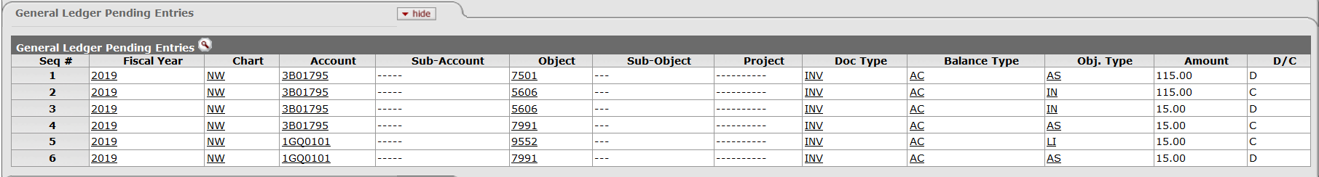
Figure 8

2.7 Notes and Attachments Tab

Figure 9

In this tab you are required to add notes and attachments as supporting documents to the transaction.

1. | Type your note in the Note Text field.
2. | Click on and browse on your computer for the file that you want to attach.
3. | Click on

2.8 Pro Forma Invoice

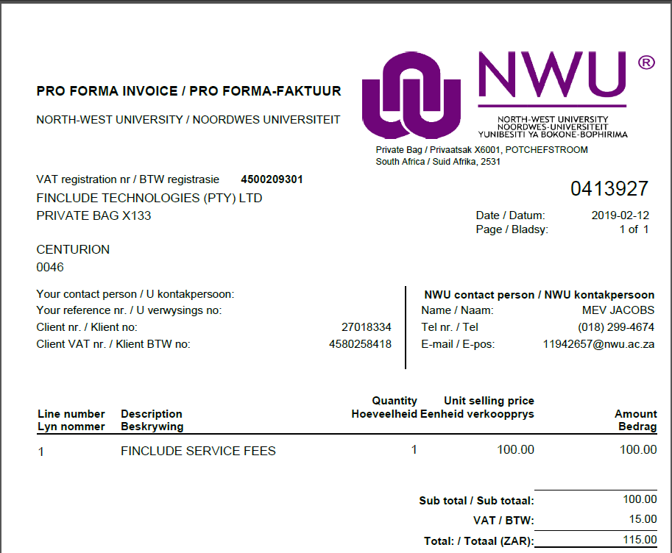
Figure 10

1. | Click on if you want to generate the Actual Invoice.
2. | Click on
3. | Click on to view the Actual Tax Invoice.

2.9 Tax Invoice

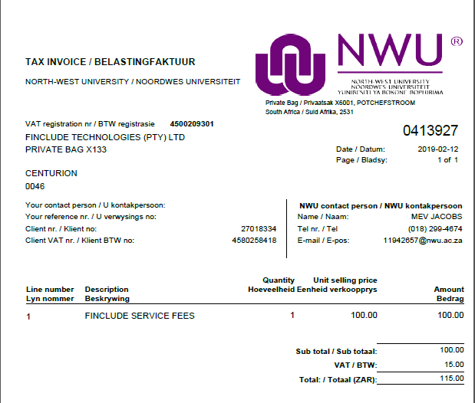
Figure 11

Lesson Summary
Having completed this lesson you should be able to:
- Navigate to the Customer Invoice
- Select a Customer
- Select a Billing and Shipping Address
- Add an Item Code
- Enter the Invoice Quantity / Description and Unit Price
- View General Ledger pending entries
- Generate a Pro-Forma Invoice
- Generate a Tax Invoice

