Accounts Receivable (AR)
Create a new Customer Debtor
Document Summary
Product Owner / Author | Elizna Jacobs
Editor Name | Chimoné Barends
Date | 2019/02/12
Time
Template | Verbose

CREATION OF A NEW CUSTOMER (DEBTOR)
Main menu – Transactions - Accounts Receivable – Customer – Create New
To create an individual as customer
General Information
- Choose correct nationality
- Customer type – must be individual
- Ownership type – must be individual
- Customer number will be generated by the sub-system after submission
- Customer Name will concatenate automatically from the personal information entered
- Enter valid ID number
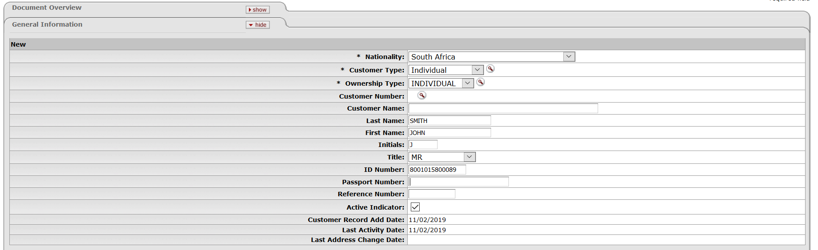
Figure 1
Corporate Information

- Enter valid VAT registration number if individual is registered, otherwise tick the VAT exempt indicator
- Currency must be entered in correspondence with the nationality specified at the General information – this currency will determine the currency used in the invoice
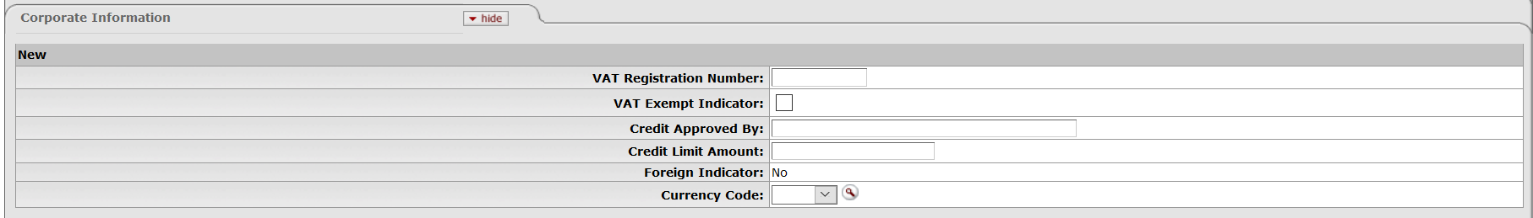
Figure 2
Contact Information

- Enter Birth date that are checked against ID number
- All compulsory contact information must be completed as indicated

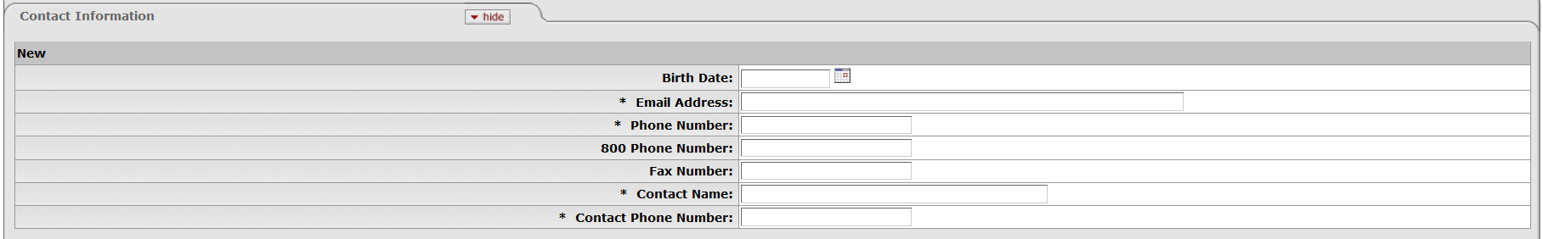
Figure 3
Addresses
- A primary address must be added as that is the address where the statement is emailed to
- All compulsory contact information must be completed as indicated
- An alternate address can be added (might be more relevant to businesses than individuals)

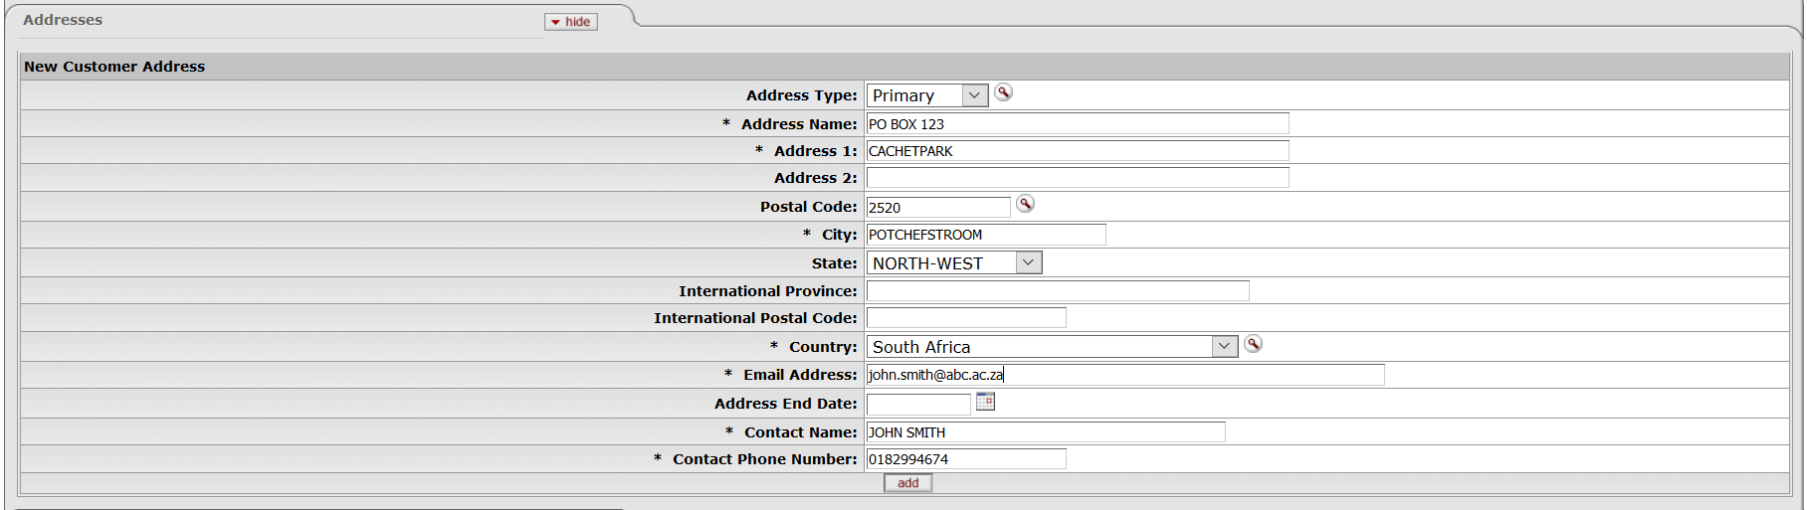
Figure 4
Notes and Attachments
- ID document
- VAT registration, if registered for VAT
The document route to the Central Debtors department for approval
The customer number is generated with submission
Figure 5

To create a business as customer
General Information
- Choose correct nationality
- Customer type – must be Private Business
- Ownership type – must be Institution
- Customer number will be generated by the sub-system after submission
- The company’s name must be entered at Customer Name
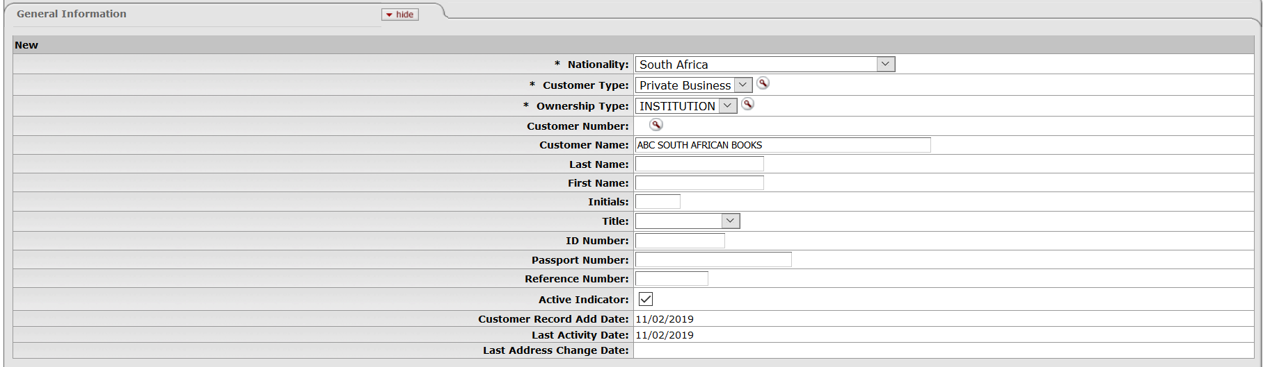
Figure 6
Corporate Information

- Enter valid VAT registration number if registered, otherwise tick the VAT exempt indicator
- Currency must be entered in correspondence with the nationality specified at the General information – this currency will determine the currency used in the invoice

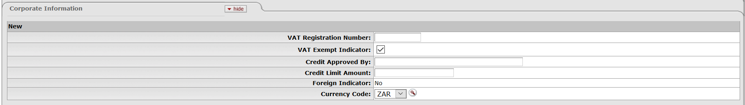
Figure 7
Contact Information

- Birth date will not be applicable for an Institution
- All compulsory contact information must be completed as indicated
Figure 8
Addresses
- A primary address must be added as that is the address where the statement is emailed to
- All compulsory contact information must be completed as indicated
- An alternate address can be added if company have more than one branch or different departments

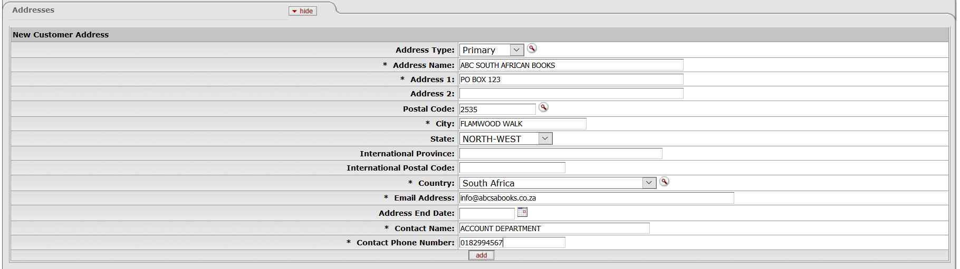
Figure 9
Notes and Attachments
- Company registration
- VAT registration, if registered for VAT

- The document route to the Central Debtors department for approval

- The customer number is generated with submission
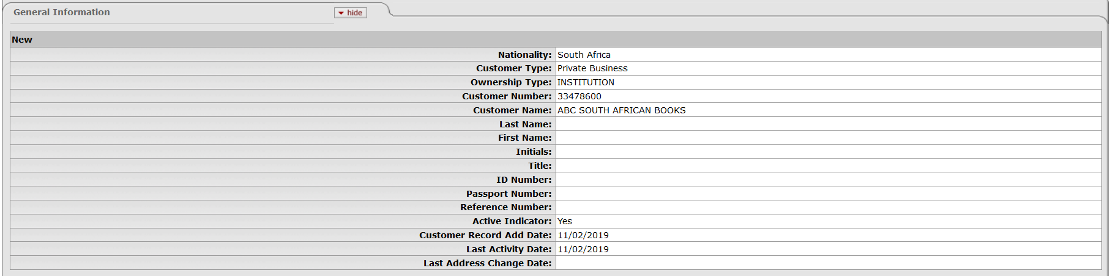
Figure 10

