Financial Processing
Non-Check Disbursement:
Petty Cash Debit Cards
Document Summary
Product Owner | Frikkie Venter
Editor | Chimoné Barends
Date | 2016/09/28
Time | 10:00 AM
Template | Verbose

Lesson Objectives
On completion of this lesson you should be able to:
- Navigate to the Non-Check Disbursement in KFS
- Know the process to create a new Non-Check Disbursement
- Know how to approve a Non-Check Disbursement
- Know how to correct a Non-Check Disbursement

Lesson Scenario
- As an existing staff member you will be able to create a Non-Check Disbursement for upload of money in to Debit Cards issued to employees.
- You will also be able to attach relevant documentation and be able to submit the Non-Check Disbursement in order for it to route via approval levels to Financial Administration for payment.

Lesson Prerequisites
- You need to be a NWU staff member that is registered on KFS as a user.

How to create a Non-Check Disbursement

KFS: Main Menu > Administrative Transactions > Financial Processing > Non-Check Disbursement
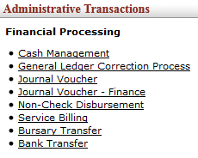
Figure 1

Document Overview

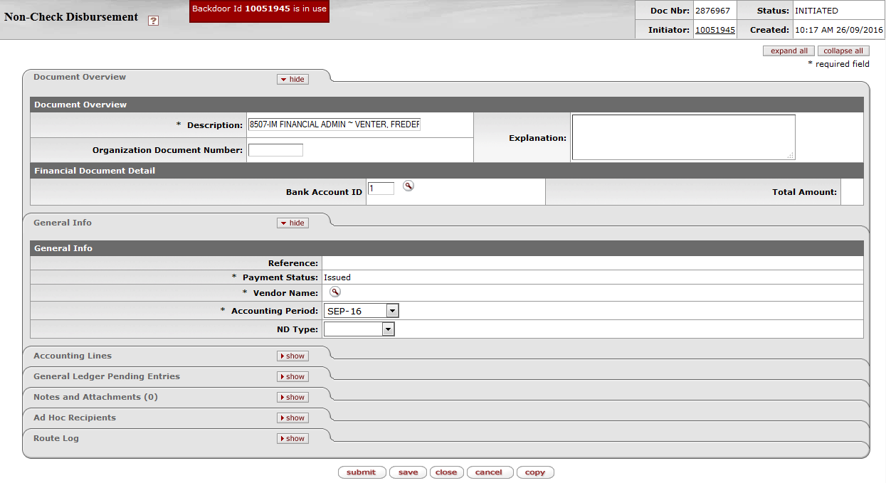

Figure 2

1. | No need to complete the Description field.
2. | Click on Vendor Name to search for relevant Vendor. The Vendor name should be created in the following format: DT CARD-VENTER FJ
3. | Click on Accounting Period and select the relevant period.
4. | Click on drop-down arrow and specify the required ND Type:  - Petty Cash: To upload funds onto your Debit Cards issued by staff members.  - Foreign: To make payments to Foreign Vendors.  - Standard: For centralized use by Finance only.
5. | This ND Type will reflect on your Action List in the Title column, for example:
6. | Navigate to accounting lines, click on the drop-down list for Chart, Account and Object codes and search for relevant account and object. Also complete Amount, Reference Number (staff number) and Line Description.
7. | In case of a new petty cash Debit (D) Object 7982 and Credit (C) the relevant cash account. In case of replenishment of existing petty cash Debit (D) actual expense object and Credit (C) the relevant cash account.
8. | Click on add.

Notes and Attachments
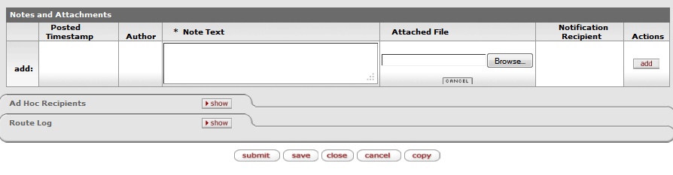
Figure 3

1. | Click on Notes and Attachments and complete the Note Text field. Click on to attach the relevant documentation. For a new petty cash copy of Id must be attached.
2. | Click on to add the attachment.
3. | Click on and a message will appear - document was successfully submitted. The ND will first route to AP Manager/Bank Recon Manager for approval and then to fiscal officer for final approval.

The ND General Ledger Pending Entries

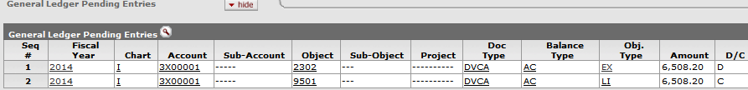
Figure 4

 | 1. | Click on the General Ledger Pending Entries to see the GL entries.

Lesson Summary
Having completed this lesson you should be able to:
- Navigate to the Non-Check Disbursement in KFS
- Know the process to create a new Non-Check Disbursement
- Know how to approve a Non-Check Disbursement
- Know how to correct a Non-Check Disbursement

