Accounts Payable (AP) - Financial Processing
Disbursement Voucher (DV)
Document Summary
Product Owner | Frikkie Venter
Editor | Chimoné Barends
Date | 2016/09/28
Time | 10:00 AM
Template | Verbose

Lesson Objectives
On completion of this lesson you should be able to:
- Navigate to the Disbursement Voucher (DV) in KFS
- Know the process to create a new Disbursement Voucher
- Know how to disapprove a Disbursement Voucher
- Know how to cancel and recall a Disbursement Voucher

Lesson Scenario
- As an existing staff member of the NWU you will be able to create a Disbursement Voucher for payments to staff members and certain Vendors.
- You will also be able to attach relevant documentation and be able to submit the Disbursement Voucher in order for it to route via approval levels to Financial Administration for payment.

Lesson Prerequisites
- You need to be a NWU staff member that is registered on KFS as a user.

Table of Contents

- Disbursement Voucher (DV) Process
  - Business Rules
- Disbursement Voucher (DV) Routing
- Disbursement Voucher Navigation
- Contract Disbursement Voucher (CDV) Document
- Disbursement Voucher (DV) Document
  - Document Layout
  - Document Overview Tab
  - Payment Information Tab
  - Payee Lookup for a Vendor or Employee
  - Accounting Lines Tab
  - General Ledger Pending Entries Tab
  - Notes and Attachments Tab
  - Disbursement Voucher Coversheet
  - Route Log Tab
  - How to Disapprove the DV document
  - The Disapproval Route Log
  - The Action List of the Initiator / Fiscal Officer
  - The Disapproval reason
  - How to Cancel a DV document
  - How to Recall a DV document
  - How to make an Inquiry on a DV document
- Frequently asked questions related to different scenarios

Distribution Voucher (DV) Process

  - Business Rules
- DV Payee cannot be the same as the initiator.
- DV Payee must be active.
- Check amount cannot be negative.
- There must be at least one accounting line.
- Account lines total must not be negative.
- Total of accounting lines must match the Check Total field.
- If the invoice numbers already exist for the chosen Vendor, a warning message will be given with the option to go on capturing the duplicate invoice. Validation for duplicate invoice will be both done for Payment Requests and Disbursement Voucher.

Distribution Voucher (DV) Routing
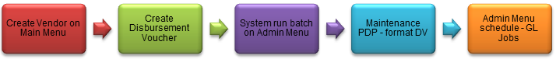
The DV document must route through a series of approvals before the disbursement is actually made based on the rules set up by the institution. Due to its unique nature, the DV document has some special routing issues which are explained below:
- The DV document first routes to the Fiscal Officer for each account in the Accounting Lines tab.
- After it has been approved by all required Fiscal Officers, the document routes, as specified by the institution’s rule, to the organization review routing level.
- After the document has been approved by all organizational approvers, the DV document goes through any special routing as required by business rules surrounding the attributes of the transaction and the payee.
- The document status becomes FINAL when the required approvals are obtained and the transaction is processed by the institution defined process, which might include the Pre-Disbursement Processor.

- Disbursement Voucher (DV) Navigation:

- KFS navigation: Main Menu > Transactions > Financial Processing > Disbursement Voucher
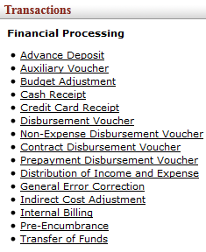
Figure 1

- The KFS-system allow you as end-users to initiate one of the following Disbursement Vouchers (DV):
  - For payments to staff members or Vendors.
  - Only specific staff members can use this option for example, Edu-loan and Salary deduction payments.
  - For better control over payments in terms of tenders/contracts on the KFS system and also to meet the auditor’s requirements.

- Contract Disbursement Voucher (CDV) Document

- All contracts and tenders for payment with a Contract Disbursement Voucher will be created on KFS.
- The information which will appear on KFS:
  - The Name of the contract/tender
  - The Total amount of the contract/tender
  - The Begin and End-date of contract if applicable.
- The KFS-system will keep record of spending funds in terms of the contract and will also give a warning when the total amount of the contract is spend or when the contract expires.
- Once a payment is made in terms of a contract/tender which is not yet created on KFS, one must send the contract/tender document via e-mail so that Frikkie Venter or Melanie Nortje can create it on KFS.

The procedure to select a contract/tender to create a Contract DV on KFS:

- Navigate to Payment Information tab and click on the search button for Tender/Contract Name.
- The Tender/Contract Lookup screen will then appear.
- Click on search button for Vendor Name and search for relevant Vendor.
- Click on return value and then on search.
- Click on relevant tender/contact name and then on return value.
- KFS will bring the tender/contract name to the Contract DV screen and you can continue to create the DV.
Examples of the Contract Disbursement Voucher (CDV) screens:

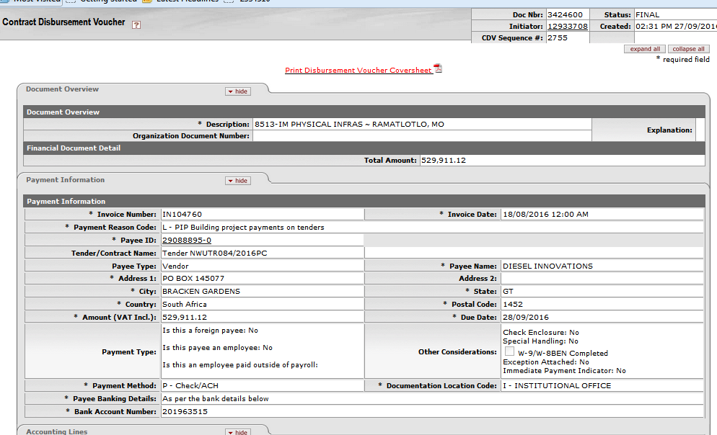

Figure 2

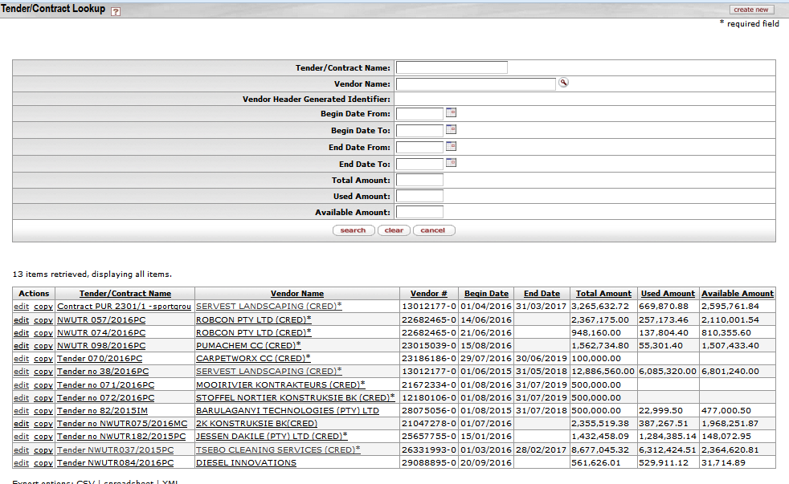
Figure 3

5.1 Disbursement Voucher (DV) Layout

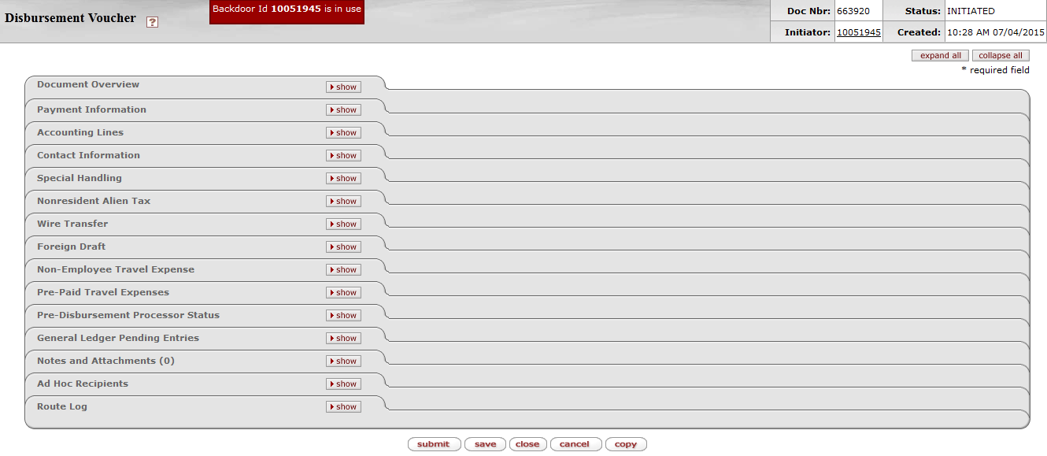
Tabs to be completed
Figure 4

- Log into KFS as necessary. A blank DV document with a new document ID appears.

- Write down the Doc Nbr on your original documentation so you can easily pull up the DV when you are performing a search.
5.2 Document Overview Tab

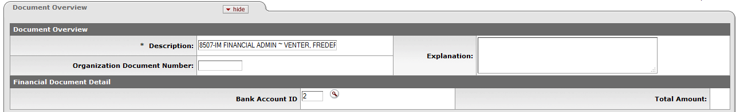
Figure 5

- The Description (Auto generated: Org code & name + Initiator’s surname & name) – do not type in this field! You may enter a brief Explanation (optional)

5.3 Payment Information Tab
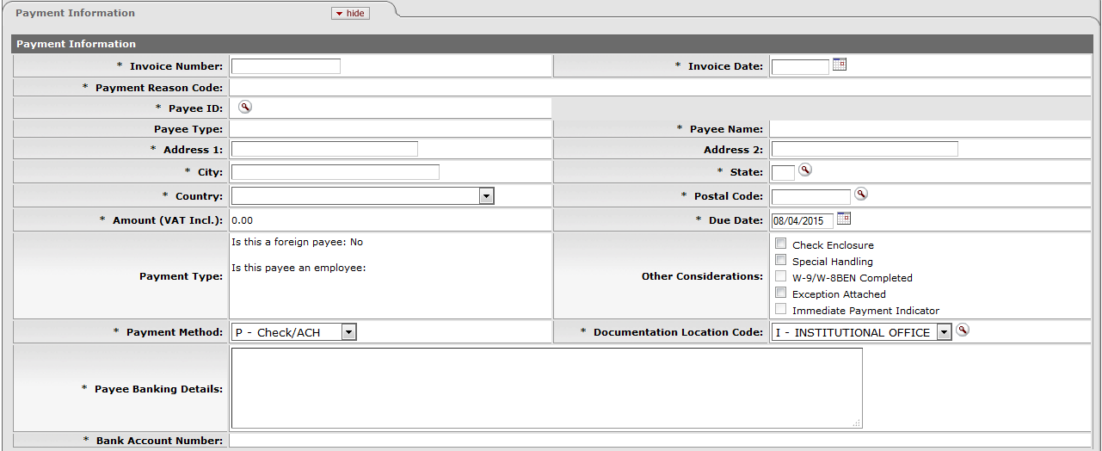
Figure 6

1. | Enter the invoice number in the Invoice Number field, for example Inv-123456
2. | Complete or the Invoice Date, for example 09/04/2015
3. | Click on to search for the Payee ID.
4. | Click on Payment Reason Code and select the relevant Payment from the list, for example B – Reimbursement Out of Pocket Expense  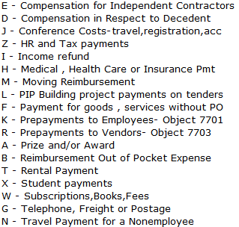  Please don’t select payment reason code  “N – Travel Payment for a Nonemployee” from the available list.

The Payment Reason Code Descriptions

KFS Navigation: > > Financial Processing > Disbursement Voucher > Payment Reason Code and click on to search the reason codes with descriptions. This information can also be exported into Excel.

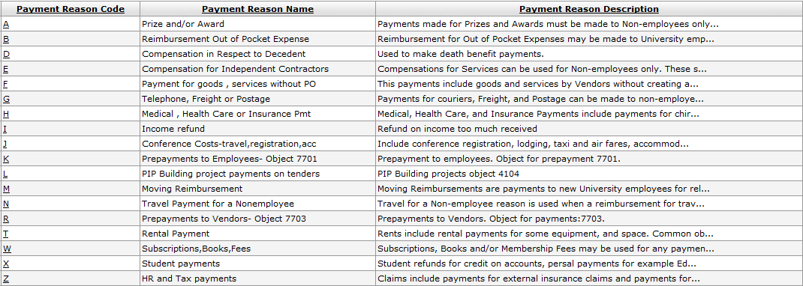
5.4 Payee Lookup for a Vendor or Employee
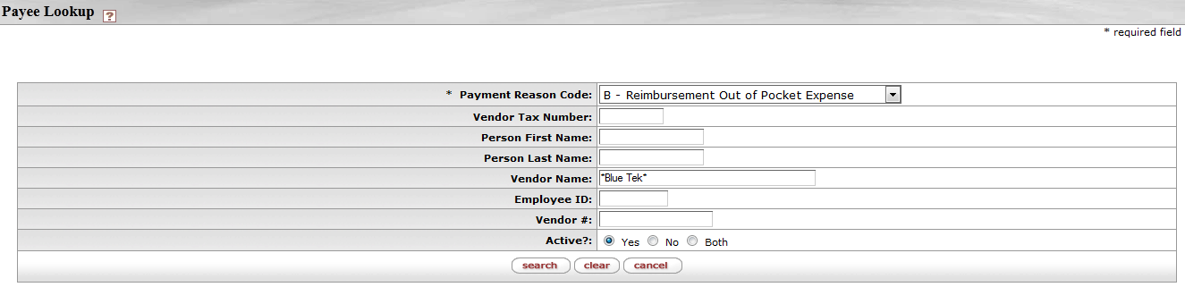
Figure 7

- Complete the following required fields on the Payee Lookup screen:

  - Persons Last Name - If you want to pay an Employee
  - Vendor Name - if you want to pay a Vendor

1. | Type the Employee Name in the Persons Last Name field, for example *Venter* or
2. | Type the Vendor Name in the Vendor Name field, for example *Blue Tek*
3. | Click on

Figure 8

1. | Click on and select the relevant name, for example

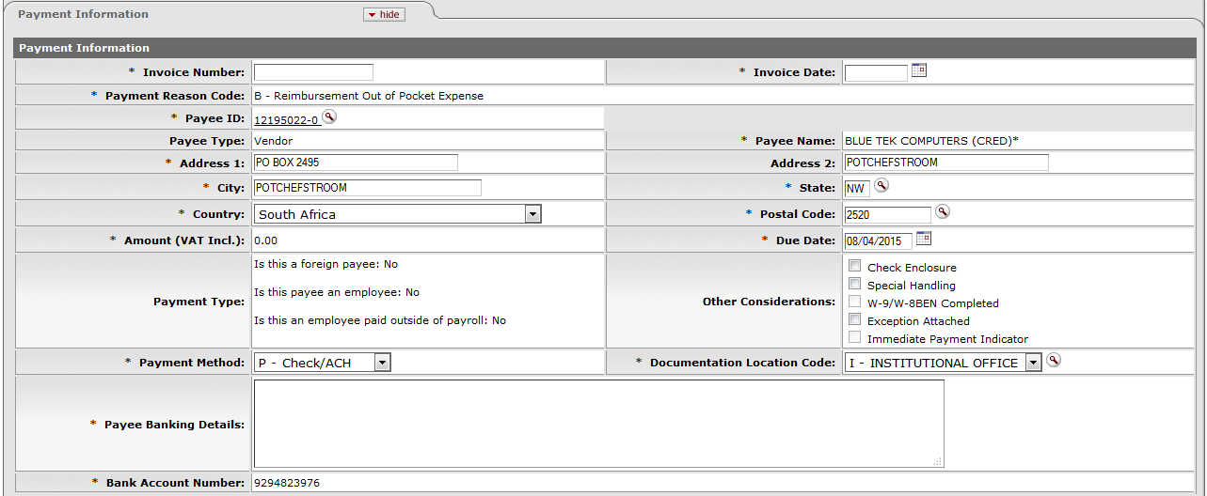
Figure 9

1. | The Address 1, City & Country will auto default after selecting the Payee ID for a Vendor  Please note to complete the Address 1, City, Country, State and Postal Code fields when you select an Employee.
2. | Click on Payment Method and select from the drop-down list.
3. | Complete the Vendor or Employee’s banking details in the Payee Banking Details field. For example: Bank Name, Branch Code and Bank Account Number.
4 | If no Payee number appears in the Payee ID field after you click on return value, it could be that a staff member’s contract is terminated.

5.5 Accounting Lines Tab
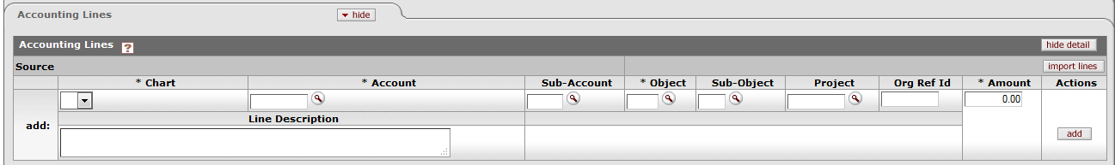
Figure 10

1. | Complete the Chart, Account, Object, Amount and Line Description.
2. | In all instances (always) complete the total amount (VAT-inclusive). KFS will handle the VAT calculation automatically and take in consideration the Vendor, Account and Object Code.
3. | Click on

5.6 General Ledger Pending Entries Tab

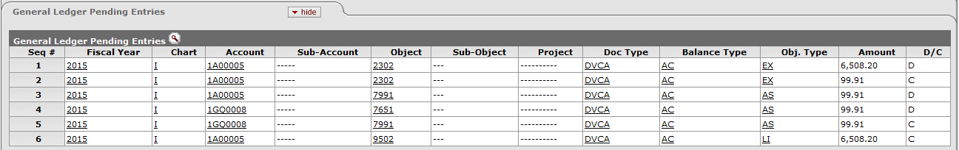
Figure 11

- The Accounting Lines that will be posted to the General Ledger can be reviewed in the General Ledger Pending Entries. (No action is required.)

1. | Click on in the General Ledger Pending Entries tab to open the tab.
2. | Debit (D) the Actual expense and Credit (C) the Accounts Payable Liability.

5.7 Notes and Attachments Tab

Figure 12

- In this tab you are required to add notes and attachments as supporting documents to the transaction.

1. | Type your note in the Note Text field.
2. | Click on and browse on your computer for the file that you want to attach.
3. | Click on when you are satisfied.
4. | Click on
5. | Click on

5.8 Disbursement Voucher Coversheet

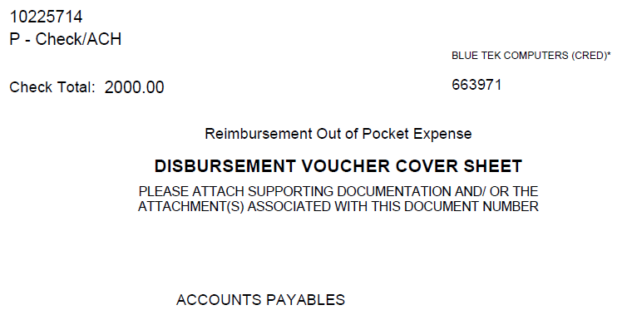
Figure 13
5.9 Route Log Tab
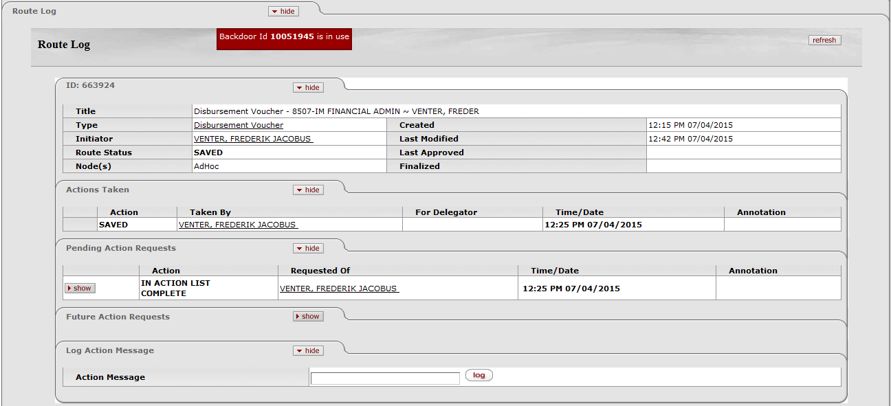

Figure 14

- Routing for the DV for NWU:
◦ Initiator - Initiate
◦ Fiscal Officer - Approve
◦ AP Manager - Approve (according to the Approval levels)
◦ Final
- After the DV’s status changed to Final, is the DV ready for extraction to the Pre-Disbursement Processor where the payment will take place.
- If you choose Payment Reason Code “E – Compensation for Independent Contractors” for services rendered, the e-doc will also route to the TAX-Manager for approval.
- If a Purchase Order (PO) Vendor is paid with a DV, the e-doc will route to the Purchasing Department for Approval.
5.10 How to Disapprove the DV document
- The Fiscal Officer or AP Manager will click on their
- The Fiscal Officer and AP Manager will be able to disapprove the document only if the DV’s status is not yet “Final” but “Enroute”.
- They will open the Doc Nbr/Id and click on instead of

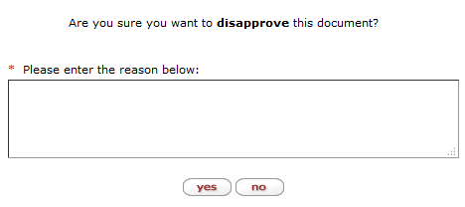
Figure 15

1. | Type your reason for Disapproving in the Please enter the reason below text field.
2. | Click on or when you are satisfied.

5.11 The Disapproval Route Log

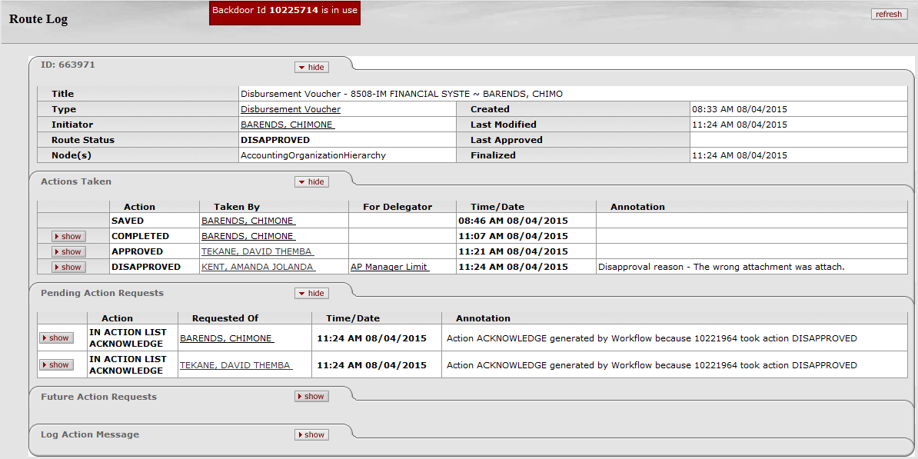
Figure 16

- The Status of the DV will change to Disapproved.
- If the Fiscal Officer (FO) disapproves the document it will only appear in the Initiator’s action list.
- If the AP Manager disapproves the document an Acknowledgement will be sent to the action lists of the Fiscal Officer (FO) and the Initiator.
- The reason for the disapproval will appear in the Notes and Attachment tab.
1. | Click on Route Log to see the additional routings for acknowledgement.
2. | The receivers must click on the e-doc in the and then on

5.12 The Action List of the Initiator / Fiscal Officer

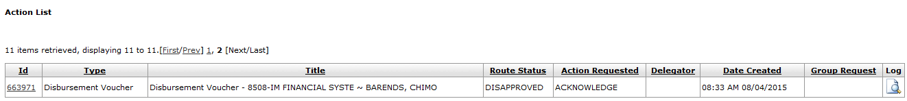
Figure 17

1. | The Fiscal Officer and Initiator must open their , click on Id of the DV with status Disapproved.

5.13 The Disapproval reason
Figure 18

- The Initiator and Fiscal Officer can read the reason for disapproval in the Notes and Attachments Node.

1. | Click to confirm the acknowledgement.
2. | The Initiator can create a new e-doc to rectify the reason for disapproval by clicking on

5.14 How to Cancel a DV document

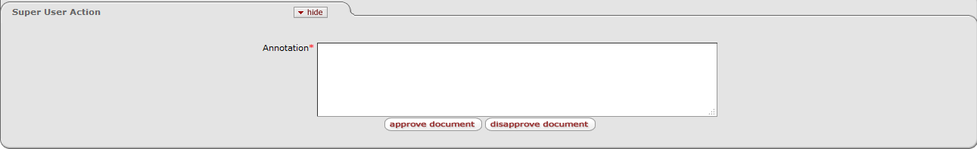
Figure 19

- The Initiator cannot cancel the DV after submitting the document.
- The Initiator can only cancel the document before the document is approved by the Fiscal Officer by using the or buttons.
- The DV-document will no longer be in your Action List and therefore, will the AP Manager be the only one who can cancel the document with a Super User Action role.

5.15 How to Recall a DV document

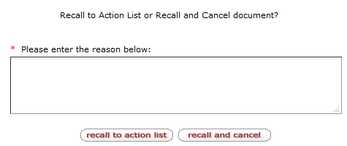
Figure 20

1. | Complete your reason in the *Please enter the reason field and click on or
2. | If you take action on the following buttons:  - Click - recall the document to the Initiator’s action list.  - Click - recall and cancel the document that will disappear from your records.

5.16 How to make an Inquiry on a DV document

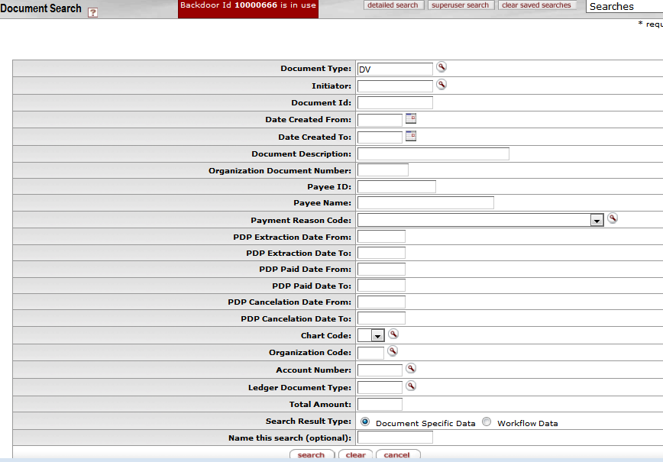
Figure 21

1. | Custom Document Searches: KFS Navigation Main Menu > Custom Document Searches > Financial Processing > Disbursement Voucher.
2. | Complete the fields you require and click on
3. | You can make use of the following search options: and
4. | Document Id: For more information regarding a DV, click on Document Id and fill in the e-doc number.

6. Frequently asked questions related to different scenarios:

 | 1. | What happens if I try to create a DV in my own name?  The Initiator and Payee cannot be the same, when you try to create a DV with the same Initiator and Payee you will receive an error message “Payee cannot be the same as the Initiator”.
 | 2. | What happens if I enter a duplicate Vendor and Invoice number?  If the invoice numbers already exist for the chosen Vendor, a warning message will be given with the option to go on capturing the duplicate invoice. Validation for duplicate invoice will be both done for Payment Requests and Disbursement Voucher.
 | 3. | What happens if I try to make a payment against an inactive Vendor?  When you select the Vendor you will get the message “The specified Payee ID is inactive”. You will also not find the Vendor on the active list but only on the inactive list if you search for it.
 | 4. | What happens if I try to make a payment against an Income object?  I will get a message “Restricted Level Code” because I am not allowed to create a DV payment against an Income object.

Lesson Summary
Having completed this lesson you should be able to:
- Navigate to the Disbursement Voucher (DV) in KFS
- Know the process to create a new Disbursement Voucher
- Know how to disapprove a Disbursement Voucher
- Know how to cancel and recall a Disbursement Voucher

