Accounts Payable (AP) - Financial Processing
How to create a Disbursement Voucher (DV)
with Payment Reason code “O”

Document Summary
Product Owner | Frikkie Venter
Editor | Chimoné Barends
Date | 2022/04/04
Time | 10:00 AM
Template | Verbose

Lesson Objectives
On completion of this lesson, you should be able to:
- Create a Disbursement Voucher (DV) with Payment Reason Code “O”.

Lesson Scenario
- As an existing staff member of the NWU you will be able to create a Disbursement Voucher for payment reason code “O”.

Lesson Prerequisites
- You need to be a NWU staff member that is registered on KFS as a user.

- Disbursement Voucher (DV) Navigation:

- KFS navigation: Main Menu > Transactions > Financial Processing > Disbursement Voucher
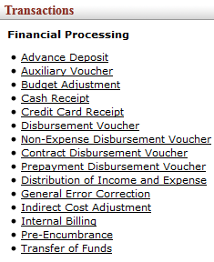
Figure 1

- Create a DV with Payment Reason Code “O”

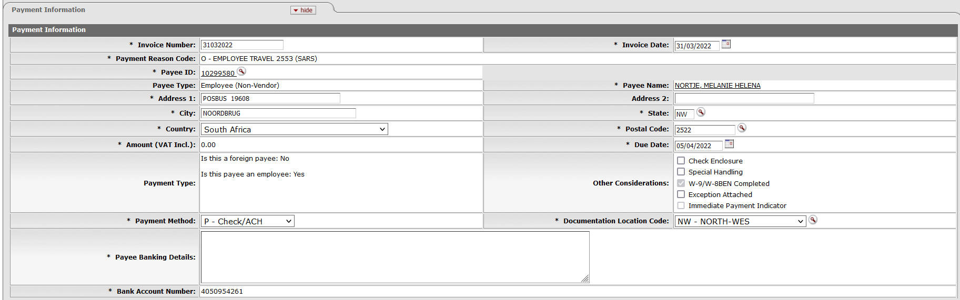
Figure 2

1. | Enter the invoice number in the Invoice Number field as the date of creation, for example 31032022
2. | Complete or the Invoice Date, for example 31/03/2022
3. | Click on to search for the Payee ID.
4. | Click on Payment Reason Code and select the relevant Payment from the list, for example O – EMPLOYEE TRAVEL 2553 (SARS)

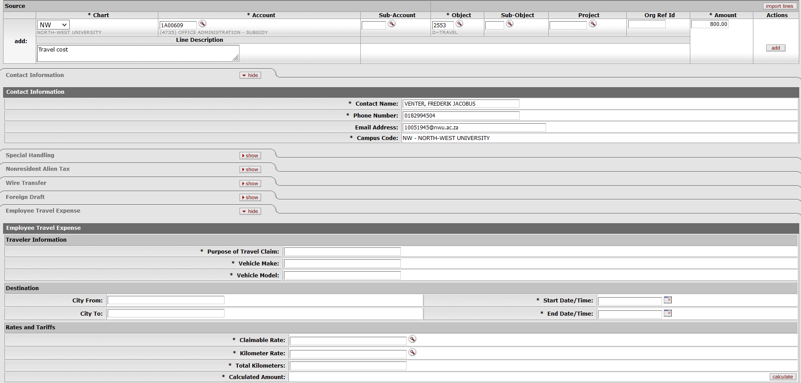

Figure 3

1. | Complete the Chart, Account, Object, Amount and Line Description.
2. | In all instances (always) complete the total amount (VAT-inclusive). KFS will handle the VAT calculation automatically and take in consideration the Vendor, Account and Object Code.
3. | Click on
4. | Click on the Employee Travel Expense tab on the show button.

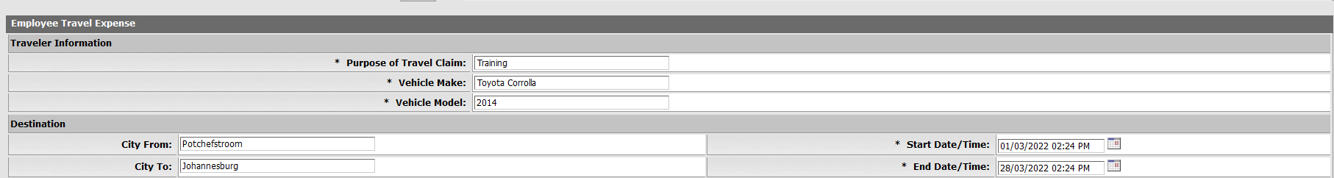
Figure 4

1. | Complete the Travel information. Purpose of Travel, Vehicle Make, Vehicle Model

Figure 5

1. | Search on Claimable Rates.

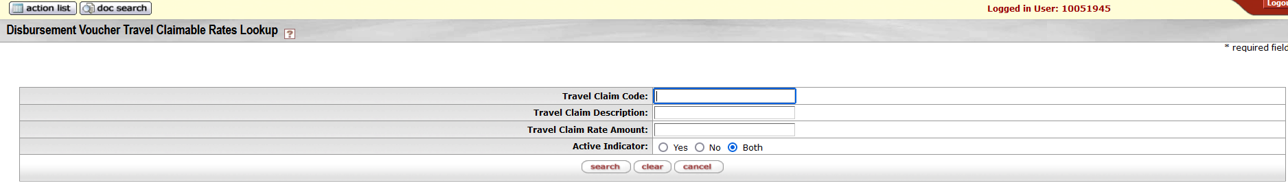
Figure 6

1. | Click on search when Travel Claimable Rates Lookup screen appear.

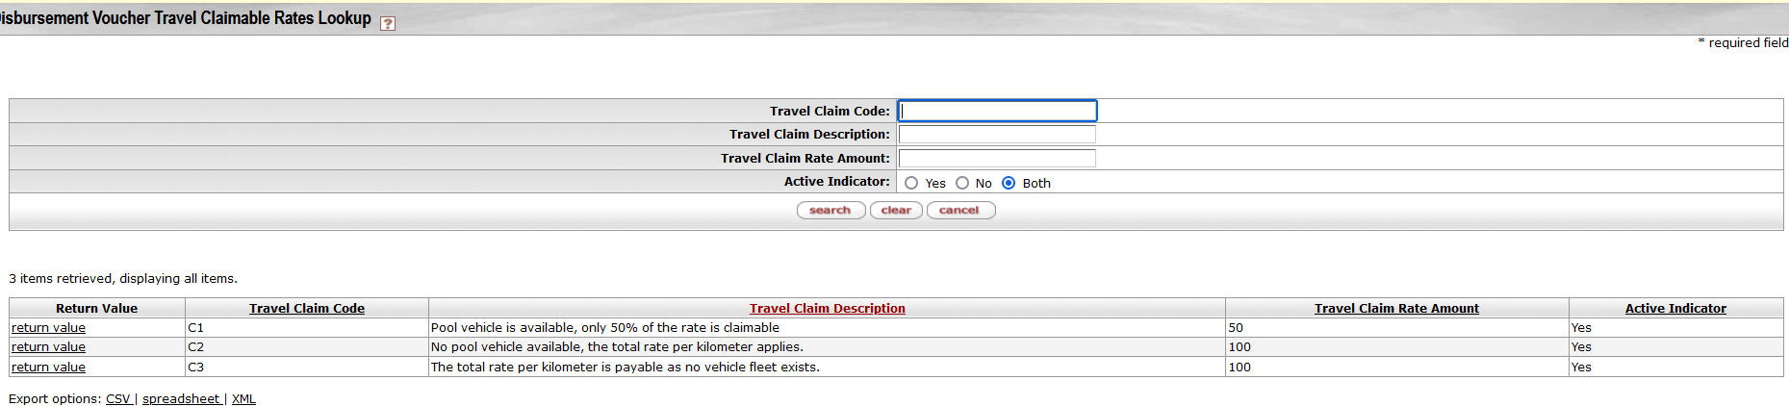
Figure 7

1. | Select applicable travel claim code and click on return value.

Figure 8

1. | Click on kilometer rate field.

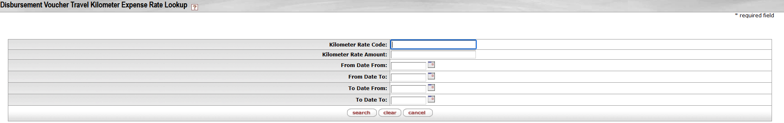
Figure 9

1. | When the Travel Kilometer Expense Rate Lookup screen appears, click on search.

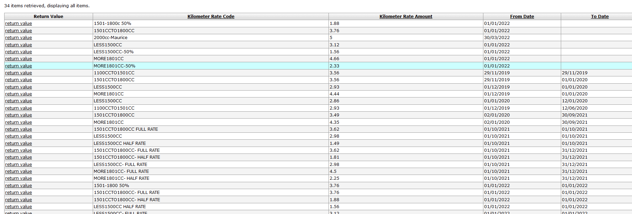
Figure 10

1. | Sort according to From Date and Select a claimable rate which is active for the period travelling. Starting date must be 1 January 2022 with no end date. Tarif R5/km is restricted.
2. | Click on return value.

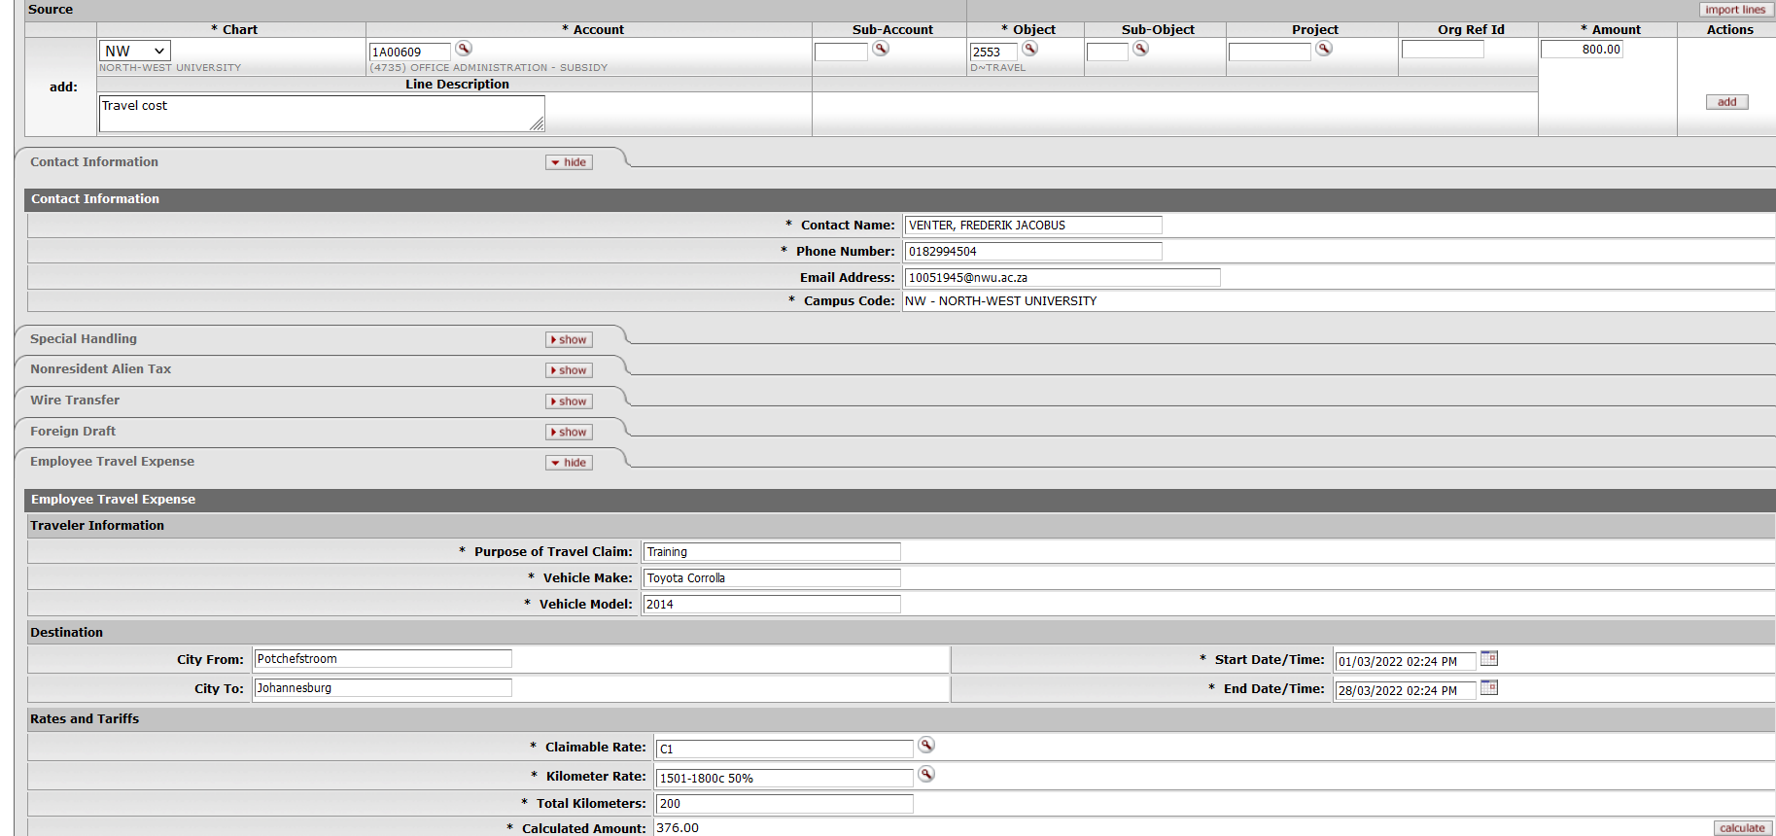
Figure 11

1. | The kilometer rate will appear in the field under Rates and Tariffs.
2. | Complete the field for the total kilometers and click on the calculate button . KFS will then calculate the amount.
3. | If the amount differs from the account on the accounting line, you can change the amount on the accounting line according to the calculation amount and refresh.

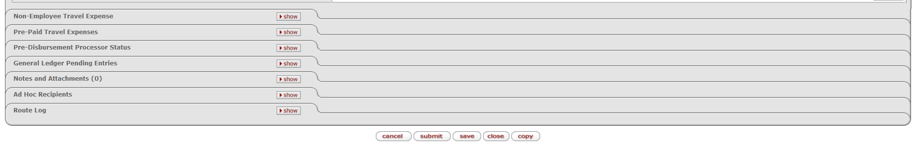
Figure 12

1. | Click on for DV payment.

Lesson Summary
Having completed this lesson, you should be able to:
- Create a Disbursement Voucher (DV) with Payment Reason Code “O”.

