Fiscal Officer

Introduction to KFS
and
Duties in KFS

Lesson Objectives
On completion of this lesson you should be able to:
- Know how to log in on KFS
- Understand and configure the Action List
- Setting up e-mail notifications
- Do a Document search
- Add and view Notes and Attachments
- Add an Ad Hoc Recipient
- Understand the Route Log
- Create a Fiscal Officer Delegate
- Approve transactions as a Fiscal Officer Delegate
- Deactivate a Fiscal Officer Delegate

Lesson Scenario
- As a Fiscal Officer of the NWU you are required to work through this lesson, make some notes if necessary and print out the documentation as a guideline.

Lesson Prerequisites
- You need to be a NWU staff member that is registered on KFS as a User. Accounts need to be assigned to you in your capacity as a Fiscal Officer.

Table of Contents
- Introduction
- Responsibilities of the Fiscal Officer
- Process Flow
- Documents that will route to the Fiscal Officer
- Login into KFS
- Main Menu Screen
- The Action List
  - Purpose of the Action List
  - Location of the Action List
  - Action Descriptions
  - Fields in the Action List
  - Configuring the Action List
    - General data box
    - Fields Displayed in Action List
    - Document Route Status Colours for Action List Entries
    - Email Notification Preferences
  - Understanding the e-mail notification
  - Acting on items in your Action List

- Document Search
  - Purpose of the Document Search
  - Location of the Document Search
  - How to do a Document Search
  - How to do a Detailed Document Search
    - Location of the Detailed Document Search
    - How to do a Detailed Document Search

- Adding and Viewing of Notes and Attachments
  - Adding of Notes and Attachments
  - Viewing of Notes and Attachments

- Ad Hoc Recipient
  - Location of the Ad Hoc Recipient tab
  - Content of the Ad Hoc Recipient tab
  - How to add an Ad Hoc Recipient

- The Route Log
  - Location of the Route Log
    - Items in your Action List
    - Document Search
    - Route Log tab inside a document
  - Content of the Route Log

- Creating of a Fiscal Officer Delegate
  - Account Delegate document
  - Document Overview tab
  - Edit Account Delegate tab
  - Notes and Attachments tab
  - Ad Hoc Recipients tab
  - Route Log tab

- Action List of Delegate

- Deactivation of Delegate

- Create a new account

- Register a new user on KFS

- Introduction

The aim of the Fiscal Officer is to ensure the correctness and completeness of financial and administrative transactions as well as the structural maintenance of the Chart of Accounts.
Each account on KFS requires a Fiscal Officer. Most transactional documents route to the Fiscal Officer for approval. The Fiscal Officer can change the accounting lines on an e-doc.
The Fiscal officer can assign a delegate(s) – the delegation can be set by account, and further be defined by transaction type and/or amount.

- Responsibilities of the Fiscal Officer
The Fiscal Officer will be responsible for the following:
Core Responsibilities
To ensure and enforce compliance to the financial policy, procedures, guidelines and business rules.
To ensure the correctness of the transaction in terms of the account, object and approved budget.
(not applicable at this stage).
To optimize the flow of the e-doc transactions by ensuring that all the routing nodes are adhered to.
To advise and assist initiators of financial transactions regarding rules and regulations as well as system requirements.
To oversee the correctness of requests associated with structural (CoA) maintenance.
To oversee the correctness of financial e-docs (including journals, asset transactions, purchase requisitions, disbursements etc).
To advise Campus and IO Management on good financial management and administrative practises. (Not applicable at this stage)
To delegate responsibility where applicable.
To approve the Rand-value of financial transactions when a mandate is assigned (Not applicable at this stage).
To ensure that supporting documents, such as VAT Invoices, are valid in terms of legal requirements.
To create new accounts.
To register new KFS users.

- Process Flow

- Documents that will route to the Fiscal Officer

The following documents are setup to route to the Fiscal Officer:
E-doc | Status
Account | Approve
Account Delegate | Approve
Account Delegate Global | Approve
Asset Fabrication | Approve
Asset Global | Approve
Asset Retirement Global | Approve
Customer Credit Memo | Approve
Customer Invoice | Approve
Customer Invoice Write-off | Approve
Disbursement Voucher | Approve
Distribution of Income & Expense | Approve
General Error Correction | Approve
Internal Billing | Approve
Journal Voucher | Approve
Order document | Approve
Payment Request | Approve
Prepayment Disbursement Voucher | Approve
Purchase Order Amendment | FYI
Reimbursement Voucher | Approve
Requisition | Approve
Non-check Disbursement Voucher | Approve
Sub-Account | Approve
Transfer of Funds | Approve
Vendor Credit Memo | FYI
Year End Distribution of Income & Expense | Approve
Year End General Error Correction | Approve
Year End Transfer of Funds | Approve

- Login into KFS
The Kuali Financial System is accessed by simply typing the URL address into your browser’s address bar.
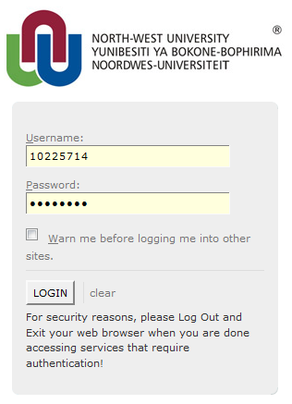
Figure 1
At the Login screen you can enter your employee number as your username and your Novell password to logon to the system.

1. | Type in your Username = employee number
2. | Type in your Novell Password
 | Click on

- Main Menu Screen

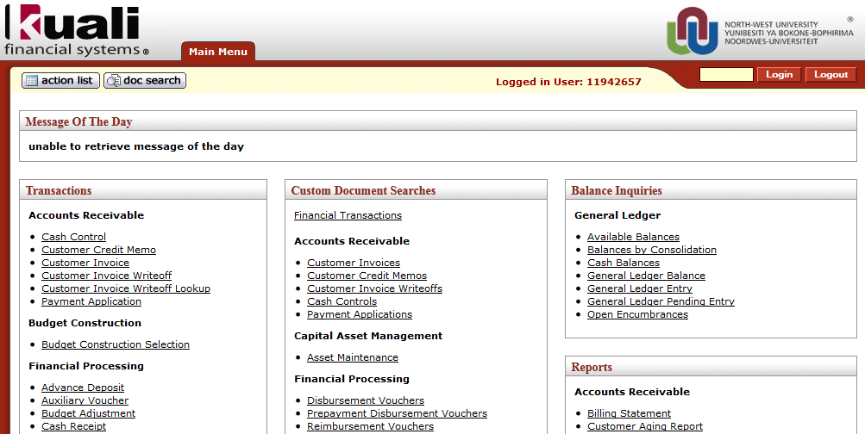
Figure 2
After login, the Main Menu will open up in the system.
1. | The Main Menu tab displays the list of transactions and functions that regular users are permitted to initiate.
2. | This includes transactions out of Accounts Receivable, Financial Processing, Purchasing and Accounts Payable modules but also has the functionality to perform custom document searches, lookup and maintenance transactions.
3. | It also has your balance inquiries and some reports.

- The Action List

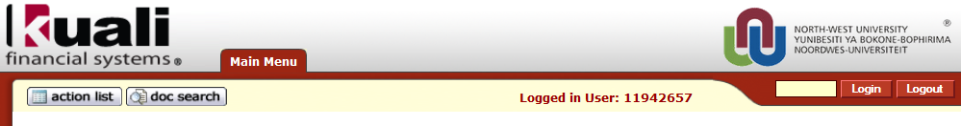
Figure 3

  - Purpose of the Action List
The in KFS allows you to receive action requests for e-Docs that were routed to you for further attention and/or approval.
  - Location of the Action List

The Action list is located in the top left corner of all KFS Screens beginning with the KFS Main Menu.
  - Action Descriptions
Documents sent to your Action List may require different types of actions from you.
The actions that are required for you to take in your Action List will depend on your role or responsibilities of the document. The table below lists and describes required and recommended actions to be taken:

Action to Take | Description
Acknowledge | It is a workflow action request in which the user states he or she has reviewed the e-Doc.  Document will continue routing without any action on your part. Document can be removed directly from your Action List without opening.
Approve | The assigned approver must either approve or disapprove the e-Doc for it to continue routing.  Document is waiting for your action. Review the e-Doc for accuracy and appropriateness. If error-free, approve the action. If errors exist, you may be able to make changes (depending on what fields need to be changed); otherwise, you will need to disapprove the document. In that case, the Initiator is notified and will need to create a new document.
FYI | It is a workflow action request that can be cleared from a user's action list with or without opening and viewing the e-Doc. A request for FYI will not disrupt e-Doc routing. An e-Doc with no pending approval requests but with pending FYI requests will be in "Final" status.

  - Fields in the Action List

The table below lists and describes document attributes and descriptions commonly displayed as table headers on the Action List screen based on your set Preferences.

Document | Attributes Description
Id | Corresponds to the Document Number (Doc Nbr) generated at the time the Document was created. Clicking the Id link will open the Document. The Id is the same as the Doc Nbr, which is located in the top right corner of each e-Doc.
Type | Corresponds to the type of Document created (Vendor, Disbursement Voucher, etc.).
Title | Corresponds to the Type and Description generated at the time the Document was created. For example: edit Vendor Details - sdf
Route Status | Describes where in the process the Document is and corresponds to the Route Log generated during the Document approval process.  ENROUTE – the document is still pending approvals  SAVED - the document has not been submitted
Route Status | DISAPPROVED - the document has been disapproved by an approver after the document was submitted  PROCESSED - the document was blanket approved  FINAL - the document does not have pending actions  EXCEPTION - the document had a system error during processing
Action Requested | Indicates the action you need to take on the e-Doc. The Action List can be sorted by this field so that items needing to be Approved are together.  ACKNOWLEDGE - The document requires you to open the e-doc and acknowledge that you have reviewed the e-doc before it can be removed from your action list. An action of Acknowledge does not stop the e-doc from moving through the workflow approval process.  APPROVE - The document requires you to open the e-doc and either approve or disapprove the e-doc before it can be removed from your action list. An action of Approve prevents the e-doc from moving through the workflow approval process until you take action.  COMPLETE – A document that you initiated and saved but have not yet submitted will remain in your action list until the action of Complete (e-doc submitted) has been taken, and therefore the e-doc has not routed anywhere or would route to an Ad Hoc Recipient if specified on the e-doc for completion.
Action Requested | FYI - The document requires you to either open the e-doc and take action by clicking the FYI button at the bottom of the e-doc, or select the FYI option from the Action column on the action list page and then click the take action button to remove the e-doc from your action list without opening the e-doc for review. An action of FYI does not stop the e-doc from moving through the workflow approval process.  Note: The Action column is only available on the action list page if the Clear FYI checkbox is checked on the action list preferences page. The checkbox is located in the Fields Displayed in Action List section of the preferences page.
Intitiator | Indicates the user who created the Document and put it into routing. This information becomes a part of the Route Log generated during the Document approval process.
Delegator | Identifies the person on whose behalf you are taking the action. This information becomes a part of the Route Log generated during the Document approval process.
Date Created | Corresponds to the original date the Document was created.
Log | Opens the Route Log for the e-Doc showing individuals in the routing process.

  - Configuring the Action List

The Action List can be configured for each individual user by setting your action list preferences.

1. | Click on
2. | The button is in the middle of the Action List Tool bar.

3. | Click on the button.
    - General data box

The General Data box provides options to control your Action List.

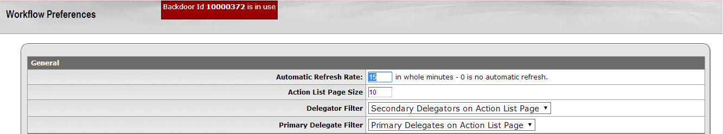

Figure 4

1. | The “Automatic Refresh Rate” field determines how often your action list will be automatically refreshed in whole minutes. Caution: A time of 0 is for no automatic refresh. If you choose 0 you must refresh your action list manually by clicking the refresh button on the action list page.
2. | The Action List Page Size field determines the maximum number of rows that display on each page of your action list.
3. | The Delegator Filter field is used by Secondary Delegates to select whether action list items for which they are a Delegate will display on his/her action list page amongst their own items, or use the filter option to search for the delegate action items. Secondary Delegators on Action List Page – This is the default selection. This selection will provide a drop-down list box on the action list page, but it is only available when there are e-docs pending action as a Secondary Delegate.
4. | Primary Delegate Filter field determine whether the Primary Delegators are visible on your Action List page or not.

    - Fields Displayed in Action List

The Fields Displayed in Action List data box lists all the columns that are available to display on your action list. To remove or add a column, click on the related “Check Box” to add or remove the check. A check in the box will display the column on your action list.

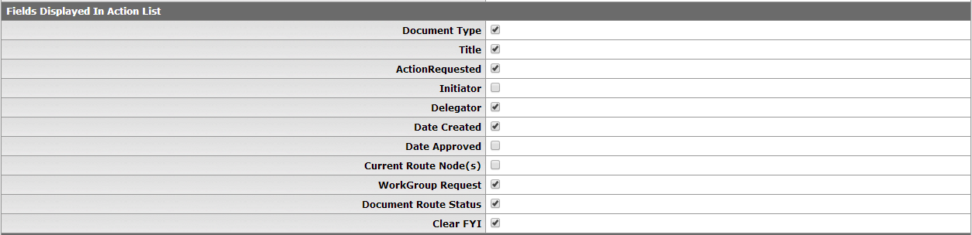

Figure 5

    - Document Route Status Colors for Action List Entries

The Document Route Status Colors for Action List Entries data box provides the option to color code the items in your action list by the Document Route Status.

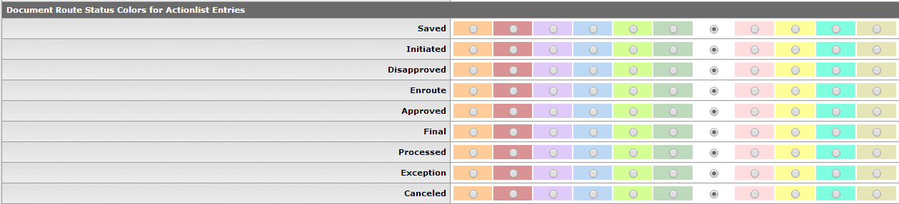

Figure 6

    - Email Notification Preferences

The Email Notification Preferences field allows you to control if and how often you would like to receive email notifications for new documents in your action list.

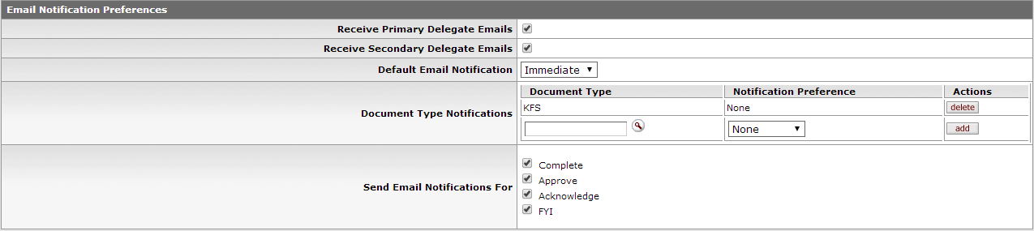

Figure 7

1. | The Receive Primary Delegate Emails field allows you to control whether or not to receive email notifications of action list items routed to you as a Primary Delegate.
2. | The Receive Secondary Delegate Emails field allows you to control whether or not to receive email notifications of action list items routed to you as a Secondary Delegate.
3. | The Default Email Notification drop-down list box. The default selection is NONE.  The Default Email Notification choices are:  None - Select if you intend to be in KFS on a regular basis and do not need reminders.  Daily - Select if you want an email notification only once a day at 6:00am.  Weekly - Select if you want an email notification only once a week on Sundays at 6:00 am.  Immediate - Select if you want an email notification every time your action list is updated.

4. | The Document Type Notifications field allows you to select what Document Types you would like to receive notifications for, for example Requisitions (REQS) or KFS to receive notifications for all of the document types.  Click in the Document Type field.  If you do not know the document type you may conduct a lookup by using the .  Enter "KFS" in the field if you want to receive notifications for all of the document types.  The Notification Preferences field allows you to select the frequency of the email notifications. Click the Notification Preference drop-down arrow button to select your preference between Daily, Weekly or Immediate.  Click on to add the document type notification.
5. | The Send Email Notifications For field allows you to further customize your action list by selecting which status you want to receive emails for, namely Acknowledge, Approve, FYI.

Note:

In order for the Action List changes to take place you need to click the 'save' button.

Click the button.

  - Understanding the e-mail notification

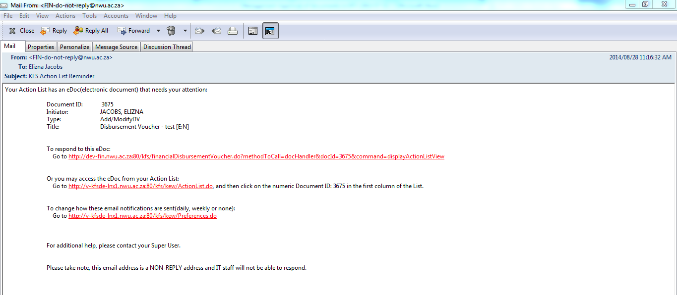

Figure 8
1. | The e-mail will be send from a programmatic e-mail address namely; FIN-do-not-reply@nwu.ac.za
2. | The e-mail will contain information regarding the e-doc that the approver must approve:  Document ID: Reference number of document in the system  Initiator: Name of person who have initiated the e-doc  Type: Indicate if a document was added/modified with the acronym of the document that was created  Title: Indicate the name of the type of document as well as the description that was completed in the beginning of that e-doc
3. | The e-mail contain three links that can be accessed from the e-mail namely:
4. | A link to respond to the e-doc directly for example:
5. | A link to access your Action List for example:
6. | A link to change your e-mail preferences – how e-mails is send and which e-mails is received for example:  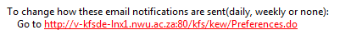

Acting on items in your Action List

1. | Click on
2. | If there is items in your action list that needs your attention, that items will be listed
3. | You may sort any column by clicking on the headings in the table that are underlined.
4. | Click on the ID number of the document you wish to take action on.

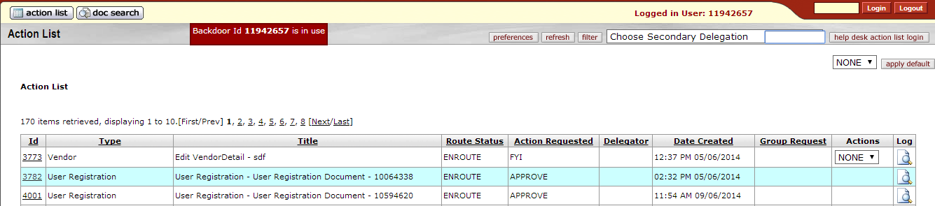
Figure 9

Figure 10

5. | At this time you would review the document for accuracy and appropriateness. After reviewing the document you would take the necessary action. Action buttons (approve, disapprove, etc.) are found on the bottom of the document.

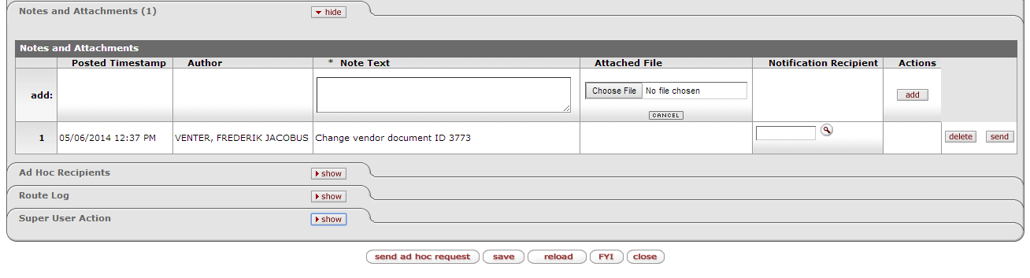

Figure 11

6. | Click on the appropriate button in order for your action to be recorded.
7. | When a document is in your Action List for an approval, you will have the option to Disapprove the document once inside the e-Doc.  Disapproving a document will return the e-Doc to the initiator. The disapproval will send an action request of Acknowledge to the initiator and to any user who already approved the document.  All disapprovals must have an explanation. The more detailed the explanation is the easier it will be for the initiator to correct the error.  It is good business practice to enter an adequate disapproval reason.  Note: The reason(s) entered for the disapproval is also added to the Notes and Attachments tab as well as a note in the Route Log.
8. | After you have taken Action on the document, that document will be removed from your Action List.

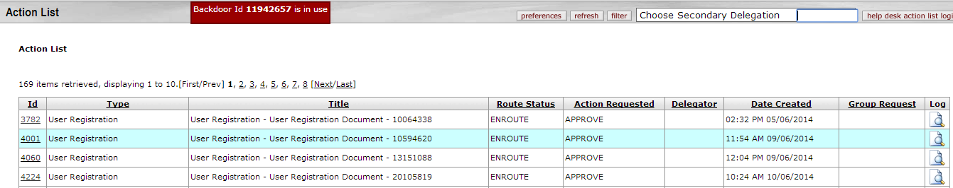

Figure 12

- Document Search

  - Purpose of the Document Search
The Document Search option is used to look for specific documents throughout the system by searching with specific attributes of the document. You can search by Document Type, Document Number, by date or initiator of the document.
These are only a few of the options that are available since you also have the functionality of a detailed search within Document Search.
  - Location of the Document Search
The button is located in the top left corner next to the Action List of all KFS Screens beginning with the KFS Main Menu.
  - How to do a Document Search
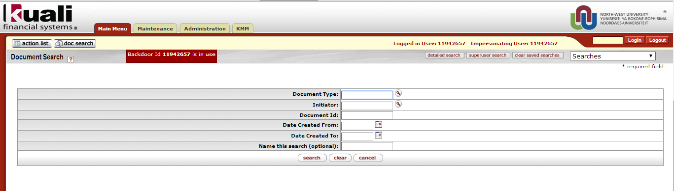

Figure 13

1. | Complete or lookup the document type and/or
2. | Complete the employee number or lookup the name of the Initiator by filling in the Surname between asterisk (*) on the person lookup screen and click on

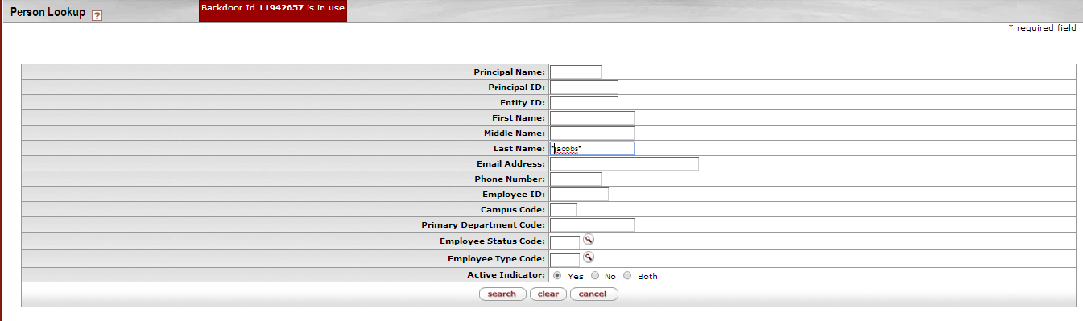

Figure 14

3. | Return the required value

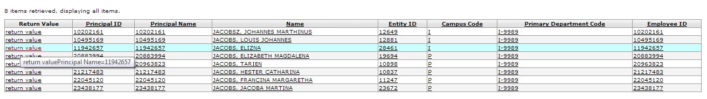

Figure 15

4. | The person details will now be in the document search field in the Initiator field and/or
5. | Complete the Document number at the Document Id field if known by you and/or
6. | Complete or lookup the date that the document was create
7. | Click on the button

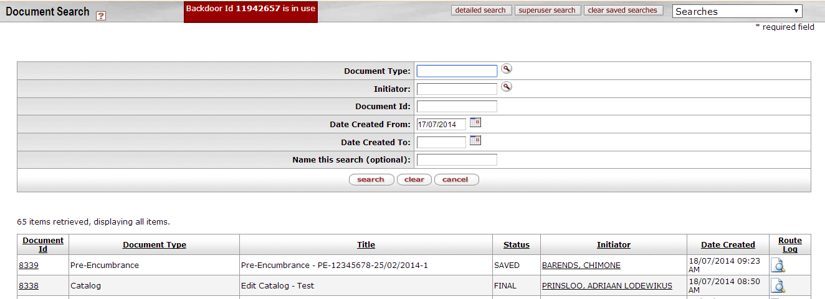

Figure 16

8. | The document(s) will return according to the search data that were provided.
9. | Click on the specific Document Id to open the document

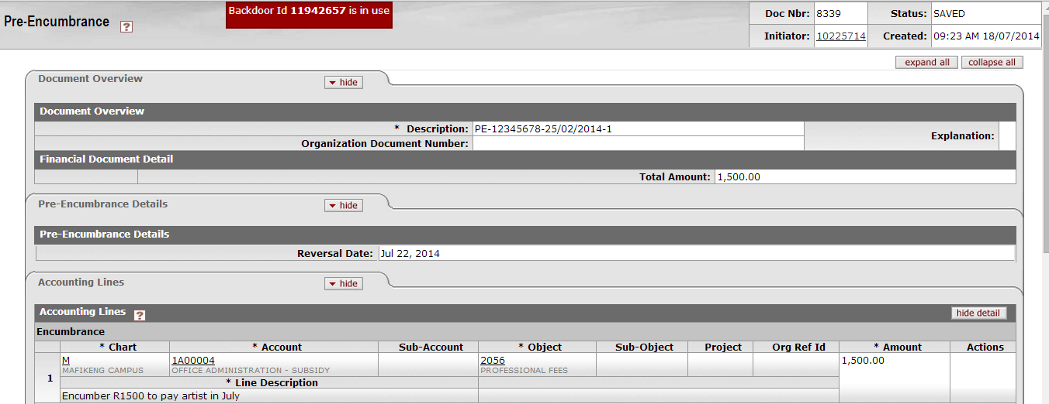

Figure 17

  - Detailed Document Search

In some cases it would be easier to search for a document by using the detailed document search option especially if you are looking for a specific document and the data as explain with the normal document search is not known by you.

    - Location of the Detailed Document Search

The button is located in the top middle of the Document Search Screen of all the KFS Screens beginning with the KFS Main Menu.

Figure 18

    - How to do a Detailed Document Search

1. | Click on the button

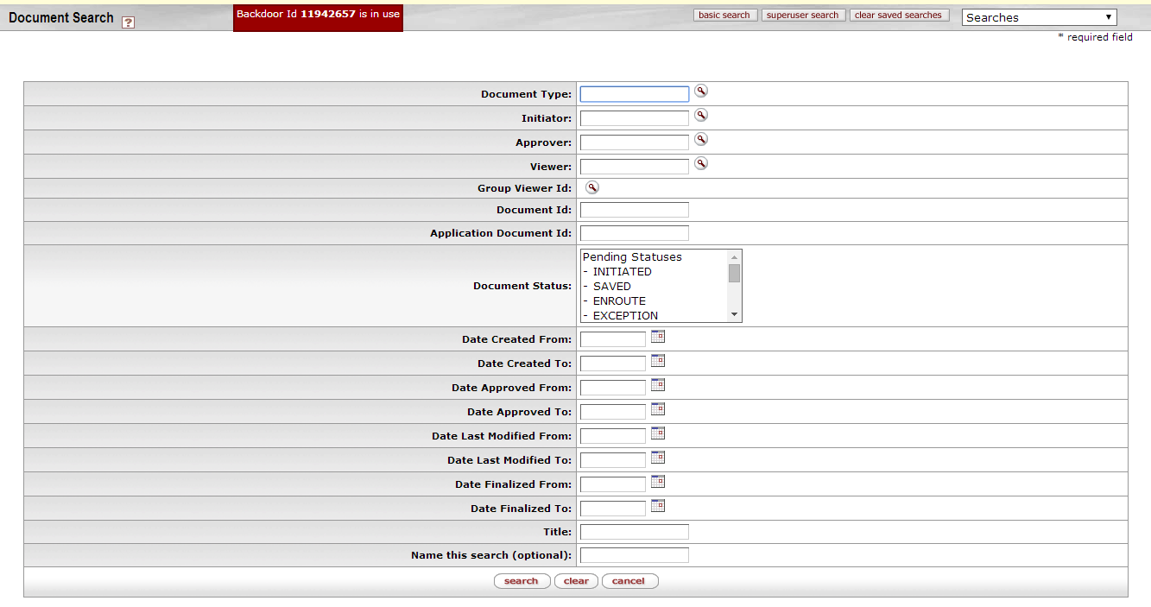

Figure 19

2. | Extra search fields will open
3. | Complete or lookup the information as known to you – you can only complete one of the fields if preferred
4. | Please note: The Date Created From will default as today’s date – change it if you are searching for a document created on another date.
5. | For this example, the Title field will be completed
6. | If you know a piece of the description field of the document that you want to search for, complete that piece of information between asterisk (*) for example *test*

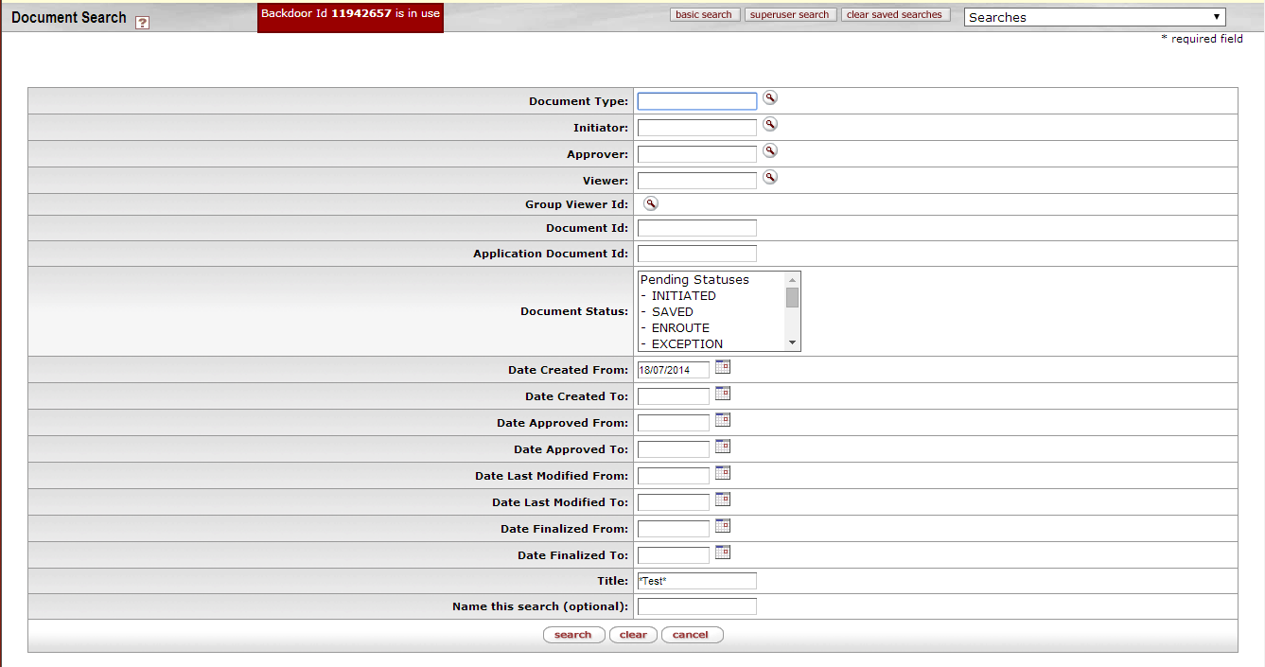

Figure 20

7. | All documents that contain that piece of information, will return

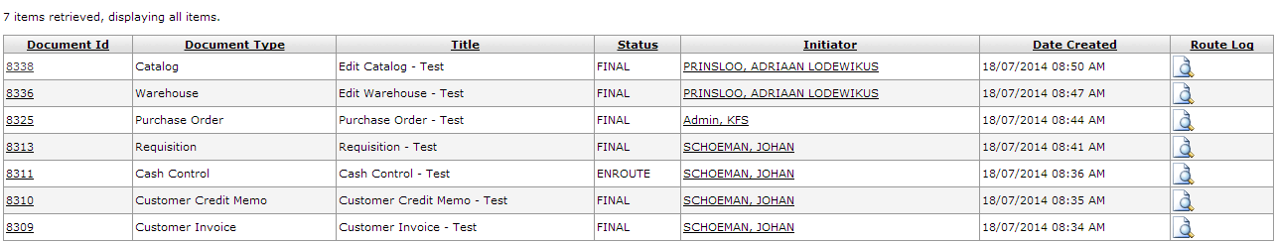

Figure 21

8. | Click on the specific Document Id to open the document

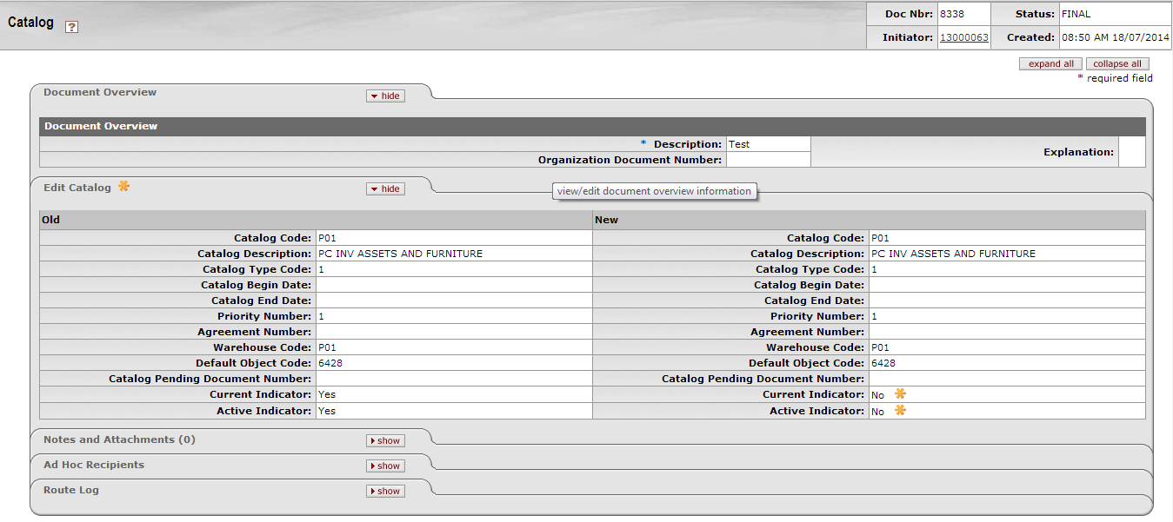

Figure 22

- Adding and Viewing of Notes and Attachments

  - Adding of Notes and Attachments

Notes and/or Attachments can be added on e-Docs when it is initiated and/or when it is in routing.

Most of the times the Initiator will add a note and/or attachment when an e-doc is created, therefore only the adding of a note and/or attachment when it is in routing, will be discussed in this manual.

1. | Choose document on your Action List or do a Document Search

2. | Open the document

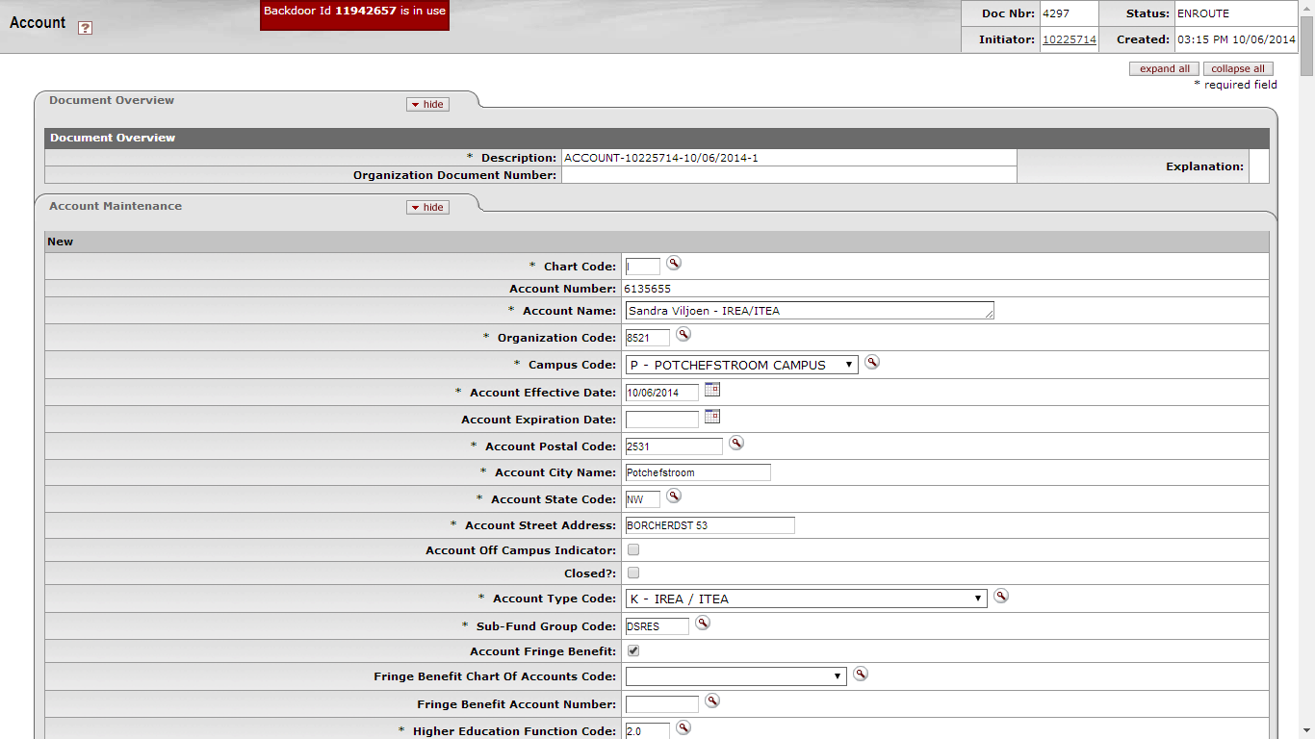

Figure 23

3. | Scroll down till you reach the Notes and Attachments tab / collapse the tabs
4. | Open the Notes and Attachments tab

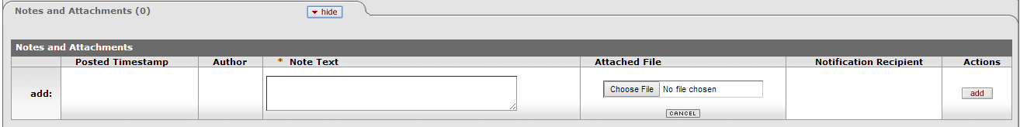

Figure 24

5. | There will be a Zero between brackets on the right of the Notes and Attachments tab
6. | Enter a note and choose the file of the document that you want to attach

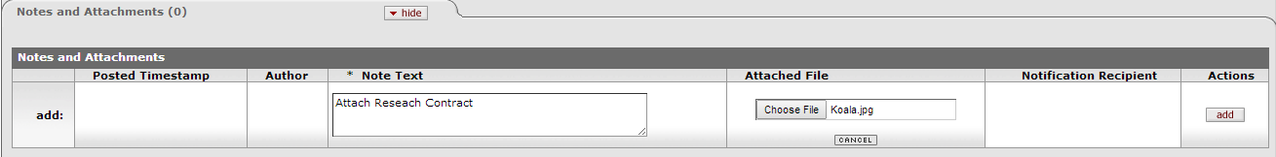

Figure 25
7. | Click on the button

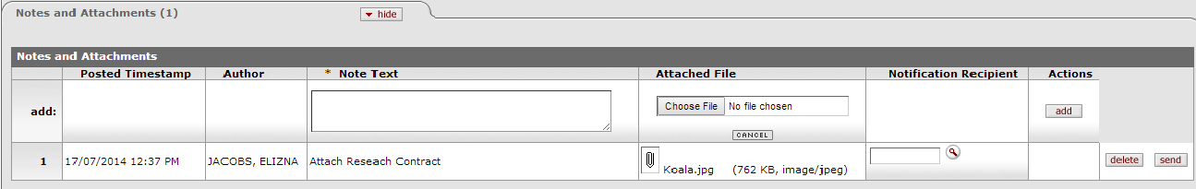

Figure 26

8. | The note and document will now be attached to the e-Doc with a timestamp and with the name of the person who have added the note and/or attachment.
9. | There will now be a number on the right of the Notes and Attachments Tab

  - Viewing of Notes and Attachments

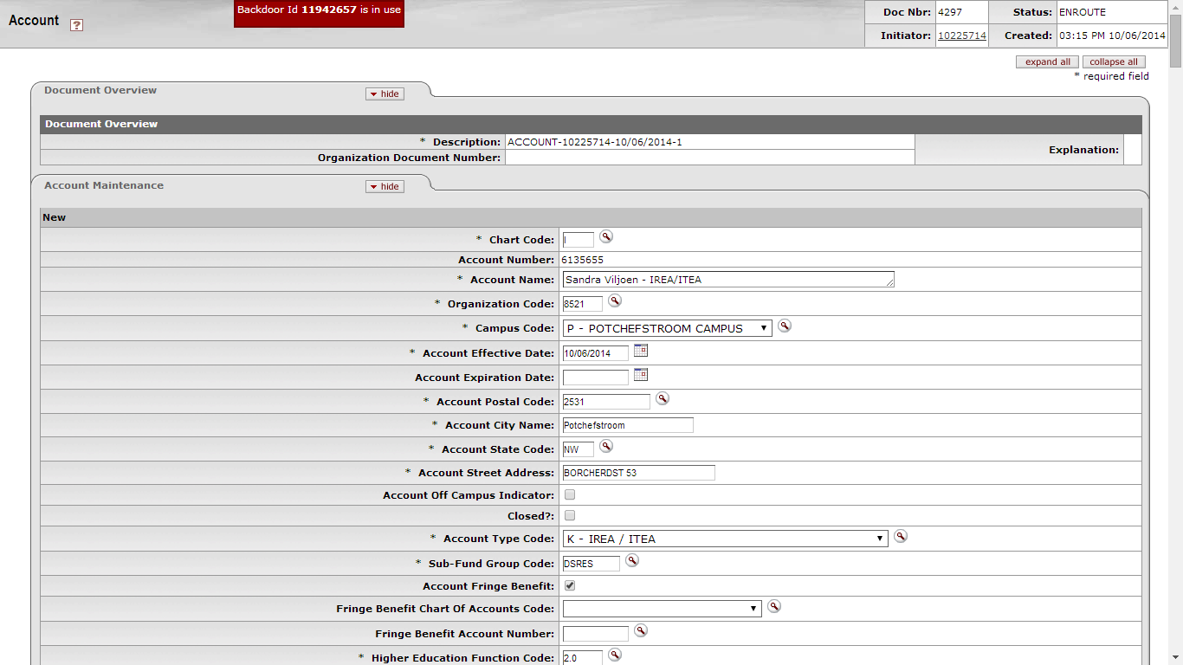

Figure 27

3. | Scroll down till you reach the Notes and Attachments tab / collapse the tabs
4. | If there are notes and/or attachments on the document there will be a number on the right of the Notes and Attachments tab.
5. | Open the Notes and Attachments tab by clicking on

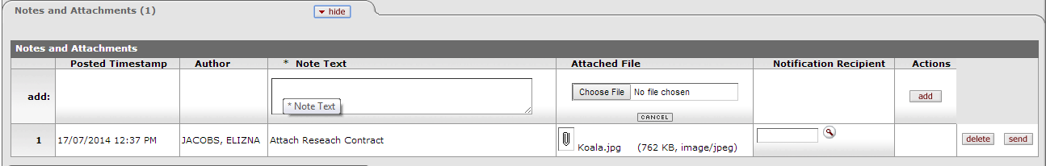

Figure 28

6. | Click on the to open and download the attachment

Figure 29

7. | The above mentioned screen will open at the bottom of your browser
8. | Click on the file to open the attachment
9. | The document will open according to the type of document

Figure 30

- Ad Hoc Recipient

1. | The Ad Hoc Recipients tab allows you to enter individuals into the workflow that is not part of the original workflow.
2. | Ad hoc routing does not supersede the normal workflow routing of the document but is in addition to the normal routing.
3. | Please note: If you wish to route the document for an additional approval you would need to add the individual to the Ad Hoc Routing tab prior to approving the document.

  - Location of the Ad Hoc Recipient tab

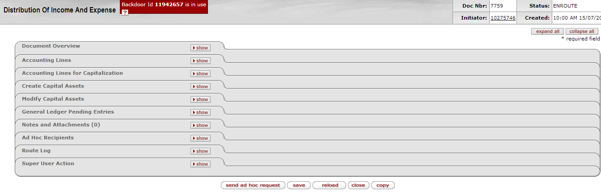

Figure 31

1. | The Ad Hoc Recipients tab is located at the bottom of the document above the Route Log tab.

  - Content of the Ad Hoc Recipient tab

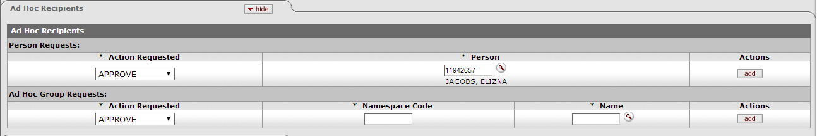

Figure 32
1. | The Ad Hoc Recipients tab has two sections: Person Requests and Ad Hoc Group Requests.
2. | Please ignore the Ad Hoc Group Requests section – make only use of the Person request section.
  - How to add an Ad Hoc Recipient

Figure 33

1. | Select the desired action for the Action Requested list. You can choose between APPROVE, ACKNOWLEDGE and FYI (See definitions in section 7.3 of this document).
2. | Enter of lookup the employee number of the person who you want to add as Ad Hoc Recipient
3. | Click on to add the Ad Hoc Recipient to the Workflow.
4. | Take the action on the document that was required from you for example

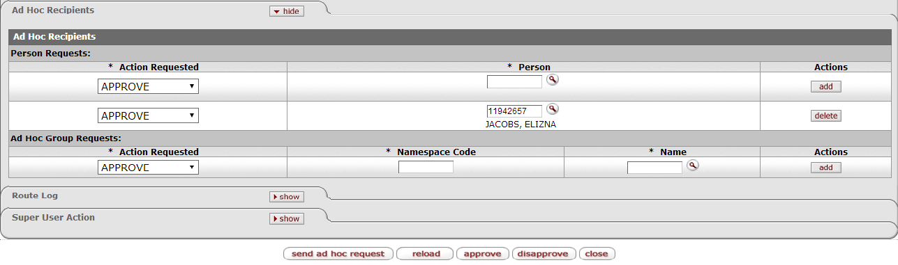

Figure 34

5. | The Ad Hoc Recipient will form know part of the routing

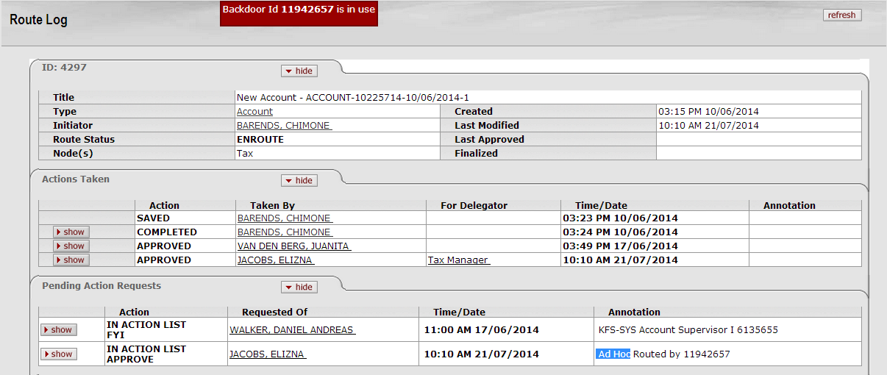

Figure 35

- The Route Log

The Route Log for each document allows users to follow its progress.

Most financial documents require one or more approvals before they impact the General Ledger. The process
usually begins with Workflow identifying all account numbers used on the document and requesting the approval of the Fiscal Officers associated with these accounts. The applicable routing information for each e-doc can be found in its Route Log tab

  - Location of the Route Log

    - Items in your Action List

1. | The route log can be viewed at each item that is listed in your Action List by clicking on the at the end of each item in your Action List.

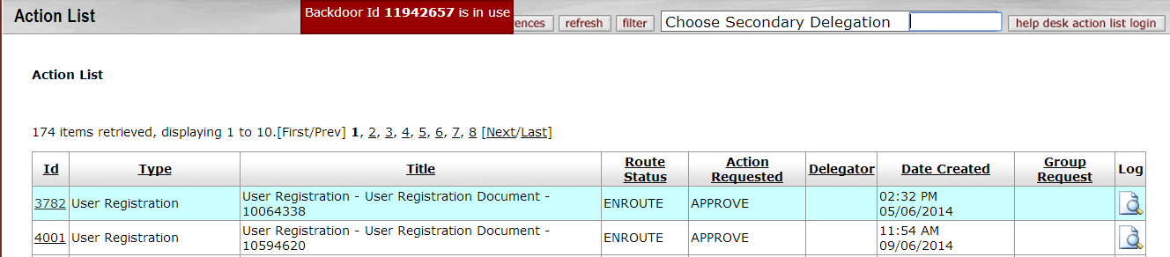

Figure 36

    - Document Search

1. | The route log of the document(s) that you searched for is visible by clicking on the at the end of that list of items that are returned with your search.

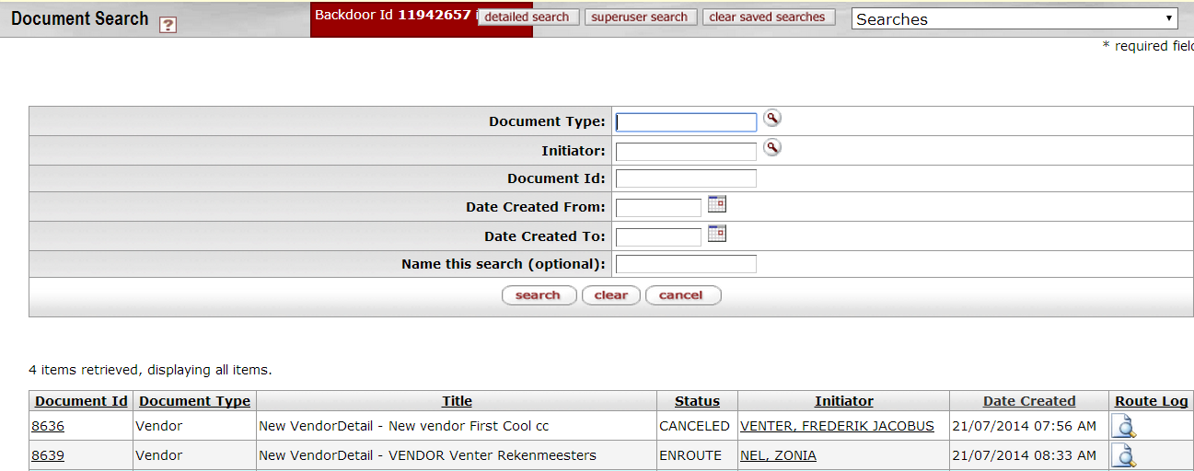

Figure 37

    - Route Log tab inside a document

1. | The route log inside a document is located in the Route Log Tab at the bottom of the document.

Figure 38

2. | Click on to reveal the content of the route log.

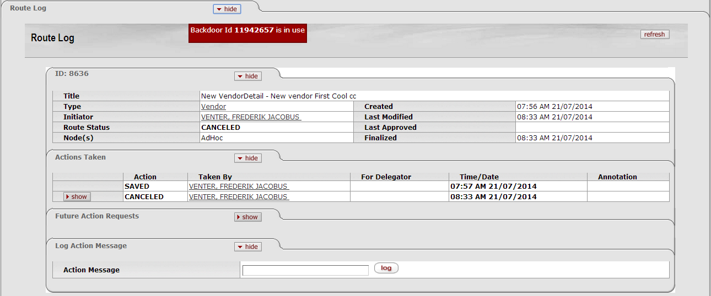

Figure 39

  - Content of the Route Log

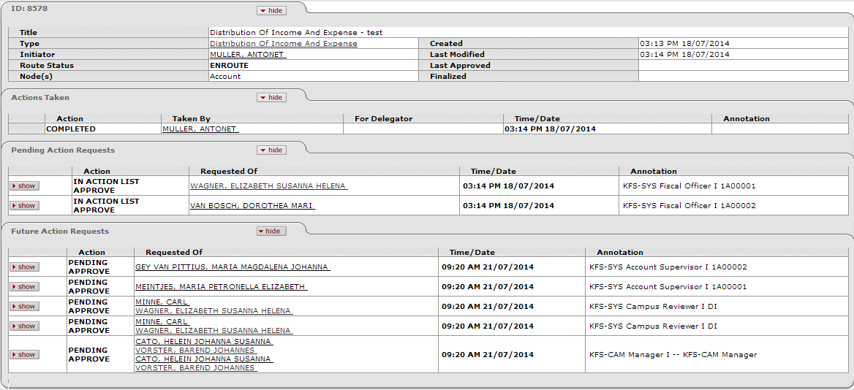

Figure 40

1. | The Route Log contains three tabs summarizing routing activities, namely Action Taken, Pending Action Requests and Future Action Requests.
2. | The Action Taken tab logs prior actions which were already taken.
3. | The Pending Action Requests tab logs actions that are next in line for completion.
4. | The Future Action Requests tab logs actions that still need to be taken before the document will reach its final status – the document will only be final after all the required actions were taken.
5. | Each tab contain the following information:  - Status of that action, for example Saved, Cancelled, Approved, FYI etc.  - Name of person who have taken the Action,  - Timestamp  - Role capacity in which the action were taken.

- Creating of a Fiscal Officer Delegate

A Fiscal Officer Delegate is a person who is assigned by the Fiscal Officer to approve certain transactions on his/her behalf. That person should be a knowledgeable person who will ensure that financial and administrative transactions are correct and complete. He/she can also be set up to only approve certain types of documents and/or transaction in a certain amount range.
Please note that the Fiscal Officer stays responsible for those transactions if he/she have created a delegate to handle the approval of those documents.
The Fiscal Officer Delegate can be created with the Account Delegate and Account Delegate Global documents.
With the Account delegate document, a delegate can only be created for 1 Account at a time. If the Fiscal Officer has more than one account allocated to him/her, he/she will need to create Fiscal Officer Delegates on separate Account Delegate documents or he/she can use the Account Delegate Global document.
Unfortunately, if the Fiscal Officer wants to deactivate the Fiscal Officer Delegate function, he/she cannot use the Account Delegate Global document. He/She will need to deactivate the delegation function of each account separately with the Account Delegate document.

  - Account Delegate document

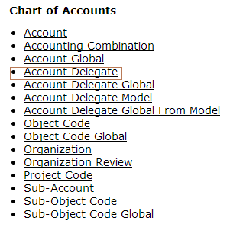
Figure 41

1. | Click on the Account Delegate option below the Chart of Accounts link.

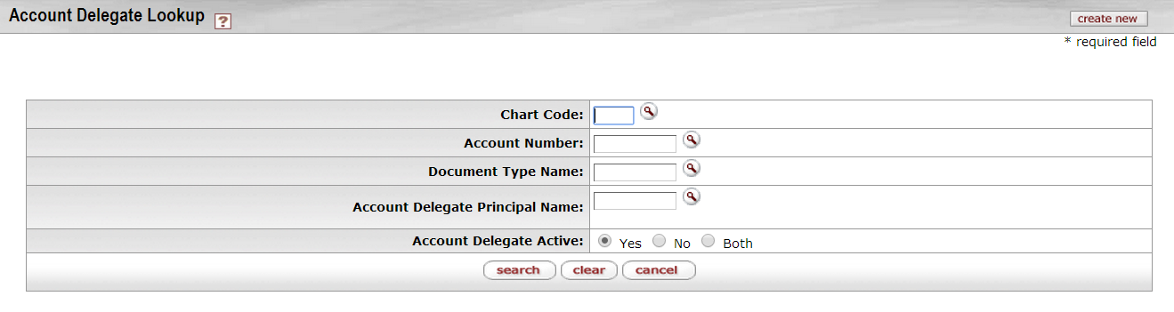
Figure 42
This screen opens up the Account Delegate document.
1. | Click on to open a new Account Delegate document.
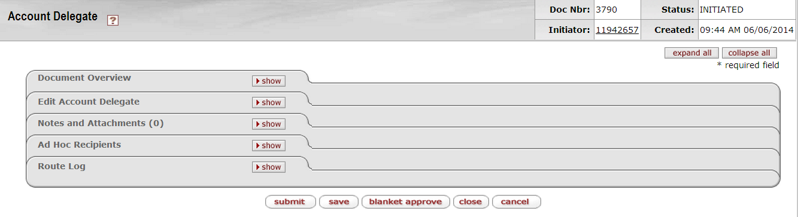
Figure 43
The tabs of this document in the example are set to collapse all to make the discussion easier.
  - Document Overview tab
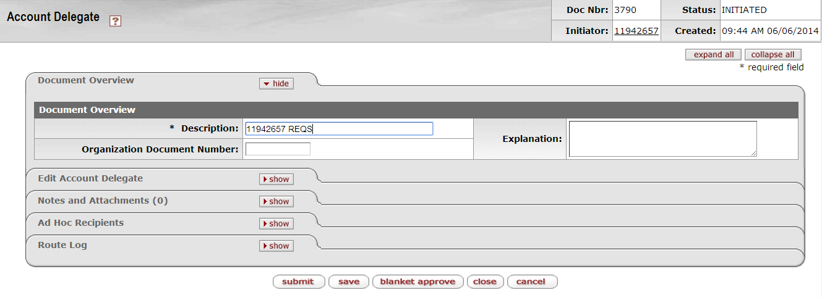

Figure 44

1. | Click on to expand the Document Overview tab.
2. | Type in a meaningful reference in the Description field for example principal number of the delegate with the document acronym that he will be the delegate of.
3. | Click on to collapse the Document Overview tab again.

  - Edit Account Delegate tab
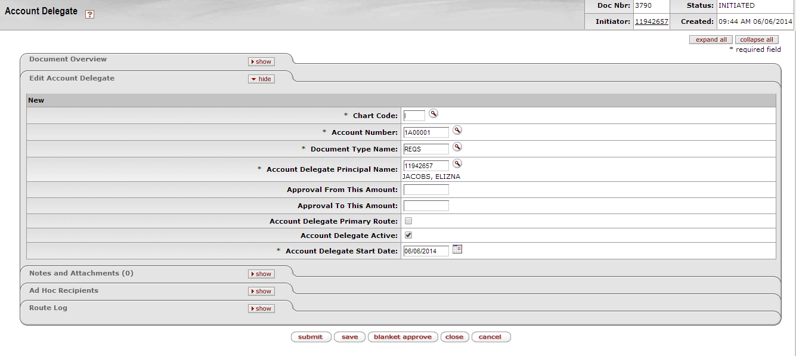
Figure 45

1. | Click on to expand the Edit Account Delegate tab.
2. | This screen contains the Chart of Account and User Information of the delegate that will be created.
3. | Complete or lookup the required (*) fields.
4. | Do not tick the Account Delegate Primary Route
5. | Click on and then on to collapse the Edit Account Delegate tab again.

  - Notes and Attachments tab
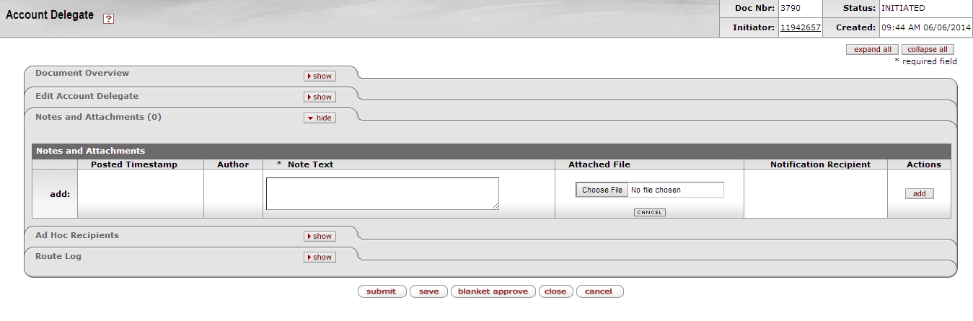
Figure 46

1. | Click on to expand the Notes and Attachments tab.
2. | Fill in a note and/or add an attachment if needed.
3. | Click on the button to add the note and/or attachment.
4. | Click on to collapse the Notes and Attachments tab again.

  - Ad Hoc Recipients tab
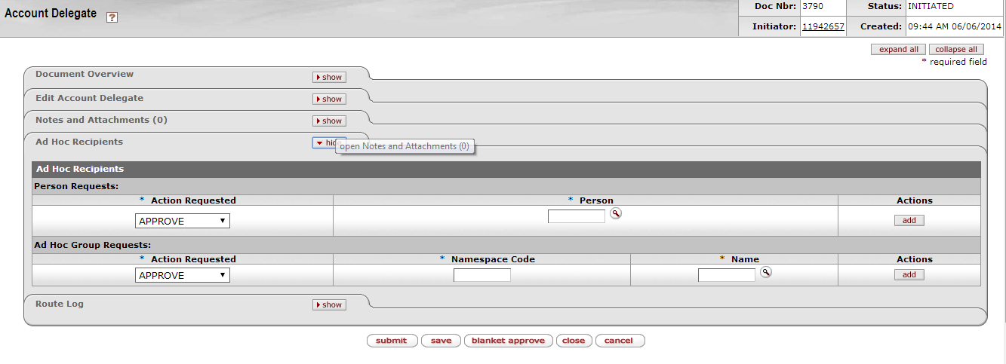
Figure 47

1. | Click on to expand the Ad Hoc Recipients tab.
2. | If needed, complete or lookup the employee number of the person who must additional approve or receive workflow of this document.
3. | Click on the button to add that person to the document.

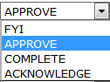
- Approve: The document is waiting for your action. Review the e-Doc for accuracy and appropriateness. If errors exist, you will need to disapprove the document.

- FYI: The document continues routing without any action on your part. Document can be removed directly from your Action List without opening.

- Complete: You need to complete your saved document before you can initiate the document. The complete action request usually goes with the “Saved” route status.

- Acknowledge: The document continues routing without any action on your part. Document can be removed directly from your Action List without opening.

4. | Click on so that the document can route to the next person in the workflow.
5. | Click on to collapse the Ad Hoc Recipients tab again.

  - Route Log tab

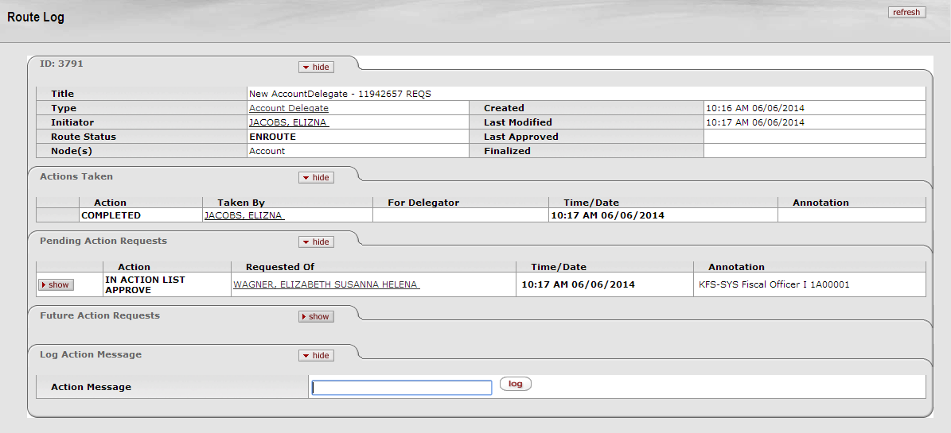
Figure 48

1. | Click on to expand the Route Log tab.
2. | This is only a preview of how the Route Log screen will look on the Account Delegate document in KFS.
3. | You can therefore see which persons must approve the document as well as where the document is stuck in the process.
4. | The Actions Taken tab displays the history of workflow actions on the e-doc.
5. | The Pending Action Requests tab displays the next action to be taken and shows more detailed routing information about this request.
6. | The Future Action Requests tab shows the action requests that Workflow will generate in the future based on the information currently on the document.
7. | If the Fiscal Officer has initiate the document himself, the document will be Final after submission and therefore no further workflow will be applicable.

Action List of Delegate

1. | When a document is processed for which the Fiscal Officer Delegate is the applicable approver, an extra field will become visible in his/her Action List.

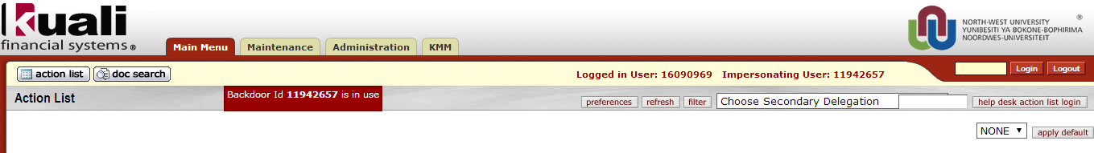

Figure 49

2. | The Fiscal Officer Delegate can then choose the name of the Fiscal Officer for which he/she is the delegate of to see the transactions in his/her Action List that he/she need to approve.

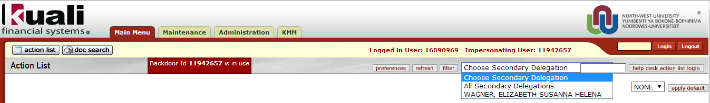

Figure 49

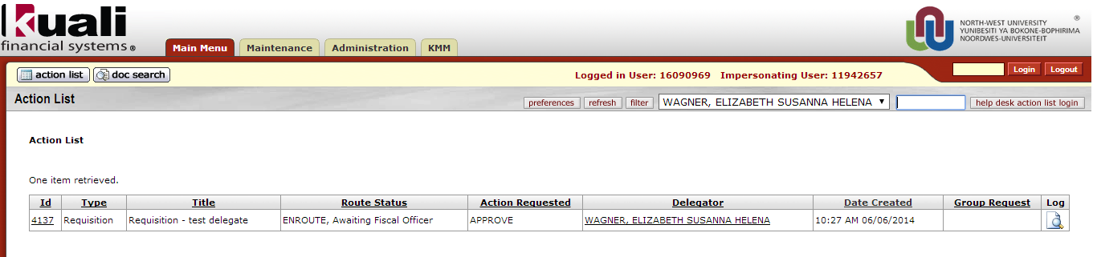
Figure 51
- Deactivation of Delegate

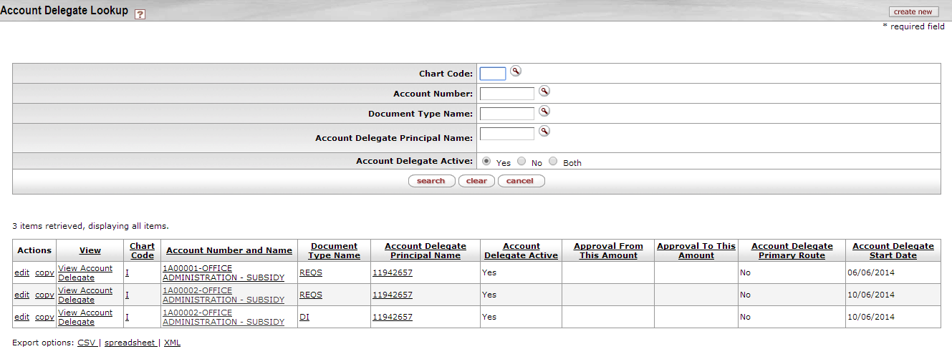

Figure 52

1. | Lookup delegate with the use of the Account Delegate document
2. | Complete Account Number and/or Account Delegate Principal Name to limit the search to specific information
3. | Choose delegate that you want to deactivate
4. | Click on edit of that specific delegate

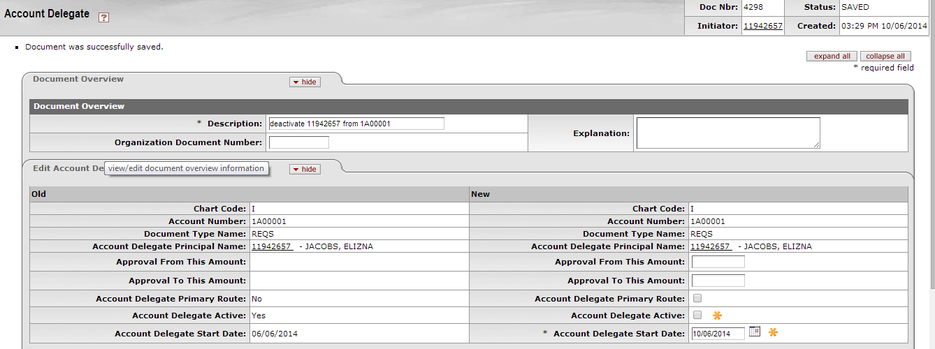

Figure 53

1. | Complete the description field with a meaningful description for example; deactivates principal ID and Account Number.
2. | Remove tick at the Account Delegate Active Field.
3. | Click on so that the change can occur.
4. | The delegate will no longer be active.

- Create a new Account

Please refer to http://www.nwu.ac.za/kfs-coa for the detailed process.

- Register a new user on KFS

Please refer to http://www.nwu.ac.za/kfs-kim for the detailed process.

Lesson Summary
Having completed this lesson you should be able to:
- Log in on KFS
- Understand and configure your Action List
- Do a Document search
- Add and view Notes and Attachments
- Add an Ad Hoc Recipient
- Understand the Route Log
- Create a Fiscal Officer Delegate
- Approve documents as a Fiscal Officer Delegate
- Deactivate a Fiscal Officer delegate

