Financial Processing – Purchasing (PUR)
Shopping Profile
Document Summary
Product Owner / Author | Riaan Prinsloo
Editor Name | Chimoné Barends
Date | 2015/07/10
Time | 09:00 AM
Template | Verbose

Lesson Objectives
On completion of this lesson you should be able to:
- Navigate to Shopping Profile
- Navigate to the Account
- Create a Profile

Lesson Scenario
- As an existing staff member of the NWU you are required to work on the KFS system as an Initiator of your Department. One of your key roles in the department is to do shopping for the obtaining of goods from the different stores.
- This lesson will show you how create a shopping profile to do shopping for future purposes.

Lesson Prerequisites
- You need to be a NWU staff member that is registered on KFS as a user.

Table of Contents

- Main Menu
- Shopping Portal Layout
- My Account – Customer Information
  - Edit Profile: DEFAULT
  - Default Ship-To Address and Default Billing Address
  - Accounting
  - Click on Save
- Lesson Summary

Main Menu
KFS navigation: Main Menu > Shopping > Shopping
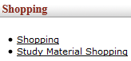
Figure 1

1. | Click on Shopping.

- Shopping Portal Layout

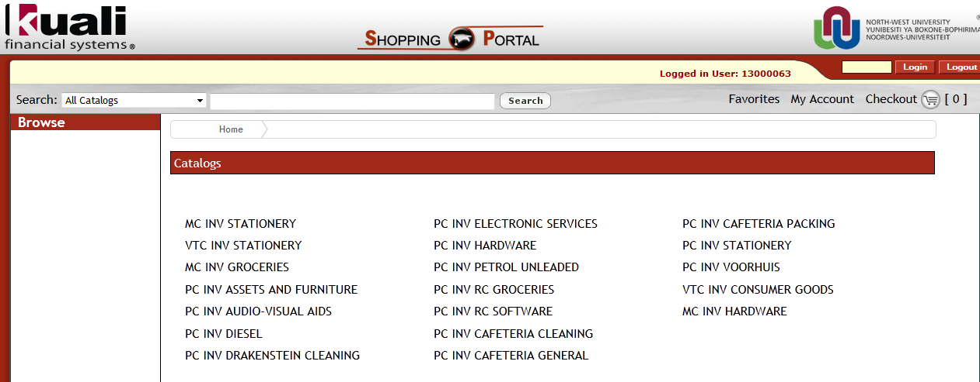
Figure 2

1. | Click on

- My Account - Customer Information:
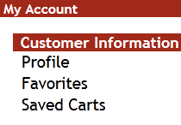
Figure 3

1. | Click on Profile below Customer Information.

3.1 Profile Maintenance: Edit Profile: DEFAULT

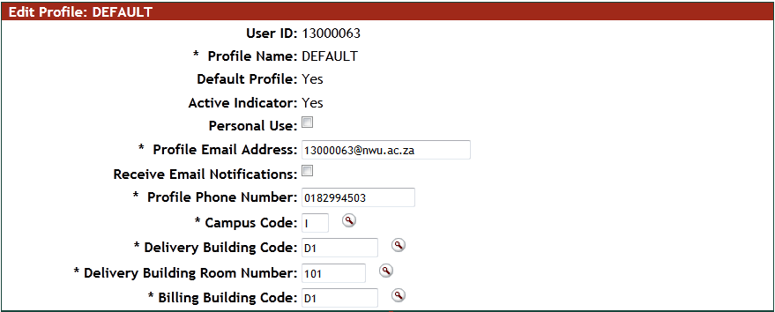
Figure 4
- Enter all the required information of the requestor.

1. | Complete or the Delivery Building Code.
2. | Complete or the Delivery Building Room Number.
3. | Complete or the Billing Building Code.

3.2 Default Ship-To Address and Default Billing Address
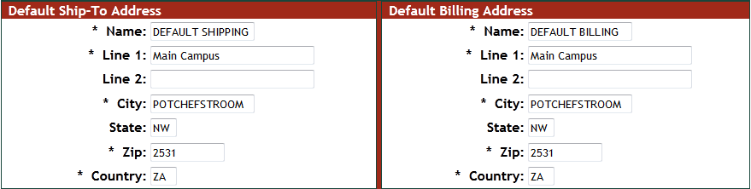
Figure 5
3.3 Accounting
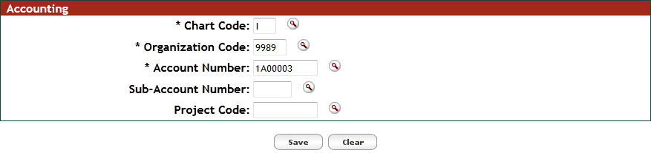
Figure 6

1. | Complete or the Chart Code.
2. | Complete or the Organization Code.
3. | Complete or the Account Number.
4. | Click on

3.4 Click on Save

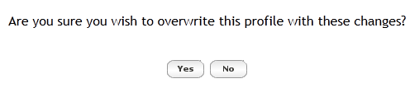
Figure 7

1. | Click on if you wish to overwrite your profile changes. When you click on , will the system indicates your
2. | Click on if you don’t want to overwrite your profile changes anymore.
3. | Please Note:  If your screen is blank, please contact your IT-Help on Campus for assistance on your Firefox version. It is recommended to down-grade to an older version so that KFS can work properly.

- Lesson Summary
Having completed this lesson you should be able to:
- Navigate to Shopping Profile
- Navigate to the Account
- Create a Profile

