Financial Processing – Purchasing (PUR)
Shopping Cart
Document Summary
Product Owner / Author | Riaan Prinsloo
Editor Name | Chimoné Barends
Date | 2015/07/10
Time | 09:00 AM
Template | Verbose

Lesson Objectives
On completion of this lesson you should be able to:
- Navigate to Shopping Cart
- Search for an Item
- Add Items to the Shopping Cart
- Checkout the Items
- Approve the Order Document

Lesson Scenario
- As an existing staff member of the NWU you are required to obtaining goods from the different Stores on the KFS system as an Initiator of your Department.

Lesson Prerequisites
- You need to be a NWU staff member that is registered on KFS as a user.

Table of Contents

- Main Menu
- Shopping Portal
  - Choose a Catalog
  - Choose a Category
  - Choose an Item
  - Add to a Favorites List
  - Checkout
  - View Cart and Create an Order
  - View Order Details
  - Submit
- Lesson Summary

Main Menu
KFS navigation: Main Menu > Shopping > Shopping
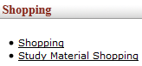
Figure 1

1. | Click on Shopping.

- Shopping Portal Layout
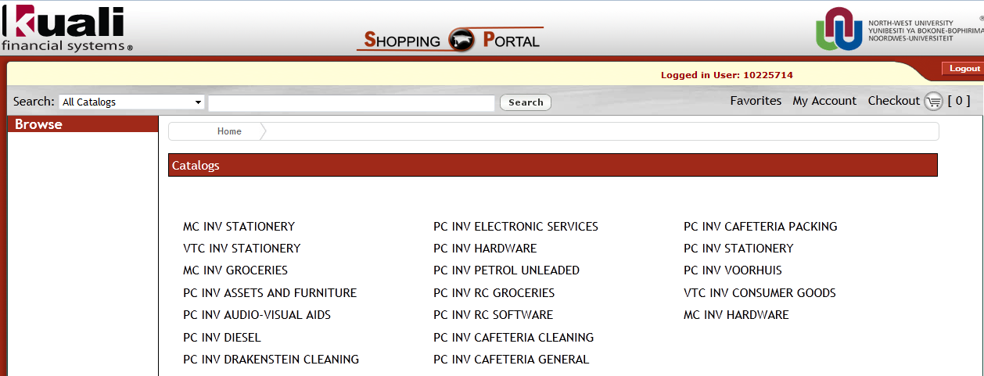
Figure 2

2.1 Choose a Catalog

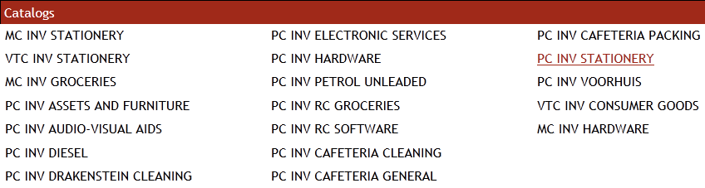

Figure 3

1. | On the Catalog List appear various stores; select the store relevant to your Campus.  MC = Mafikeng Campus  PC = Potchefstroom Campus  VTC = Vaal Triangle Campus
2. | Choose from the list of Catalogs the store you require, for example,

2.2 Choose a Category

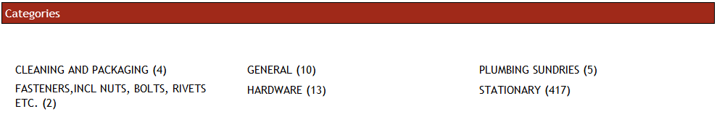
Figure 4

1. | Choose from the list of Catagories a store you want to make a purchase from. For example,

2.3 Choose an Item

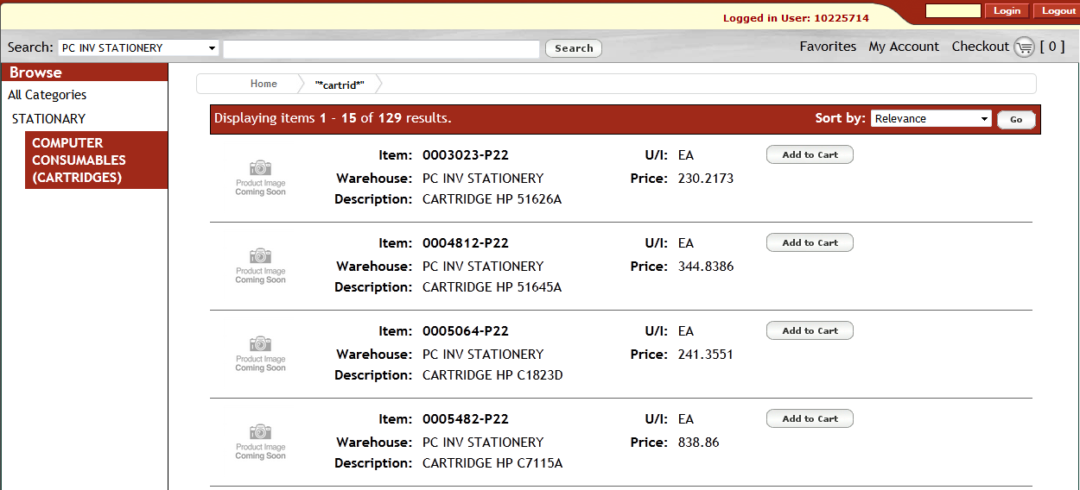
Figure 5

- If you know the item code number, insert the number in the Search field.
- If the number is unknown use the asterisk (*) wildcard to search for the item.
- The (*...*) asterisk is the wildcard to search on partial descriptions such as *cartrid* for cartridges or you can choose the catalog group to see all the items in that specific group. For example,
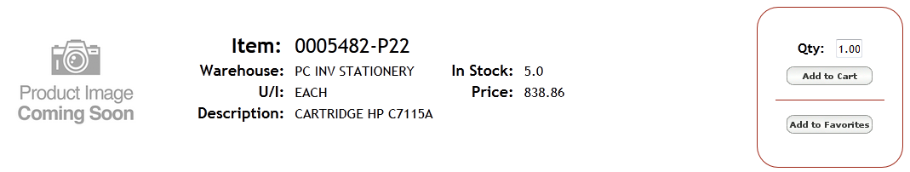
Figure 6

1. | Click on >
2. | Click on

2.4 Add to a Favorites List
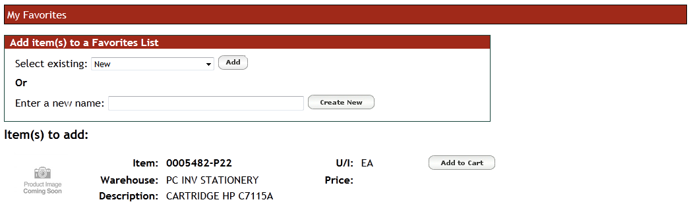
Figure 7
Add to Favorites:
- If this is an Item that you purchase regularly and do not wish to re-enter the information again, you could add this to your Favorites and it will be available on your favorites list for the next purchase. For example,

1. | Click on
2. | Type the required name, for example
3. | Click on

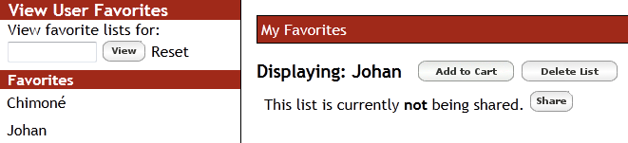
Figure 8
Use the following buttons to:

1. | Add a staff member/s to your Favorites list
2. | Remove an existing staff member from your Favorites list
3. | Share your shopping cart with another staff member that is on leave or out of office
4. | View the user favorites list by using the staff member number, for example  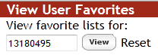

2.5 Checkout
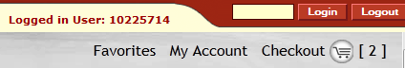
Figure 9

- You must checkout before the shopping cart could be viewed.

1. | Click on
2. | View your cart and click on

2.6 View Cart and Create Order
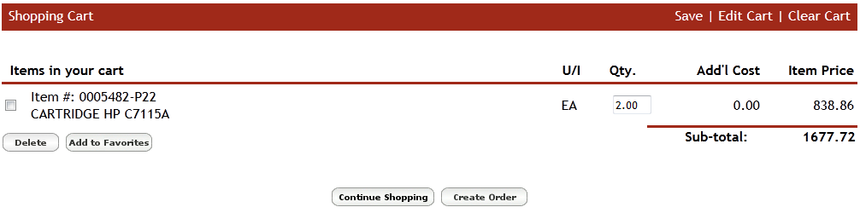
Figure 10

- Item number, description, unit of measure, quantity and total amount are displayed for the item you are purchased.
Use the following buttons to: 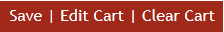
- Save: Enter a name for your cart in the Save Shopping Cart field, click on
- Edit Cart: If you want to edit the quantity of the item do the changes here. For example,
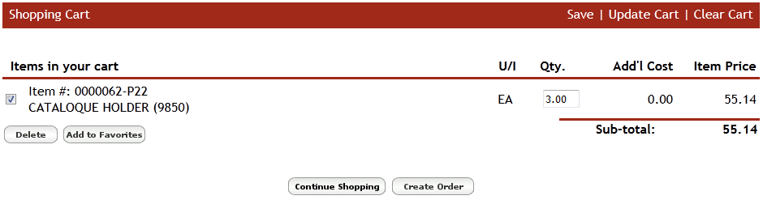
Figure 11
- Update Cart: After editing your item quantity, click on before you Create the order, otherwise will the system creates the order before the items was updated with the new item quantity.
- Clear Cart: The cart could also be cleared in total, saved or only deleted certain items from the list of items you don’t want to purchase anymore.

2.7 View Order Details and click on Submit
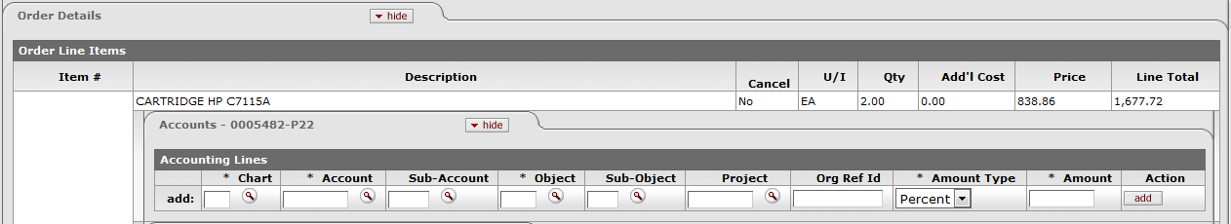
Figure 12

- The accounting populates automatically based on the info of your Profile and item chosen, but could be changed here.
- The process of creation of the store requisition is now ready for submitting.
- When you click on Submit the status of the transaction will change to “ENROUTE”
- Click on that will change the transaction status to “FINAL”

1. | Click on Submit > Reload

Figure 13

- The process is now completed. If you have the authority to approve your own purchase, otherwise it would route to the next level for approval.

Order Number:
- Please note that your Order Number will appear in the Description field as well as in the Order field of your document. For example,
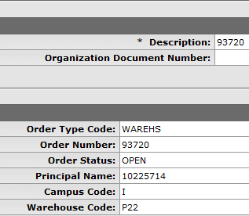
Figure 14

- Lesson Summary
Having completed this lesson you should be able to:
- Navigate to Shopping Cart
- Searching for an Item
- Add Items to the Shopping Cart
- Checkout the Item
- Approve the Order Document

