Financial Processing – Purchasing
Service Billing (SB)
Document Summary
Product Owner / Author | Johan Schoeman
Editor Name | Chimoné Barends
Date | 2016/11/23
Time | 12:00 AM
Template | Verbose

Lesson Objectives
On completion of this lesson you should be able to:
- Initiate a Service Billing (SB) document
- Add an Accounting Line in the Expense section with a description
- Add the Service Department in the Ad Hoc Recipient tab as the approver to complete the transaction
- Submit the Service Billing (SB) transaction

Lesson Scenario
- As an existing staff member of the NWU you are required to work through this lesson, make some notes if necessary and print out the documentation as a guideline.
- This lesson will show you how to initiate/create the Service Billing (SB) transaction to the NWU Vehicle Park to request and book a vehicle for a specific time and date.
- In this lesson, for example, your head of the department required the vehicle on 12 March 2015. The vehicle will be collected at 07:00 and returned at 17:00 for a meeting in Johannesburg. The estimated amount will be R750.45.

Lesson Prerequisites
- You need to be a NWU staff member that is registered on KFS as a user.

Table of Contents

- Main Menu
- Document Layout
- Initiating a Service Billing (SB) document
  - Document Overview Tab
  - Accounting Lines Tab
  - Notes and Attachments tab
  - Ad Hoc Recipient Tab
  - Route Log Tab
  - Recall/Cancel of a document

Main Menu

KFS navigation: Main Menu > Administrative Transactions > Financial Processing > Service Billing

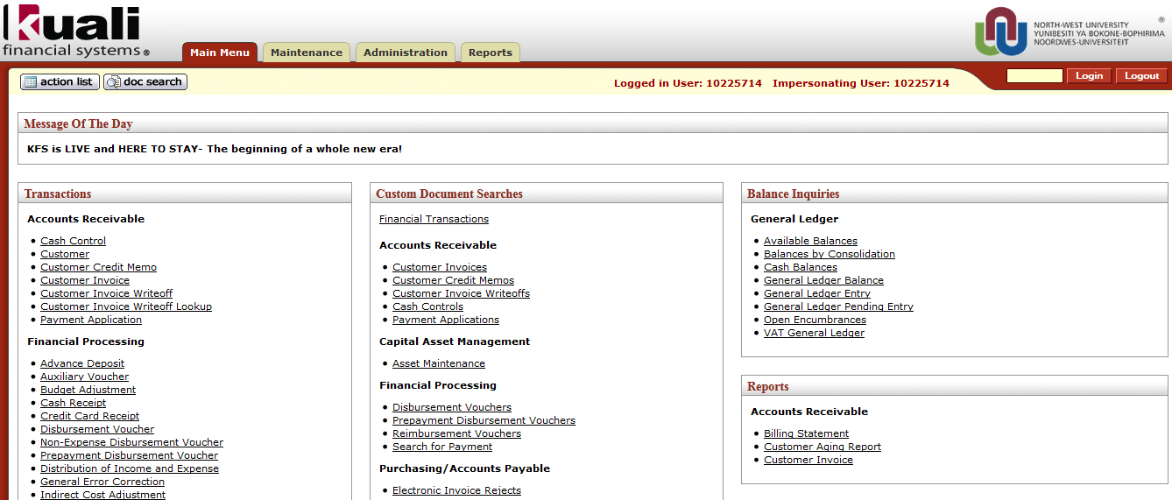
Figure 1

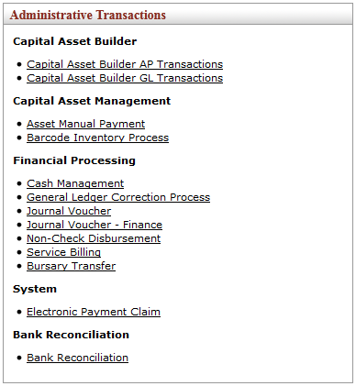
Figure 2

1. | Select Service Billing from the Financial Processing submenu group in the Administrative Transactions submenu on the Main Menu tab.

- Document Layout

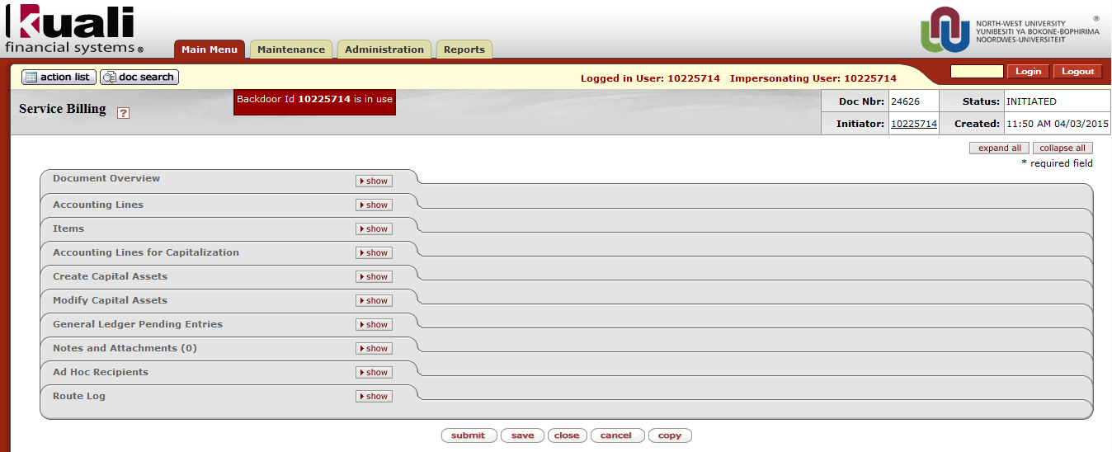
Figure 3

1. | Log into KFS as necessary. A Blank SB document with a new document ID appears.
2. | Write down the Doc Nbr on your original documentation so you can easily pull up the SB when you are performing a search.

2.1 Document Overview Tab

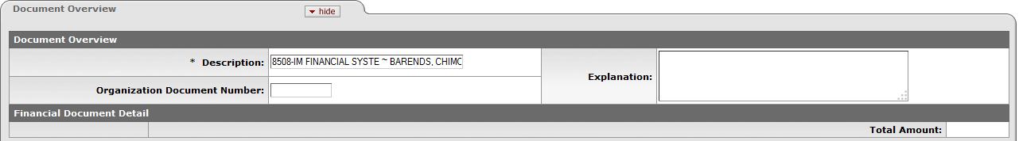
Figure 4

- The Description (Auto generated: Org code & name + Initiator’s surname & name) – do not type in this field!
- You may enter a brief Explanation (optional)

2.2 Accounting Lines Tab

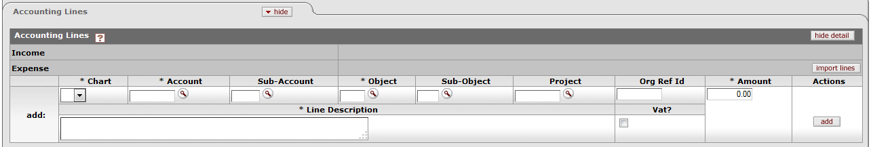
Figure 5

- Complete the Accounting Lines tab.
- Only the Expense section will be visible to complete.
- The Income section will be completed by the Service Department.
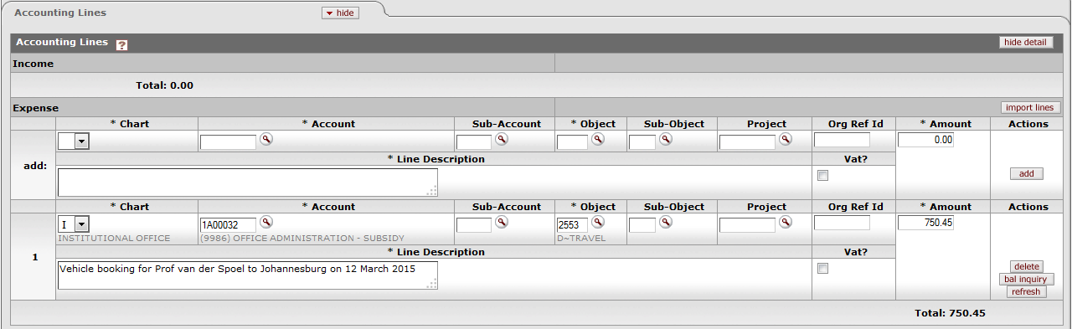
Figure 6
In the Expense section:
1. | Chart: Click on and for example select I or type I.
2. | Account: Type 1A00032 or click on to search for 1A00032 and return the value.
3. | Object: Type 2553 or click on to search for 2553 and return the value.
4. | Amount: Tab to the Amount filed and enter 750.45
5. | Line Description: Type Vehicle booking for Prof van der Spoel to Johannesburg on 12 March 2015.
6. | Click when you are satisfied that you’ve completed all the necessary information correctly.
7. | Click on at the bottom of the E-doc.

2.3 Notes and Attachments Tab

Figure 7

- In this tab you are required to add notes and attachments as supporting documents to the transaction.

1. | Type your note in the Note Text field.
2. | Click on and browse on your computer for the file that you want to attach.
3. | Click on when you are satisfied.

2.4 Ad Hoc Recipient Tab

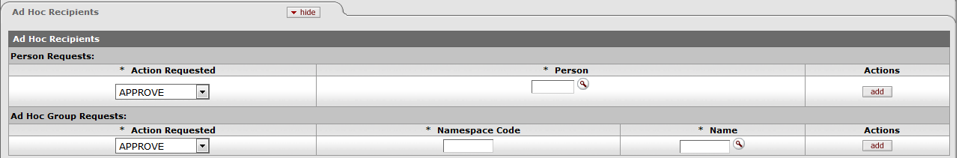

Figure 8

- With the Service Billing (SB) transaction you need to add an Ad Hoc Recipient so that the rest of the transaction can be completed by the Service Department.

1. | Click on to choose from the available Action Requested field.
2. | Choose the action.
3. | Complete the staff member number/username in the Person field or click on, to search the person and return the value.
4. | Click on

2.5 Route Log Tab

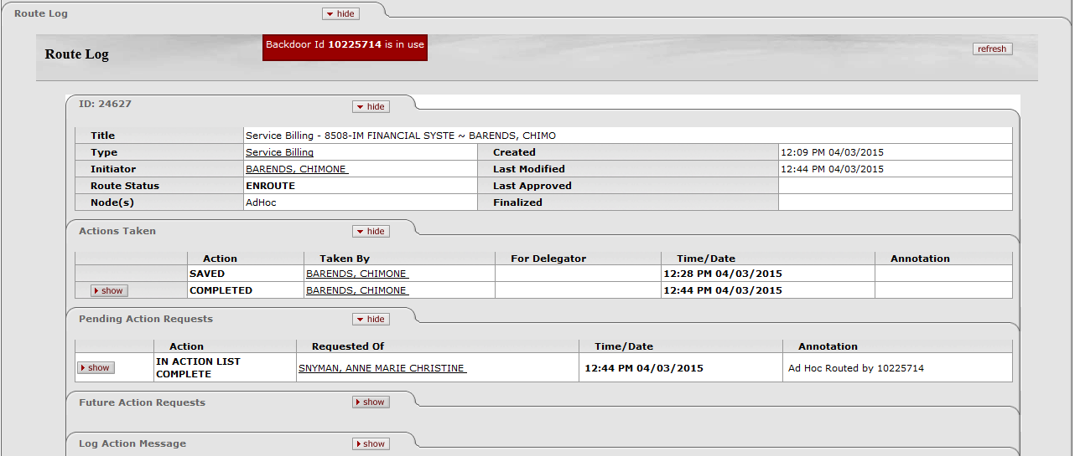

Figure 9

- The user needs to submit this document, in order for it to Route for Approval.
1. | Click on at the bottom of the E-doc. 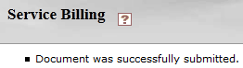.
2. | The Route Status currently shows ENROUTE.
3. | Click on in the Route Log tab to follow the workflow of the document.
4. | Click to close the document.

- Routing for the SB for NWU:
◦ Initiator - Initiate
◦ Service Department - Approve/complete
◦ Final
2.6 Recall/Cancel of a document

- If you need to make changes to a SB document, click on
- Please note the following before you take action on any of the available buttons:
  - Click on if you want to make changes to a document.
  - Click on if you want to cancel the document.
  - Click on if the document status is in “SAVED” mode, if the document is “ENROUTE” for approval you will not be able to cancel the document anymore.

- Please enter a reason in the reason text block:

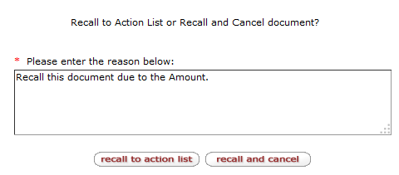
Figure 10

2.7 Service Department for Approval of the transaction

- The Service Department receive the (SB) document in their Action List.
- Please note the following before you can complete the transaction:
  - Click on
- The following informational messages will appear on the screen:
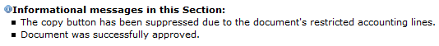
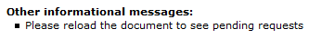
- Click on to complete the Income Accounting Lines.
- Click on
- The document status will change to “FINAL”.

Lesson Summary
Having completed this lesson you should be able to:
- Initiate a Service Billing (SB) document
- Add an Accounting Line in the Expense section with a description
- Add the Service Department in the Ad Hoc Recipient tab as the approver to complete the transaction
- Submit the Service Billing (SB) transaction

