Purchasing / Accounts Payable
Receiving (RCV)
Document Summary
Product Owner / Author | Riaan Prinsloo
Editor Name | Chimoné Barends
Date | 2016/11/24
Time | 12:00 AM
Template | Verbose

Lesson Objectives
On completion of this lesson you should be able to:
- Navigate to receiving.
- Enter the received quantity, date of receiving and the delivery note.
- Generate a receiving e-doc.

Lesson Scenario
- You are a KFS user and an initiator of your department. One of your key roles in the department is to do receiving for the goods you purchased.
- For this lesson, use your staff member number and log into the KFS system.

Lesson Prerequisites
- You need to be a NWU staff member that is registered on KFS as a user.

Table of Contents

- Receiving
1.1 Navigate to Main Menu
1.2 Navigate to Receiving
1.3 Click on Receiving
1.4 Click on Submit and Reload
1.5 Confirmation of Receiving
1.6 Correction of receiving documents
1.7 Enter a reason for the change
1.8 Do changes to the quantity
1.9 Click on Submit and Reload
2. Lesson Summary

Main Menu
KFS navigation: Main Menu > Transactions > Purchasing/Account Payable > Receiving
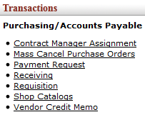
Figure 1

1. | Select Receiving from the Purchasing/Accounts Payable submenu group in the Transactions submenu on the Main Menu tab.

- Document Layout

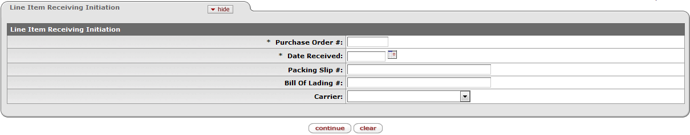
Figure 2

1. | Purchase Order #: Type the Purchase order number in this field.
2. | Date Received: Type or select date for the receiving of the items.
3. | Packing Slip #: Type the required invoice number in this field, when available.
4. | Click on

2.1 Items Tab
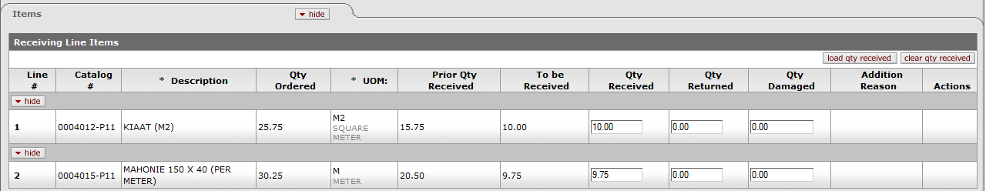
Figure 3

1. | Enter the 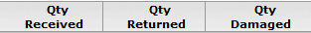
2. | Click on and to make sure that the status is “Final”.

Figure 4

- The document number is used for the receiving number and the process is completed.
- After completing the receiving process, certain changes can be made to the quantity.
1. | Click on to correct the quantity on the document.

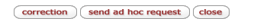
Figure 5

1. | Type the reason for the change and click on

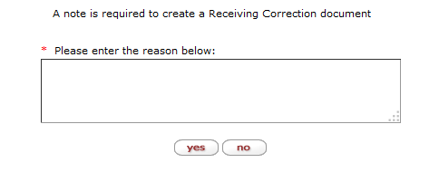
Figure 6

1. | Make changes to the quantity.

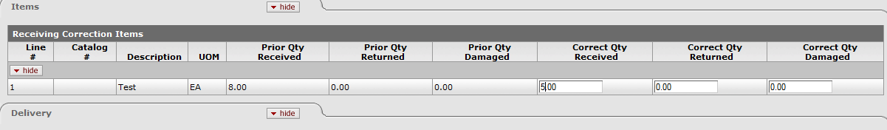
Figure 7

1. | Click on and then on
2. | You will receive a new document / receipt number.

Lesson Summary
Having completed this lesson you should be able to:
- Do receiving the items you have purchased;
- Do corrections on the receiving quantity.

