Guidelines to Approve a Service Billing (SB) and Bursary Transfer (BBT) document

- KFS navigation: Main Menu >
- Click on the specific Document number (Id) to open the document.
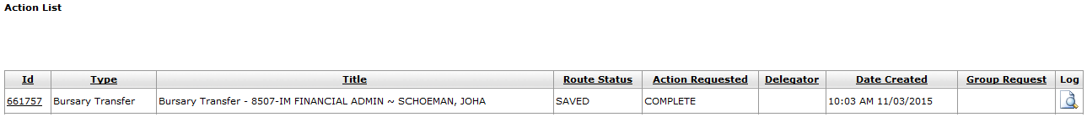

 | Tab / Action | Fields to be completed
1 | - Click on
2 | - Click on
3 | Accounting Lines – Income Section | - Complete or Chart Code  - Complete or Account Number  - Complete or Object  - Complete Amount  - Complete Line Description  - Click on
4 | Complete the document | - At the bottom of the document, click on

