NWU KFS Shopping Portal (KMM)
Mixed Content Permanent Fix
Document Summary
Product Owner | Johan Schoeman
Editor | Chimoné Barends
Date | 2016/05/16
Time | 10:00 AM
Template | Verbose

Table of Contents

- About Mixed Content
- Viewing Blocked Mixed Content
- Effects of Mixed Content in KFS Shopping Portal
- Enabling Mixed Content
  - Firefox
  - Internet Explorer
  - Google Chrome

About Mixed Content

When you visit a secure web page (i.e., using HTTPS), your connection is encrypted with SSL. If the HTTPS page also includes content retrieved through a regular HTTP connection, the connection is only partially encrypted. This is called a web page with mixed content.

Viewing Blocked Mixed Content

By default, mixed content is blocked in Internet Explorer (version 10+), Mozilla Firefox (version 23+) and Google Chrome (version 21+). When mixed content is blocked, you may see a blank page or a message saying that "Only secure content is displayed".

Effects of Mixed Content in KFS Shopping Portal

- Users receive a blank screen when searching for a catalogue item.
- User receives errors when adding item to the shopping cart. E.g. Firefox is blocking content on this page - Insecure Content.
- Users are prompted to complete a shopping profile before checkout. After creating a shopping profile the problem persist with this error message: Your profile is incomplete, please complete before checking out.

Enabling Mixed Content

  - Firefox:

- Type about:config in Firefox's address bar.
- Ignore the warning and click on "I'll be careful, I promise!"
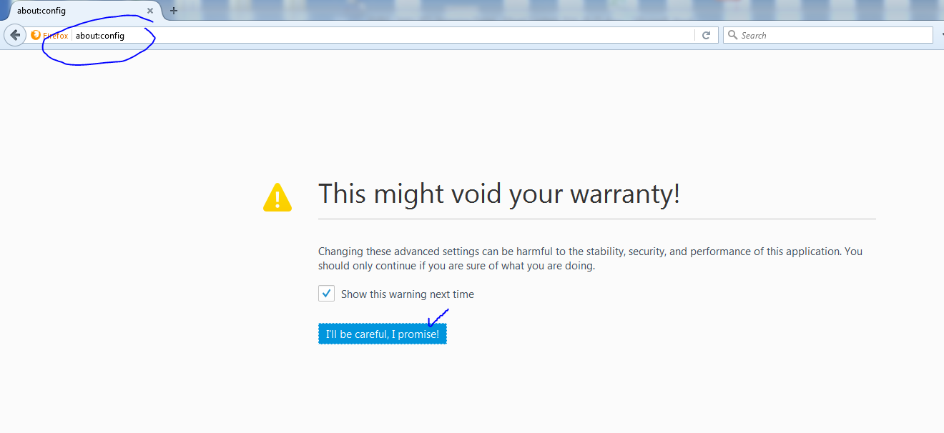

- Search for security.mixed_content.block_active_content
- Double-click on the item to toggle it to False
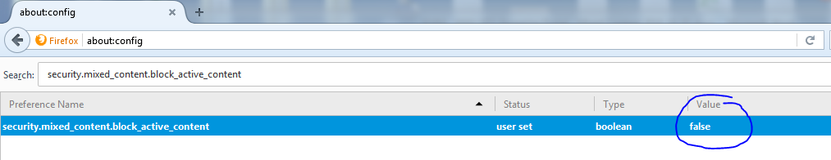
- Do the same for security.ssl3.dhe_rsa_aes_128_sha
- Do the same for security.ssl3.dhe_rsa_aes_256_sha

  - Internet Explorer:

- Go to Internet Options >> Security
- Click on the Custom tab.
- Then scroll down to the miscellaneous area, and enable "Display mixed content".
- Click on OK.
- You will need to restart IE.
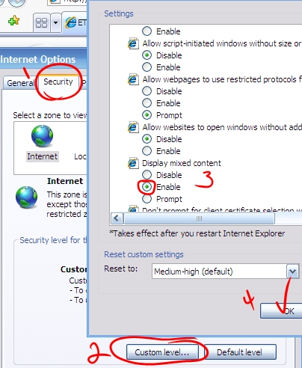

  - Google Chrome:
When a page has insecure content, the following shield icon will appear in the address bar.
Click on it, and select "Load Anyway" or "Load unsafe script". The video or other media will load.

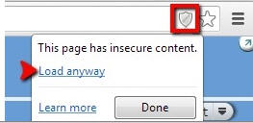
Or
