Financial Processing – Purchasing
Bursary Transfer (BBT)
Document Summary
Product Owner | Johan Schoeman
Editor Name | Chimoné Barends
Date | 2018/10/02
Time | 08:30
Template | Verbose

Lesson Objectives
On completion of this lesson you should be able to:
- Add a Bursary Transfer (BBT) Accounting Lines with a description.
- Add a Completer to approve & complete the Bursary Transfer (BBT)
- Submit the Bursary Transfer (BBT) transaction.

Lesson Scenario
- You are the Administrative Assistant in your department. You need to create a bursary transaction to transfer funds to the Financial Support Services to pay out a bursary to a student.

Lesson Prerequisites
- You need to be a NWU Staff member that is registered on the KFS system as a user.

Table of Contents

- Main Menu
- Document Layout
- Initiating a Bursary Transfer (BBT) document
  - Document Overview Tab
  - Accounting Lines Tab
  - Notes and Attachments tab
  - Ad Hoc Recipient Tab
  - Errors occur in the Bursary Transfer (BBT) document
- Import Accounting Lines from Excel to the BBT E-doc

Main Menu

KFS navigation: Main Menu > Administrative Transactions > Financial Processing > Bursary Transfer
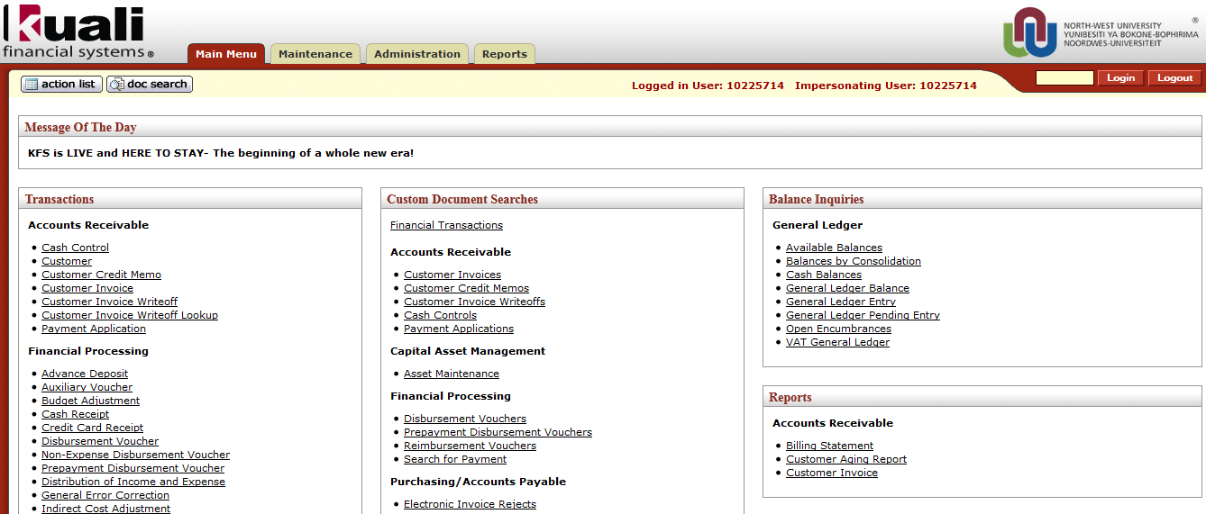
Figure 1

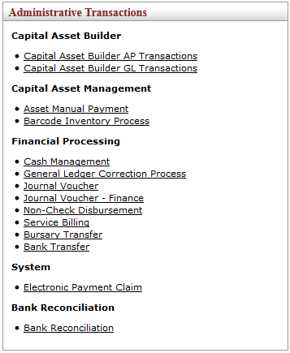
Figure 2

1. | Select Bursary Transfer from the Financial Processing submenu group in the Administrative Transactions submenu on the Main Menu tab.

- Document Layout

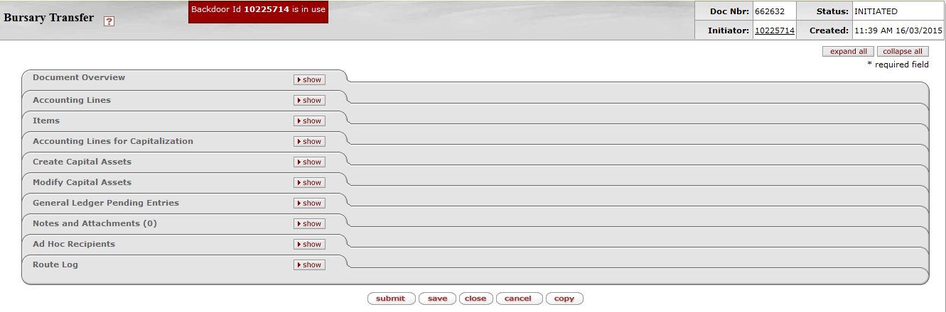
Tabs to be completed

Figure 3

1. | Write down the Doc Nbr on your original documentation so you can easily retrieve the BBT when you are performing a search.

3.1 Document Overview Tab
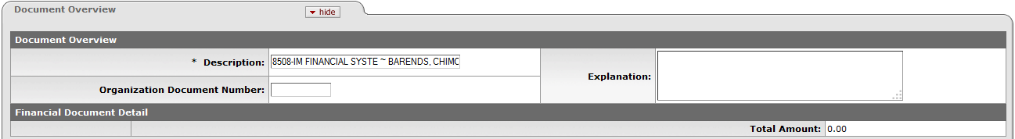
Figure 4

- The Description (Auto generated: Org code & name + Initiator’s surname & name) – do not type in this field!
- You may enter a brief Explanation (optional).
3.2 Accounting Lines Tab

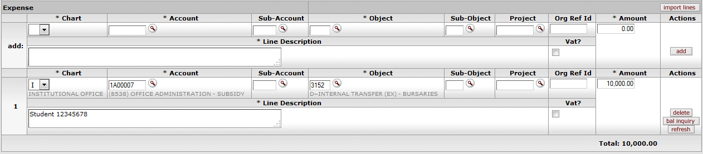
Figure 5

- The Expense section will be visible to complete while the Income section will be completed by the Financial Support Services. The expenditure for the service will be debited.
- In the case of the Bursary Transfer transaction you must specify the amount as the exact bursary amount that will be paid to the student.
1. | Complete the Chart, Account & Object combination in the Expense section. The Income section will be completed by the Financial Support Services.
2. | Type the exact bursary amount in the Amount field.
3. | Type a descriptive explanation in the Line Description field that includes the student number etc.
4. | Click on

3.3 Notes and Attachments Tab

Figure 6

- In this tab you are required to add notes and attachments as supporting documents to the transaction.

3.4 Ad Hoc Recipients Tab

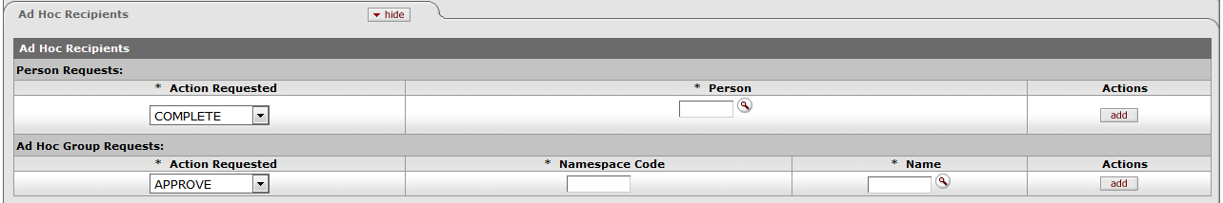
Figure 7

- With the Bursary Transfer (BBT) you have to add a Completer.
- Choose the complete action since the person at the Financial Support Service Department will complete the rest of the transaction for you.

1. | Click on next to the Ad Hoc Recipients tab.
2. | Choose the action.
3. | Complete the person’s staff number/username or click on, search in the next screen for the person and return the value.
4. | Click on

Figure 8
1. | Click on at the bottom of the E-doc. 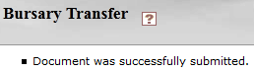. The document will then route to the staff member specified on the Ad Hoc Recipient tab for approval.
2. | The BBT document will automatically route to the Approver (director of the organization) for approval, no matter the value.
3. | The Route Status currently shows ENROUTE.
4. | Click on in the Route Log tab to follow the workflow of the document.
5. | Click to close the document.

- Errors on a Bursary Transfer (BBT) occur when you?

1. | Click at the bottom of the E-doc without adding a Ad Hoc Recipient. 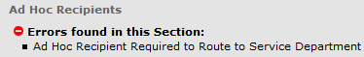
2. | Click on the Ad Hoc Recipient tab without completing your Accounting Lines.
3. | Click on the Accounting Lines using Income Object Codes instead of Expense Object Codes.

- Import Accounting Lines from Excel

- KFS line import templates allow you to import any number of accounting lines from a comma-delimited (.csv) file.
- The BBT-template is also available on the KFS-Website: www.nwu.ac.za/kfs
1. | Double click the Excel icon to open the BBT-template.

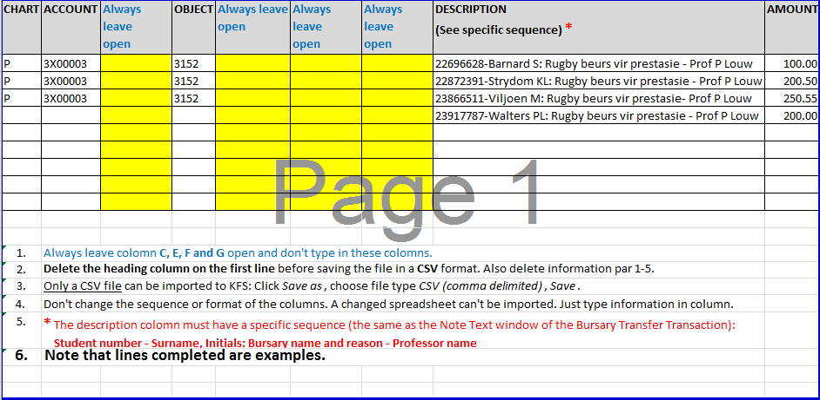
Figure 9

1. | The next step is to complete your Accounting Lines in the columns as indicated  (Red = Required).
2. | You can enter as many lines as preferred/needed.
3. | Remember to delete the heading column on the first line before saving the file in a .csv (Comma delimited).

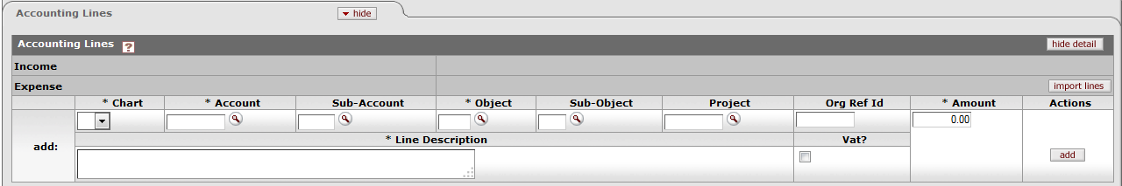
Figure 10

1. | Proceed to KFS
2. | KFS navigation: Main Menu > Administrative Transactions > Financial Processing > Bursary Transfer.
3. | Take the same steps as described at the beginning of the manual until you get to the point where you would manually complete the accounting lines. Instead of manually completing the lines, click on
4. | Click on Choose File
5. | Select the file from the folder where you saved it and click Open. Make sure you change the file types to All Files to include the .csv files.
6. | The file name is now displayed next to Choose File 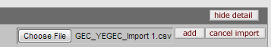
7. | Click on

Lesson Summary
Having completed this lesson you should now be able to:

- Add a Bursary Transfer (BBT) Accounting Lines with a description.
- Add a Completer to approve & complete the Bursary Transfer (BBT)
- Submit the Bursary Transfer (BBT) transaction.

