NWU KFS Chart of Accounts (COA)
Account Type Guidelines
Document Summary
Product Owner / Author | Chimoné Barends
Editor
Date | 2021/09/02
Time | 08:00 AM
Template | Verbose

Table of Contents

- The purpose of an Account
- Navigation to create a new Account
- Important notes when you apply for a new account
- Account Type Guidelines
- Attachment examples per Account Type

- COA E-doc:

 | Type of E-doc: | Purpose of the E-doc & important notes: | Transaction Examples: | Notes and Attachments:
1 | Account | - An account is used to identify a pool of funds assigned to a specific university organizational entity (OE) for a specific purpose.  - An account has valuable attributes – based on the info you supply, these attributes are assigned to an account. The attributes determine where the transactions are recorded in the financial statements – which is why it is so important that you supply us with the correct information. These attributes include for example: Account type, SOF (Source of funds), Sub-Fund Code, Higher Education Function Code, Interest and VAT. | - Create a new account | - A short description about the account and what it will be used for. We need complete information to ensure we create the correct account.  The information we need are for example:  - The purpose and nature of the account  - Is this account purely for service delivery, research or a bit of both (indicate which will be more?)  - Are there any students involved who will contribute to the deliverables / output?  Supporting documents:  - Any supporting documents proofing the funds that will be received and the person/company/source/origin of the funding  - Complete, final, signed contracts  - Letters from research councils for example the NRF, indicating the amount that will be received. The UID number must be provided.  - Letters with reference numbers, for example from the WRC.  - SCAS approval letters with regard to short courses.  - Information regarding workshops (poster, registration form, who will attend etc.)  - Letters from the Research Support Office with regard to postdoctoral fellowship awards or any other research awards.  - Letters / minutes of meetings regarding research awards within faculties (from deans/directors/campus finance/ faculty research Committees)  - Letters regarding IREA/ITEA awards or list of publication awards  - GL summary report of accounts that will be replaced (restructuring)

- Navigation to create a new Account:

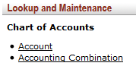
- Main Menu
- Lookup and Maintenance
- Chart of Accounts
- Account
- Click
When you apply for a new account:
1 | Give us a short description about the account and what it will be used for. You can use the 3 Guideline/Purpose Text blocks, the Explanation field or the Notes & Attachment tab. We need complete information to ensure we create the correct account. The information we need are for example:  - The purpose and nature of the account  - Is this account purely for service delivery, research or a bit of both (indicate which will be more?)  - Are there any students involved who will contribute to the deliverables / output?
2 | Attach ALL the supporting documents. We need the information to determine the purpose of the account and consequently the specific type of account that we need to create.
3 | Where contracts apply, we need the complete, final, signed contracts with all annexures attached. It happened in the past that only part of the contracts were attached to applications. This may lead to incorrect VAT / interest handling – all because the complete contract(s) are not brought to our attention.
4 | The contract must clearly indicate the date of commencement and end of the contract as well as the amount of the contract.
5 | For every new contract - you need to create a new account.
6 | An account has valuable attributes – based on the info you supply, these attributes are assigned to an account. The attributes determine where the transactions are recorded in the financial statements – which is why it is so important that you supply us with the correct information. These attributes include for example: Account type, SOF (Source of funds), Sub-Fund Code, Higher Education Function Code, Interest and VAT.
7 | Accounts may NOT be re-used! By re-using it for another purpose, the account is not evaluated again by all the approvers and it may happen that the attributes are no longer correct for the re-used purpose of the account. The reporting on the funds will then be incorrect and the VAT, for example, may also be incorrect. It is YOUR responsibility to ensure you use the correct type of account for the correct purpose!
8 | The purpose of an Account may NOT be changed. If the purpose changes, you must apply for a new account and close the one(s) you do not need anymore.
9 | Accounts are not “date-driven”, in other words – if we change the name of the account or any of the attributes – it would appear as if it were that way from the day it was originally created. Therefore, if you need the history to remain as is – create a new account instead of requesting changes. Requests for changes must be motivated and will be strictly evaluated.
10 | An account need to be closed if the project/purpose was completed. Please refer to the “Closing of Accounts” manual http://services.nwu.ac.za/kfs-module/kfs-coa. An Account should have an “Account Expiration Date” AND the Closed indicator must be “YES”, only then the Account is finally closed.
11 | Please do not use other account(s) while waiting for a new account. The setup (VAT etc.) may be incorrect. Apply in time for an account and if you need the account urgently send an email to chimone.barends@nwu.ac.za

- Important notes when you apply for a new Account:
Correct | Wrong
- The Chart & Campus Code – must be the same  (PC, MC, VC, NW – New charts after restructuring)  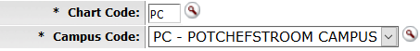 | - The Chart & Campus Code – The chart & campus codes cannot differ  (P, M, V, I – Old charts before restructuring)  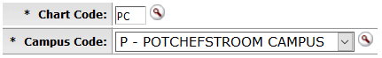
- Account Name: OU code in front & Account name in Capital letters.  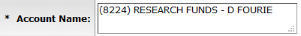  Make sure the staff number correspond to the award letter.  Account Name:  Award letter:  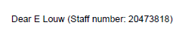 | - Account Name: The Account name without OU code & in small letters.  The staff number differs from the award letter. For example:  Account Name:  Award letter:
- Fringe Benefit Chart of Accounts Code:  - Don’t complete this field - leave it blanc/open. | - Fringe Benefit Chart of Accounts Code - shouldn’t be completed
- Budget Record Level & Account Sufficient Funds Codes: Always by  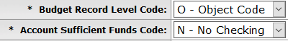 | - Budget Record Level & Account Sufficient Funds Codes: Never by: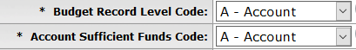

- Account Type Guidelines:

 | Account Type Code/Name: | Account Type Code Explanation | SOF | General info & Attachments:
1 |  | - Account where general office expenses are booked including the salary expenses of the department. | 1 | General info:  - Please make sure that there is not an existing 1A-account for the Organisation before you apply for a new account.  - There can only be one 1A-account per organisation.  Attachments:  - Attach the new OU / restructuring documentation from People and Culture.  - Email or a written request to open the account as supporting documentation.
2 |  | - All external fund income activities which are not associated with research.  - Pure service delivery e.g. consultations, contracts, workshops, conference and sales. | 3/5 | Attachments:  - The complete, final signed contract or agreement must be attached to the new account.  - A short description about the purpose and nature of the account and what it will be used for. We need complete information to ensure we create the correct account.  - Is this account purely for service delivery? Describe the services to be delivered.  - Is there any research involved in delivering the service? Explain.  - Are there any students involved who will contribute to the deliverables / output?
3 |  | - Entities where the income and expenses are not part of the NWU statements. | 3 | General info:  - This account type is not regularly used - contact Chimoné Barends before applying for this account.
4 |  | - Short courses presented by the University. Short course can either be SCAS approved or not.  - The VAT of the account is determined by the SCAS approval. | 3/5 | Attachments:  - The SCAS (Senate Committee for Academic Standards) approval letters with regard to short courses received from Tiaan Boshoff.  - Please note that the SCAS approval letters are valid for 3 years, make sure the letter attached are still valid, before you apply for the new account - if not, attach the renewal letter.  - If the short course is not SCAS approved, attach all the supporting documentation regarding the short course.
5 |  | - Research that is supported by subsidy. | 1 | Attachments:  - Research Awards from Dean / Director (faculty) or Research Support.  - Indicate the Account number from where the funds will be transferred via a transfer of funds.  - Award letters from Mpe Meintjies for Postdoctoral Fellowship Funds.  - The award letter must be signed, contain the staff member number and amount awarded.
6 | 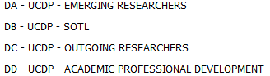 | - This separate account types as part of UCDP grant - for purpose of allocating awards. | 1 | Attachments:  - Attach the award letter received from Mpe Meintjies or Melvin Mothoa for UCDP-grants.  - The award letters must be signed and contain the staff member number, period & amount awarded.  Standard format example for 1DA-1DD Accounts:  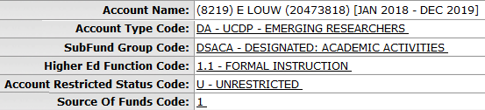
7 | 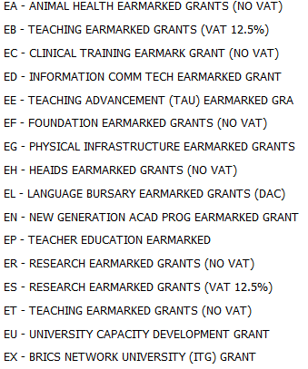 | - Earmarked grants received from DHET. To ring-fence each Earmarked Grant type as per DHET (Department of Higher Education and Training) requirements. Must audit and report serately. | 1 | General info:  - Only Yolandé Bechaz will give instruction to open a certain 1EA-1EX account from the list.  - She will also provide the relevant supporting documentation.  Attachments:  - An email from Yolandé Bechaz or DHET award letter must be attached as supporting documentation.  Infrastructure: 1EG-Accounts  - The only exception is the 1EG-Accounts that will be used by Infrastructure (Naomi van Rooyen) and the following apply:  - Sub-fund Group Code: DSSUP or FAADR  - Higher Education Function Code: 7.1  - Account Restricted Status Code: U - Unrestricted  - Source of Funds: 1  Attachments:  - Attach the project letter with Marius Coetzee’s approval of the SubFund Group Code for example: DSSUP or FAADR - it must be stipulated on the project letter.
8 |  | - Income received for internal services delivered by individual staff members are hosted here. The funds can be used by that individual for professional development according to the approved Policy. | 3 | General info:  - Only one Staff Development account allowed per organization.  - NO direct payments or internal transfers are allowed on these accounts. Make use of the Transfer to Staff Development - Supporting Document form that is available on the KFS website: http://services.nwu.ac.za/kfs-module/general-ledger-gl  - Please note that The Staff Development Policy is not yet available on the intranet - will be uploaded soon.  Attachments:  - Attach the email or letter as proof to open a new Staff Development account as supporting documentation.
9 |  | - Activities funded by subsidy which are not associated with the general administration of the department/office. | 1 | General info:  - Subsidy accounts – budget transfers are recommended and no actual transfers.  - Physical Infrastructure (Naomi van Rooyen)  - SubFund Code either: DSSUP or FAADR  - Higher Education Function Code - always 7.1  - Electronic Services (Sharon Reynolds)  - SubFund Group Code: DSSUP  - Higher Education Function Code - always 4.5  - Other - Motivate why you need a separate account.  Attachments:  Infrastructure:  - Attach the project letter with Marius Coetzee’s approval of the SubFund Group Code for example: DSSUP or FAADR as supporting documentation.  Electronic Services:  - Attach the email or letter as proof to open the new project accounts as supporting documentation.  Other:  - Any documentation supporting the motivation why you need a separate SOF 1 account.
10 | 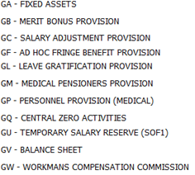 | - These accounts are centrally used. | 1 | General info:  - These accounts are for central use only.
11 |  | - Used mainly by Deans to budget for buffer funds with regard to research, personnel development, examiners etc. | 1 | Attachments:  - Attach the letter or emails (supporting documentation) associated with the reason why this account should be created.
12 |  | - Surpluses from Fund stream 3 accounts, allocated to the school/research entity. | 3 | General info:  - Surpluses are journalized to these accounts by Financial Planning at the closing of Fund stream 3 accounts, taking into account the school/research entity's agreement as at the opening of the Fund stream 3 account.  Attachments:  - Attach the Excel spread sheet or relevant emails as supporting documentation.
13 |  | - Strategic funds budgeted for in a budget year are allocated to this account. Strategic funds support the NWU’s strategic direction for that specific budget year.  - These funds are allocated to each budget unit from where the distribution is administrated. | 1 | General info:  - Contact Corene Flemming to make sure of the account name before applying for the new account.  - The 1GS-accounts may only be used for a specific project.  - Indicate the purpose - academic, support or research.  Attachments:  - Attach the Excel spread sheet received from Corene Flemming or relevant emails as supporting documentation.
14 | 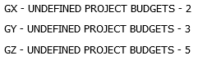 | - Accounts that are used during budget process to accommodate the budget of foreseen SOF 2, 3 & 5 projects. | 2/3/5 | General info:  - 2GX, 3GY & 5GZ - These accounts are used during the budget period to accommodate the budget of foreseen SOF 2, 3 & 5 projects – Farai Chingono will request you to open an account.  - It is only used for budgeting. No Actual or Encumbrance transactions may be posted on a GX, GY & GZ account.  - When the correct new SOF 2, 3 or 5 account was created, the budget must be moved from a GX, GY & GZ account to the relevant new account.  Attachments:  - Attach the Excel spread sheet or relevant emails as supporting documentation.
15 |  | - All Residence and Catering Services accounts. | 3 | General info:  - This account type may only be used by Residence and Catering Services (RCS).  Attachments:  - Attach the supporting documentation relevant to the account.  Standard format example for 3H-accounts:  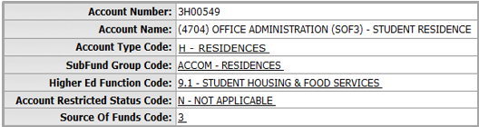
16 |  | - Institutional Research Excellence Award (IREA). One account per person. | 1 | General info:  - IREA (Institutional Research Excellence Award) / IRECO (Institutional Research Excellence Awards for creative outputs).  - Use this account only for staff for IREA awards (only 1 account per person).  - Search for duplicates before a new account is created on KFS.  - The account can only be created if the staff member is appointed permanently, for a fixed term or temporarily. You cannot apply for an account if the staff members is an ex-employee.  - Rules for the Institutional Research Excellence Awards (IREA) is available on the following link: http://www.nwu.ac.za/sites/www.nwu.ac.za/files/files/i-governance-management/policy/9P-9.2.1.6_IREA_e.pdf  Standard format example for 1K-accounts:  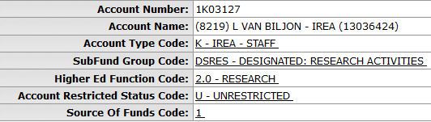  Attachments:  - Attach the applicants excel list received from Teresa Smit or award letter as supporting documentation.  - If the staff member is an extraordinary professor attach the appointment letter.
17 |  | - Institutional Research / Teaching Excellence Award budget. | 1 | General info:  - This account type will only be used centrally.
18 |  | - Institutional Research / Teaching Excellence Award reserve. A repository for balances of ITEA / IREA accounts of which the “owners” are no longer employed by the University. | 1 | General info:  - This account type must be created when a staff member resigns or has passed away and you need to close the staff member’s 1K/KT account.  - Only one account per OU code.  Standard format example for 1KG-accounts:  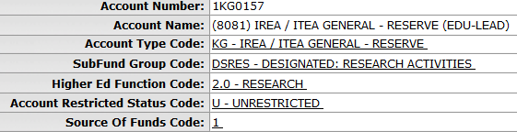  Attachments:  - Attach an email or excel list as supporting documentation.
19 |  | - Institutional Research Excellence Award for students (one account per OU code) | 1 | General info:  - Only for students for an IREA award and only one account per OU code.  Standard format example for 1KS-accounts:  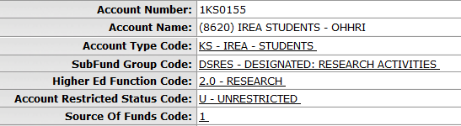  Attachments:  - The initiator must attach the applicants excel list received from Teresa Smit / award letter as supporting documentation.
20 |  | - Institutional Teaching Excellence Award (ITEA) only for staff members (one account per person) | 1 | General info:  - Only for staff members for an ITEA award and only one account per person.  - The Institutional Teaching Excellence Awards (ITEA) Policy is available on the following link: http://www.nwu.ac.za/content/policy_rules. Please note that the policy is not yet available on the intranet - will be uploaded soon.  Standard format example for 1KT-accounts:  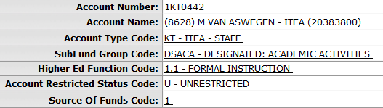  Attachments:  - Attach the applicants excel list received from Luzelle van Rensburg or the award letter as supporting documentation.
21 |  | - Bursary funds administrated by the Bursary Offices. | 1/2/3 | General info:  - This account type will only be used by the Bursary Offices.  Attachments:  - Attach relevant information to the account, for example contracts or agreements regarding bursaries.
22 | 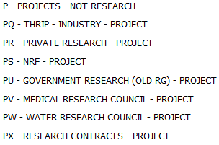 | - Accounts with surplus distribution. The P in front for Project accounts - Profit sharing is allowed. | 3/5 | General info:  - These account types are no longer in use. The Account Contribution field replaced the purpose of these account types.  - Previously the P-Accounts were used to identify profit sharing accounts.  - There are still 3P-accounts used by departments, but they will phase out.  - Please note: The P-accounts will still be listed in the drop-down list for history and reporting purposes.  - Please do not use these account types anymore when applying for new accounts.
23 |  | - Funding received from the Industry partner for research conducted as a partnership between the NWU, NRF and Industry. | 3 | General info:  - THRIP awards together with the 2ST-account.  - The 2ST-account is the NRF amount (SOF2), Q is the Industry partner’s contribution to the research project (SOF3).  Attachments:  - Attach the THRIP award letter or contract as supporting documentation.
24 |  | - Research funded by a grant to enhance University’s skills - deliverable to the Industry. | 3/5 | General info:  - Research funded by a grant to enhance University's skills.  - Main purpose is research, not service delivery.  - Funding is in the form of a grant/award or contribution - not payment for services rendered.  - Contracts/invoices apply and the result is a deliverable to the Industry.  - The contract must be signed.  - The contract will specify the duration/period of the project.  Attachments:  - Attach the complete, final signed contract/agreement or grant letter as supporting documentation.
25 |  | - Research funded by a grant (similar to donations) to enhance University’s skills. No contracts or deliverables to Industry. Industry/Individual may request recognition. | 3/5 | General info:  - Research funded by a grant (similar to donations) to enhance University’s skills.  - No contracts or deliverables to Industry.  - Industry/Individual may request recognition.  - Funding is for research - not a formal contract - maybe a letter.  - There is no grant conditions - not for specific research purposes.  Attachments:  - Attach the award letter as supporting documentation.
26 |  | - All National Research Foundation (NRF) research awards. Including Thuthuka, Rated Research, etc. | 2 | General info:  - Research awards from the National Research Foundation (NRF).  - The account name must always consist of the UID & Reference number as stipulated on the letter.  Attachments:  - Attach the NRF award letter and the conditions of grant as supporting documentation.  Standard format example for 2S-accounts:  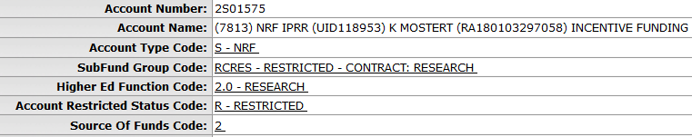
27 |  | - National Research Foundation (NRF) awards for student bursaries. Awarded for student running expenses calculated based on subsidies received (subsidy: Staff Discount, Registration Subsidy, Accommodation Subsidy & Study Subsidy). | 2 | General info:  - Student bursary awarded by the National Research Foundation (NRF).  - These funds are transferred to the study leader for the specific student’s running costs. It may be used for: small equipment, materials and supplies, data collection, site visits and technical assistance for specialised skills.  - The account name must always consist of: The Grant UID number, student’s surname and initials (student number) and study leader’s initials & surname.  - These funds must also be spent in the current financial year and unspent funds will be returned to the NRF.  Attachments:  - Attach the NRF student award letter as supporting documentation.  Standard format example for 2SS-accounts:  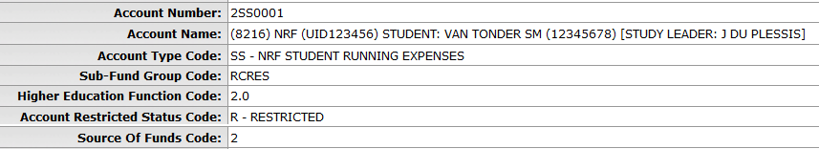
28 |  | - All National Research Foundation (NRF) Thrip research awards. | 2 | General info:  - The THRIP awards from the National Research Foundation (NRF).  Attachments:  - Attach the NRF award letter and the conditions of grant as supporting documentation.
29 | 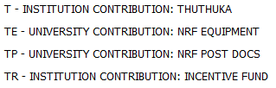 | - T - NWU’s contribution to NRF Thuthuka research funding.  - TE - NWU’s contribution to NRF Equipment funding.  - TP - NWU’s contribution to NRF PostDocs funding.  - TR - NWU’s contribution to NRF Rated Researcher’s Incentive funding. | 1 | General info:  - The University’s contribution (SOF 1) to a NRF award.  - Apply for an account if stipulated on the award letter, for example:  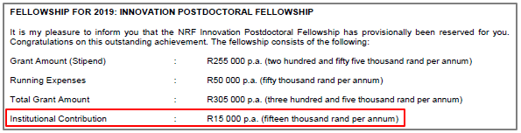  Attachments:  - Attach the NRF award letter and the conditions of grant as supporting documentation.
30 |  | - Research supported by government departments e.g. DSI or DTI. | 2 | General info:  - Government Departments e.g. DSI ~ Department of Science and Innovation or DTI ~ Department of Trade and Industry.  - Make sure the funds are received directly from the government department and not through another institution.  - If the funds are received from another institution, the account type will correspond with funding from that institution.  Attachments:  - Attach the complete, final signed contract/agreement as supporting documentation.
31 |  | - Medical Research Council (MRC) research awards. | 2 | Standard format example for 2V-accounts:  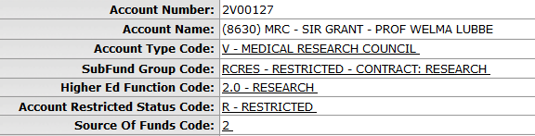  Attachments:  - Attach the MRC award letter and/or contract as supporting documentation.
32 |  | - Water Research Council (WRC) research awards. | 2 | Standard format example for 2W-accounts:  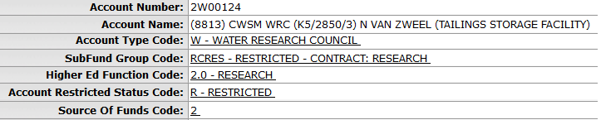  Attachments:  - Attach the WRC award letter and/or contract as supporting documentation.
33 |  | - Service delivery - but research needs to be done in order to deliver the result to the Industry. | 3/5 | General info:  - Service delivery is the main purpose.  - The request is to provide a service - not to do research.  - Research is only an aspect of the services rendered. Research is not the main goal.  Attachments:  - Attach the complete, final signed contract as supporting documentation.
34 |  | - Human Sciences Research Council research awards. | 2 | General info:  - HSRC is an entity of the Department of Science and Innovation (DSI).  Attachments:  - Attach the award letter and/or contract as supporting documentation.

- Attachment examples applicable to certain Account types:
- 3C – Short Courses (SCAS approval letter)

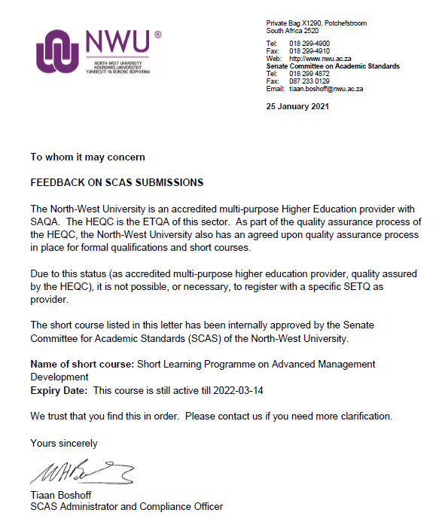

- 1D - Subsidised Research - Postdoctoral Fellowship award letter
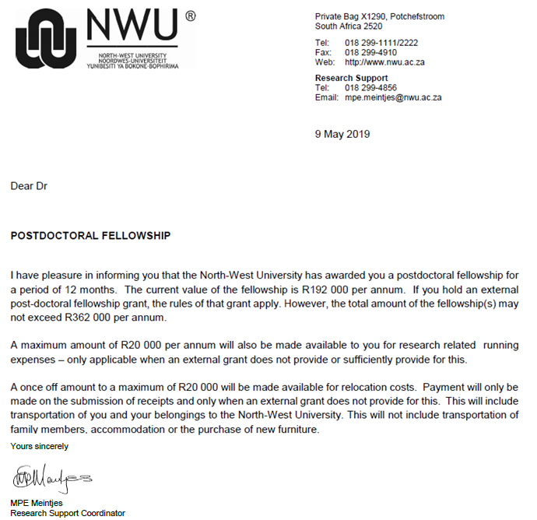

- 1DA-1DD Accounts – Award letter
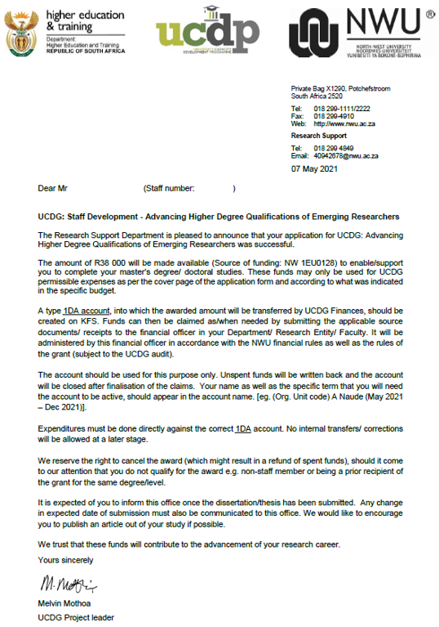

- 1EG & G - Physical Infrastructure: Project activation letter
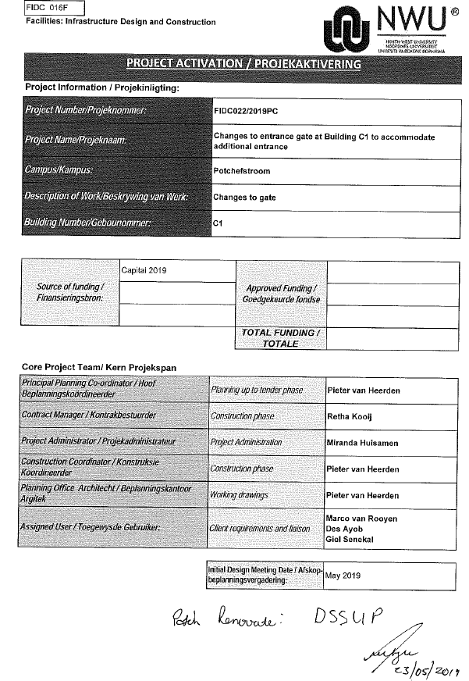

- 1K - IREA Staff: Extraordinary appointment letter
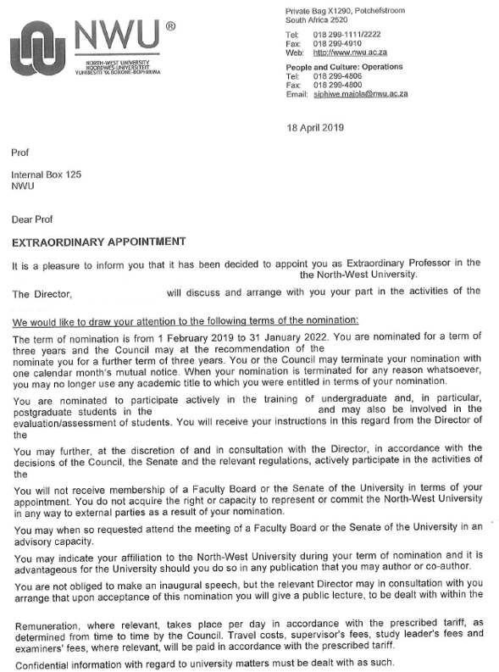

- 2S – NRF award letter

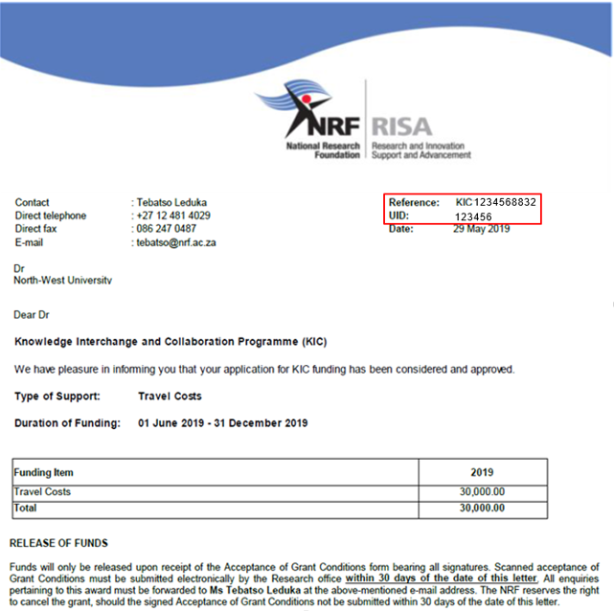

- 2SS – NRF student running expense award letter

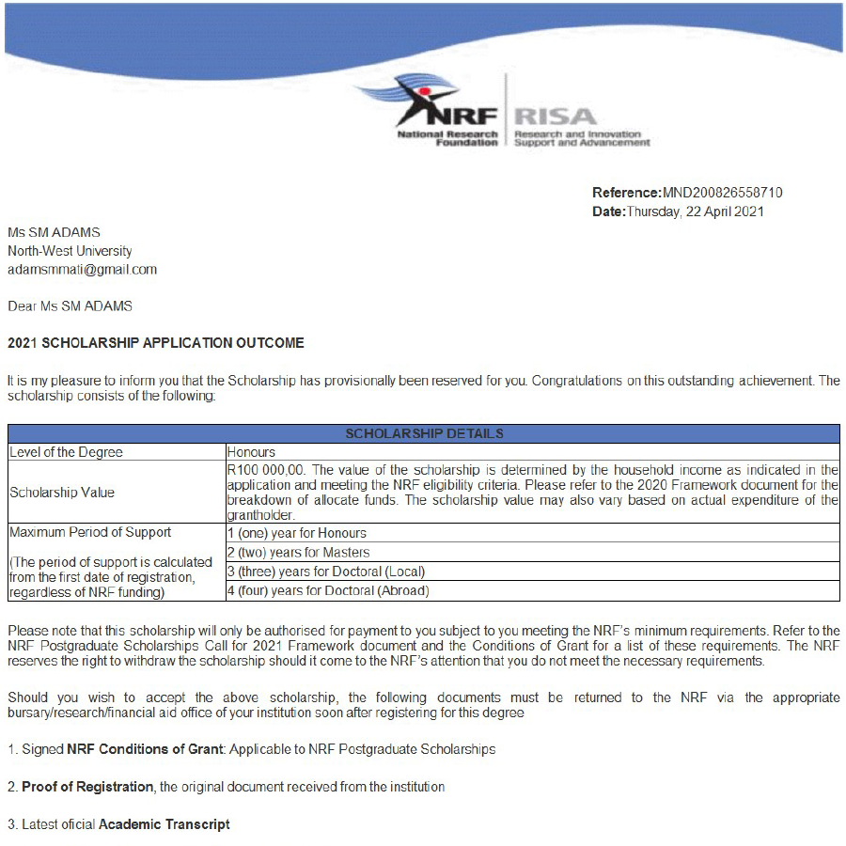
MND123487777777

- 3Q – THRIP award letter
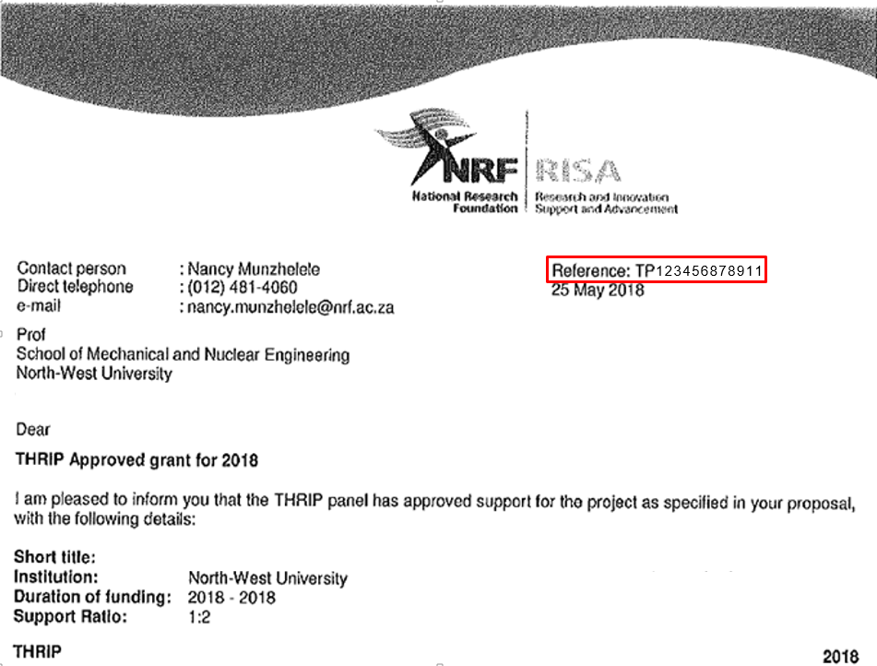

- 2V – Medical Research Council (MRC) grant letter or contract
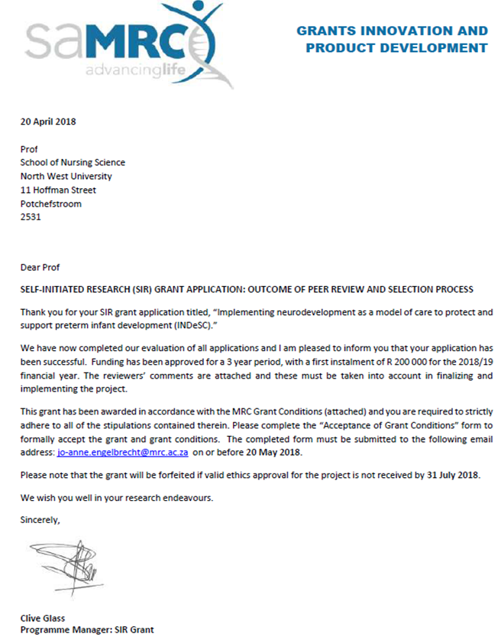

- 2W – Water Research Commission (WRC) grant letter or contract
