Chart of Accounts (COA)
Closing of Accounts
Document Summary
Product Owner / Author | Antonet Müller
Editor Name | Chimoné Barends
Date | 2023/07/11
Time | 12:00 PM
Template | Verbose

Lesson Objectives
On completion of this lesson you should be able to:
- Understand the process of closing an Account

Lesson Scenario
- As an existing staff member of the NWU you are required to work through this lesson, make some notes if necessary and print out the documentation as a guideline.
- This lesson will teach you the process of closing an Account.

Lesson Prerequisites
- You need to be a NWU staff member that is registered on KFS as a user.
- You need to understand that you have a responsibility towards the financial reporting of your department and the university to ensure that all transactions comply with the rules and regulations.
- Your duties in your department require of you to process transactions in GL as well as maintaining your Accounts in KFS, which includes closing Accounts. In order to do so, you need to understand the process of closing Accounts in KFS.

Table of Contents

- Getting a list of my Accounts
- Running GL reports to determine balances per Account
- GL transactions to clear any balances
- Transactions from sub-systems
- Request the closing of the Account

Getting a list of my Accounts

- KFS report COABI002 provides you with a list of Accounts per Organisation. Included in this report are an “Account Date To” and a “Closed Indicator” that you will need to determine which of your Accounts are closed and which are still active.
- You may also use COABI001 – the Excel version of COABI002.
- COABI004 can also be used if you prefer this format. It has all the necessary information as well as a lot of additional information. This additional information that COABI004 has to offer will however not be needed for the purpose of closing Accounts.
- To get a list of your Accounts and to check which of them are active or inactive, we recommend COABI002.

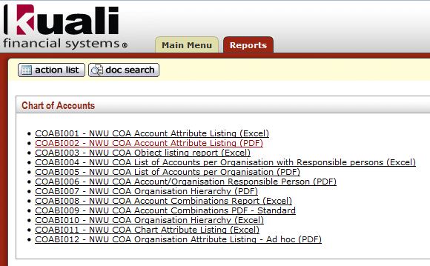
Figure 1
1. | Select COABI002 from the Reports tab in KFS.
2. | Complete the Input Controls: At least Chart and Organization need to be selected. Please note: If you have more than one Organization, you have to select all of them together with the correct Charts.  Depending on the Chart(s) and Organization(s) you choose, the Account Groups will include the entire hierarchy that reports to these organization(s). Therefor please ensure you select the correct data.  If you choose for example the OU for a Faculty, the Account Groups will already include the entire Faculty – it is therefore not necessary to choose all the OU codes manually for the Faculty. If you are responsible for more than one OU and they do not report in the same hierarchy – then you need to select both OU’s.
3. | Click on Apply to run the report.

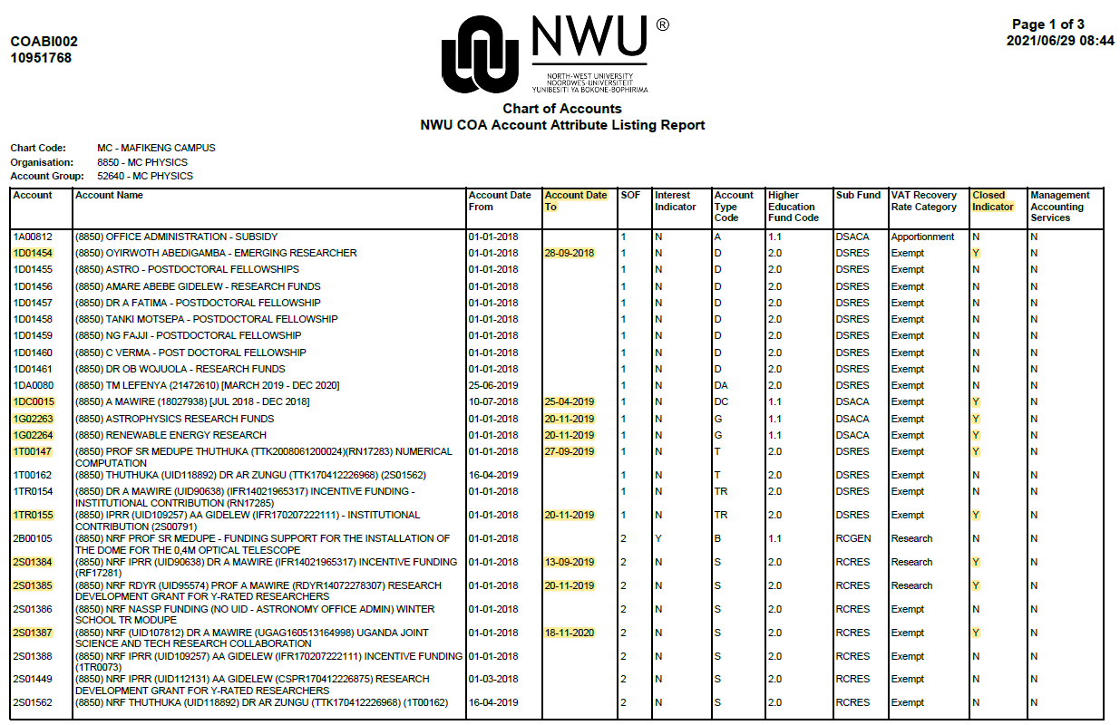
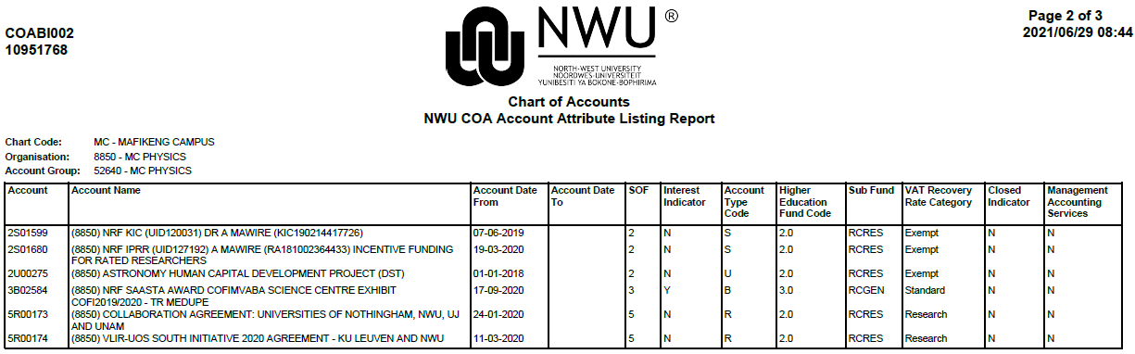
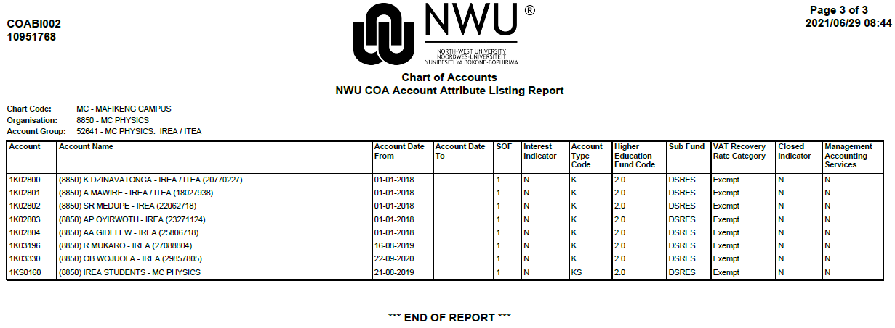
Figure 2
1. | The report will consist of a list of Accounts that reports to the organization(s) that was chosen in the IC’s (Input Controls).
2. | For each Account the “Account Date To” and “Closed Indicator” are also displayed. Only when there is a date in the “Account Date To” column AND the Closed Indicator is Y (YES) the Account was successfully closed. If either of the two fields does not meet the requirements, your Account is NOT closed yet. In the example in Figure 2 (above) all the accounts marked in yellow are closed.

- You now have a list of all your Accounts in the Organization(s) chosen.
- Ensure that you run this report for all your Organizations if you are responsible for more than one.

- Running GL reports to determine balances per Account

- You now have to run the GL reports to check the balances and determine if any Accounts can be closed.
- If an Account has zero balances, it will not reflect in the GL reports. You have to check the GL report against the COA report to ensure that Accounts not listed on the GL report are either already closed in the COA report or they are new Accounts with no balances yet. Older Accounts with no balances need a closer look.
- If there are any Accounts not listed in the GL report and it is not a new Account and not closed yet in COABI002, it means that all the funds were used but the Account were never closed or there were never any transactions. Unless there is a valid motivation why it cannot be closed yet, you have to inform GRT (Governance, Reporting and Treasury) to close these Accounts. (Procedure to follow). Even if an Account has zero balances, the Account is still active until you request GRT to close the Account.
- The easiest way to check your Accounts are to compare COABI002 and GLBI014. GLBI014 consists of a list of Accounts in the organization(s) requested, indicating the balances for these Accounts in one summarized line per Account. You may also use GLBI004 - it gives a summary of all objects per Account.

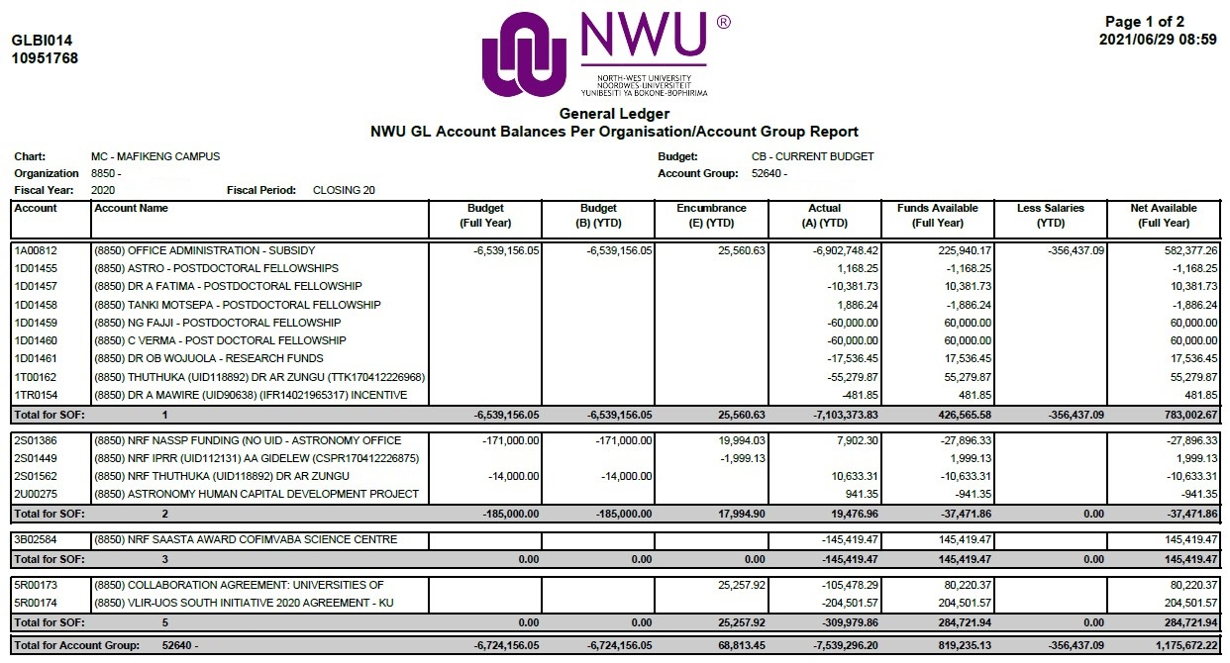
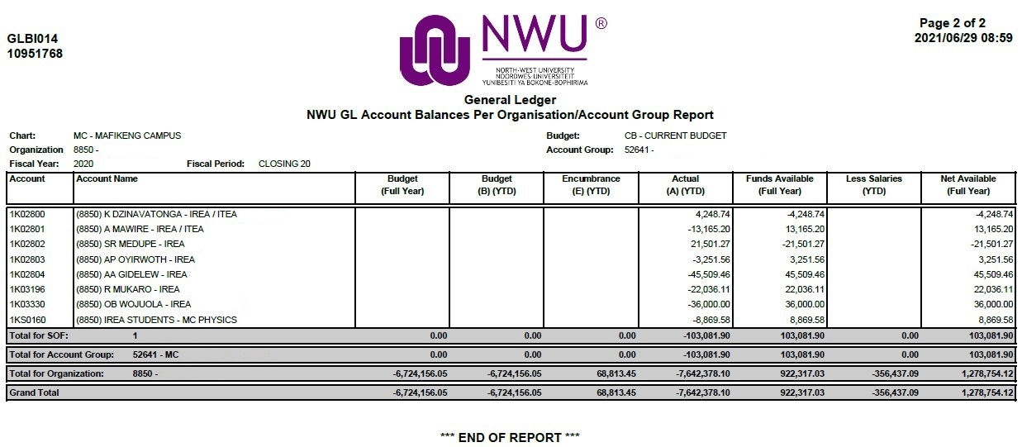
Figure 3
1. | Select GLBI014 (or GLBI004) from the Reports tab in KFS.
2. | Complete the Input Controls.  Please note: It is very important to make sure that you select the same organizations as in COABI002. GLBI014 has an option to include the hierarchy. That means that if you include the hierarchy, other organizations that report to the one requested, will also be included, while COABI002 include the hierarchy in the Account Group Input Control. Please ensure that you compare the same organizations in both the reports and that it includes all the organizations that you are responsible for.
3. | Click on Apply to run the report.
4. | The report provides you with a list of Accounts and their balances. You now have to work through the list to determine which Accounts are no longer active/needed and can be closed. GLBI004 gives more detail per Account than GLBI014 – if you prefer that.

- GL transactions to clear any balances

- Possible cases of Accounts that can be closed may include:
    - Accounts that only have small balances and there are no more transactions taking place. You may apply for a reserve account to journalize these balances to.
    - Accounts that may have been cleared (no balances), but not yet closed in KFS.
    - Accounts from projects or contracts that have been completed.
    - Accounts that are overspend.
- The importance of closing accounts:
    - Accounts may not be re-used for any other purpose than initially created for.
    - The implications of re-using accounts for any other purpose are that the assigned attributes (for example, centrally assigned coding, contribution, interest, VAT etc.) may lead to incorrect transactions or incorrect recording of transactions in the financial statements.
    - It is your responsibility to ensure that you use the account only for the purpose it was created for.
    - As soon as the purpose of the account has been achieved, the contract has ended and/or the project has been finalized, the account must be closed.
    - Accounts that are closed will still be available for queries in KFS as well as in the KFS reports.
    - By closing inactive Accounts, you simplify your Account structure for the effective management thereof.
- Some rules to remember:
    - SOF 1 – balances cannot be cleared to a SOF 3 reserve account, please use your 1A account or as indicated below per account type, where specific rules apply, for example regarding 1K or 1D accounts.
    - SOF 1 – funds may not be used to correct an overspending on a SOF 3 account.
    - SOF 2, 3 or 5 – balances can be cleared to a SOF 3 reserve account.
    - Only 1K- and 1KT-Accounts (NOT 1D-Accounts) may be closed off to 1KG-Accounts.
    - 1D-Accounts (other than Postdoctoral Fellowships & Emerging Researchers) can be closed off to a 1A-Account or 1G-Account.
    - 1D-Old Emerging Researchers Accounts: The remainder of the funds received from grants must be returned, please contact Janine Robert (x852071) or Tebogo Kgaile (x892490).
    - 1D-Postdoctoral Fellowship Accounts: After completion of the postdoctoral fellowship, the remainder of the funds received from the Research Support Office must be returned to 1G01487 (Completer: Heide Goedhals). Please contact Mpe Meintjes (x994856).
    - 1DA, 1DB, 1DC, 1DD: The remainder of the funds from UCDP grants must be returned, please contact Janine Robert (x852071) or Tebogo Kgaile (x892490).
    - Incentive funding for rated researchers (2S & 1TR-Accounts) may NOT be closed off to 1K / 1KS / 1KG / 1KT Accounts.
    - SOF 2 and 3 accounts may not be closed off to another SOF 2 or 3 account with an active contract or agreement.
    - SOF 2 and 3 accounts must rather be closed off to a reserve account. You may use these funds in the reserve account to correct overspending, pay bursaries etc.
    - Accounts (For example NRF) that must still be audited, may not be cleared per object and closed. NRF accounts that were already finalised and audited, can however be closed. If you are uncertain, please contact Johann du Plessis (x994854).
    - Please verify that you did not budget for future periods on accounts that you want to close.
- Pending transactions
- Please note: If there are any Pending transactions on the Account – it first needs to be finalised to create a transaction that must then be cleared in order to close the Account. The system does not allow an Account to be closed if there are any pending transactions.
- The General Ledger Pending Entry Inquiry should be used to check if there is any pending Entries. Ensure that all pending entries are completed or cancelled.

Figure 4
1. | Select General Ledger Pending Entry from the Balance Inquiries tab in the Main Menu screen in KFS.
2. | Complete the Chart and Account field and leave the Balance Type Code field empty to include all possible pending entries of all balance types. Select the Fiscal Period.
3. | Click on Search to run the Inquiry.
4. | The results can be downloaded in Excel – if there is any. Click on Spreadsheet at the bottom of the results.

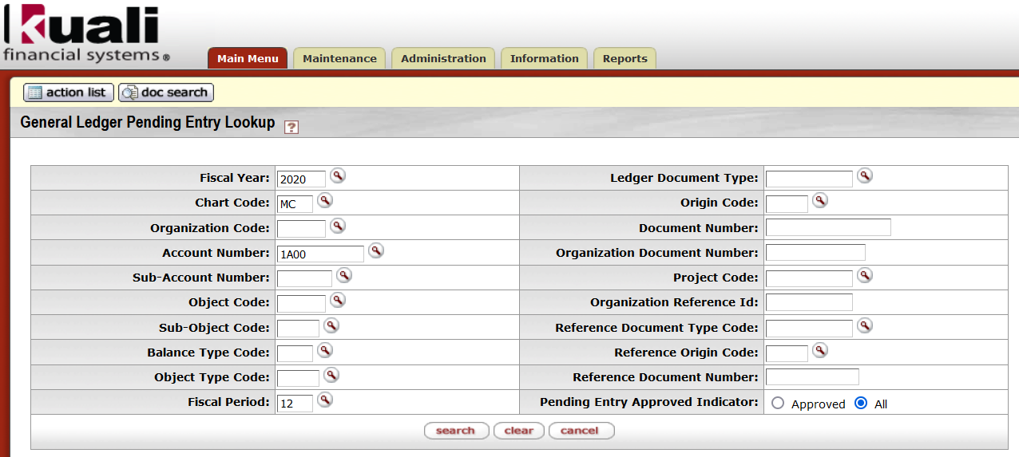
Figure 5
- Overspending
- If you want to close an account that is overspend
  - It is not necessary to first transfer funds to rectify the overspending.
  - You can just clear all the objects to an account that has enough funds to rectify the overspending. It must be the same SOF as far as possible.
  - The same closing procedures apply as for other accounts with an available balance.

- If you want to rectify an overspending:
- If the overspending is from the previous year, you must transfer funds via the fund object (reserves) (Object starting with an 8) on the “Transfers between Fund Objects (Type FB) (Fund Balances)” form available at http://services.nwu.ac.za/kfs-module/general-ledger-gl under the heading “Administrative Transactions >> Financial Processing >> Journal Voucher”.
- If the overspending is in the current year, you must transfer funds via the “TF – Transfer of Funds” document.
- Overspending must be rectified from the same Source of Funds (SOF) as far as possible.

- If you identified Account(s) that can be closed, but it still has balances, you need to do GL transactions in order to clear the balances and close the Account.
- Run report GLBI004 in order to get the Summary Report of the identified Account(s) – to determine which objects still have balances.
- Example: The Account below needs to be closed but there are still Budget, Encumbrances and Actuals. In order to close the Account, the balances on the objects need to be cleared. Guidelines are given below on forms or doc types to be used in the process.

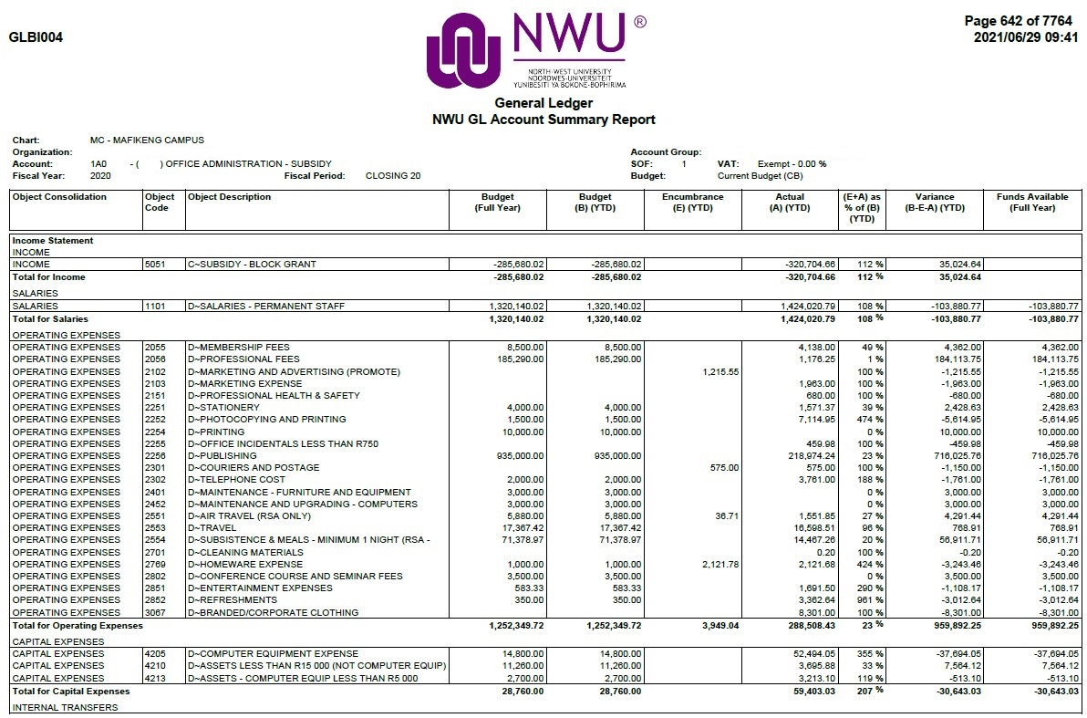
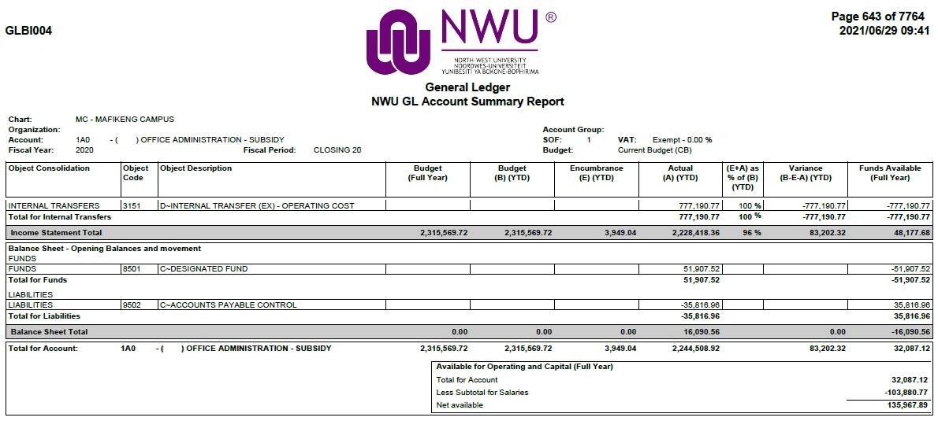
Figure 6
- The Account must have zero balances per object - all balances must be journalized to a continuation Account. If not, the system does not allow the Account to be closed. A continuation Account is the account where transactions will post if perhaps another transaction goes through. If there is no continuation Account - please use the 1A of the relevant OU.
- If an Account cannot be cleared per Object due to reporting and/or audit purposes, you will not be able to close the Account in the same year that you still have to report on it. You may clear it on the bottom line (in total) with a journal on the Fund Object. The Account will however not be finally closed yet. The continuation account is entered as well as a temporary end date. After the balances have been carried forward to the following year (during April), only then can the Account be finally closed if all Objects have zero balances.
- Please note: In the process of closing Accounts and writing journals to clear balances, there should not be any VAT transactions. As Initiator of the E-doc, you will not be able to make any changes to the “* Calculate VAT” field on the GL documents.
The FIN Approver has the access to change “Yes” to “No”. Closing an Account is a valid reason why VAT should not be calculated; therefore, you should request the FIN Approver to change the calculation of VAT to “No”. The VAT was handled in the initial transaction and should not be claimed or paid again. Add a note to the Explanation field and/or Notes and Attachments Tab where you request the VAT to be changed to “No".
- If the Account still has any of the following balances / transactions, please follow the guidelines below (the coloured arrows refer to Figure 6):

  - Budget
  - Please note: If there is any Budget on the Account/Objects – please request a Budget Adjustment in order to move the budget to a continuation Account to be able to close the Account.
  - Contact: Farai Chingono (x103102) or Tharien Claassen (x103151).
  - Please also verify that you did not budget for future periods on accounts that you want to close.

  - Encumbrances
  - Please note: If there is any Encumbrances on the Account – the Encumbrance first needs to be finalised to create an Actual transaction.
  - Open PO’s: Request Andrew Fouché (x994532), Elsa Petersen (x852844) or Sonia Mosetlhi (x852843) to close open PO’s where possible.
  - Encumbrance queries in GL: Please contact Marí van Bosch (x994832).
  - Request GLBI011 or GLBI012 for a Detail Report on the outstanding encumbrances. In the example in Figure 6 there were 4 encumbrance amounts. Report GLBI011 / 012 will indicate the detail of these encumbrance amounts as in Figure 7 below (Please note: some detail (numbers/names) were removed for privacy purposes).

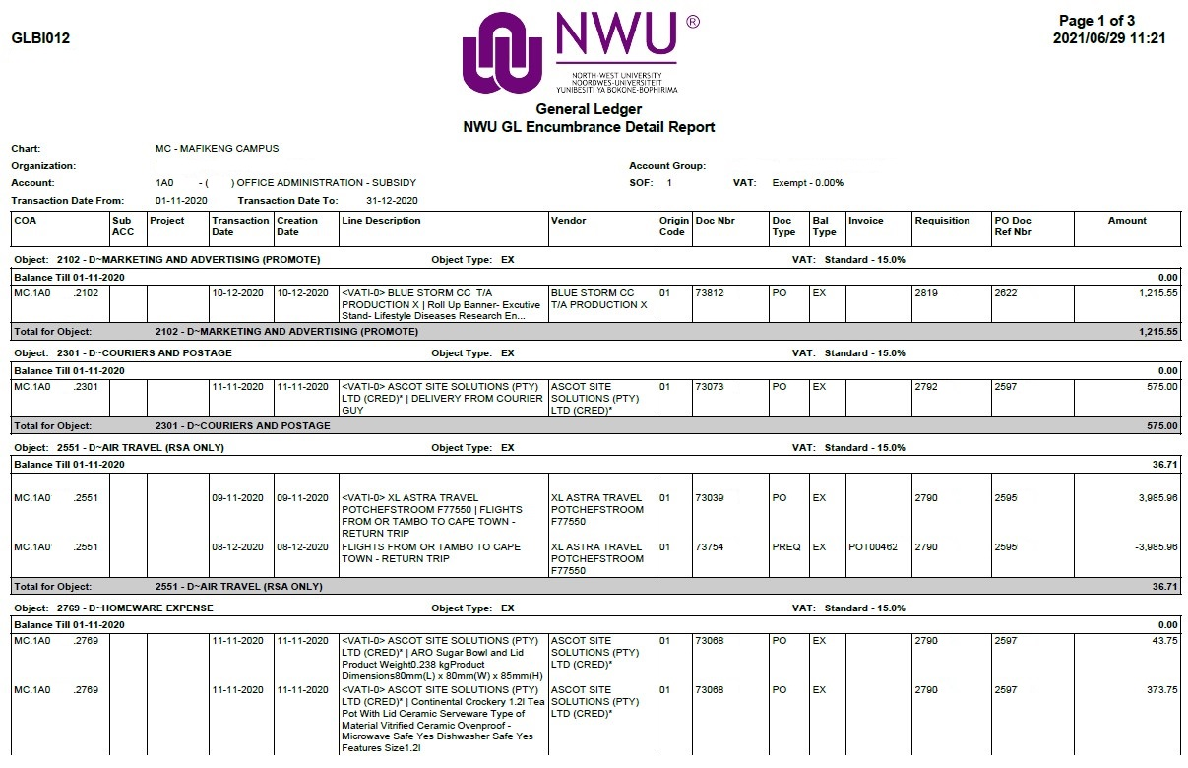
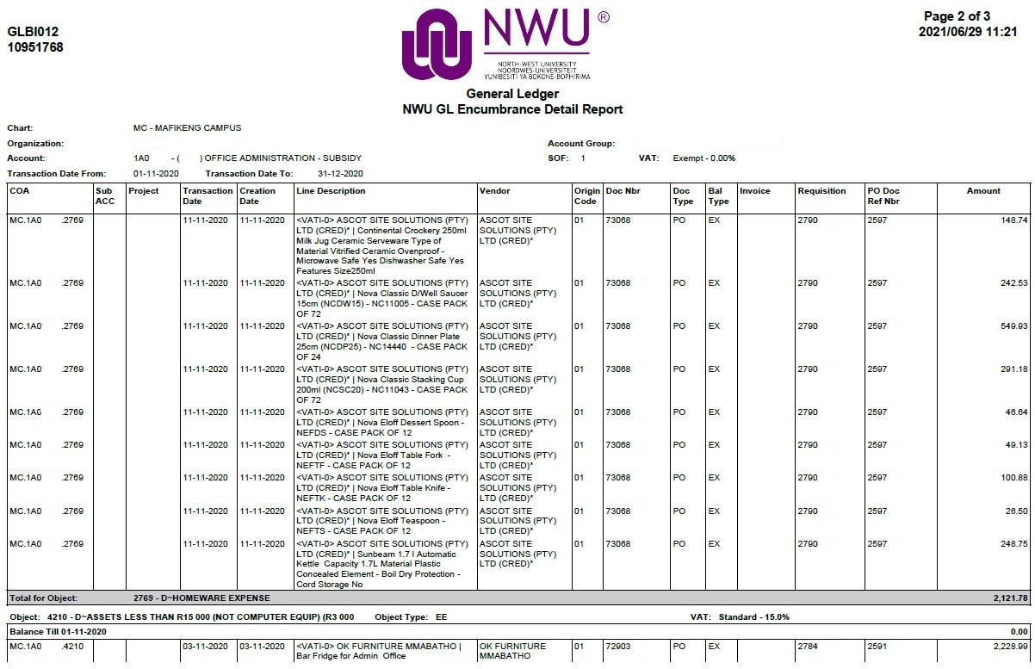
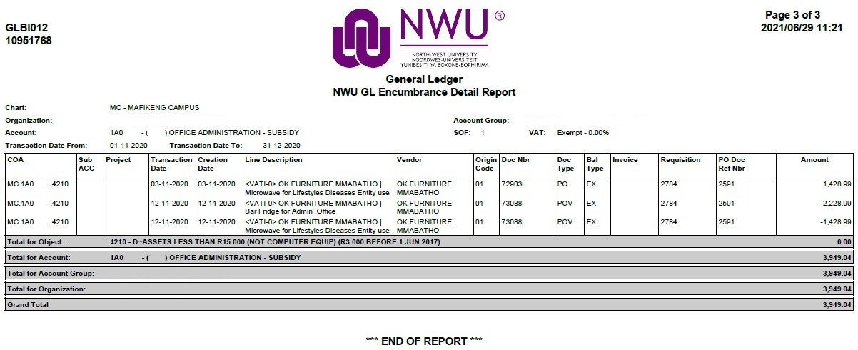
Figure 7
  - The Open Encumbrance Inquiry in KFS should also be used to check if there is any outstanding Encumbrances. Ensure that all outstanding Encumbrances are completed or cancelled – otherwise the Account cannot be closed.
Figure 8
1. | Select Open Encumbrance from the Balance Inquiries tab in the Main Menu screen in KFS.
2. | Complete the Chart and Account field and remember to choose to include ALL pending entries.
3. | Click on Search to run the Inquiry
4. | You need to check every Fiscal Year for Open Encumbrances.
5. | The results can be downloaded in Excel. Click on Spreadsheet at the bottom of the results.

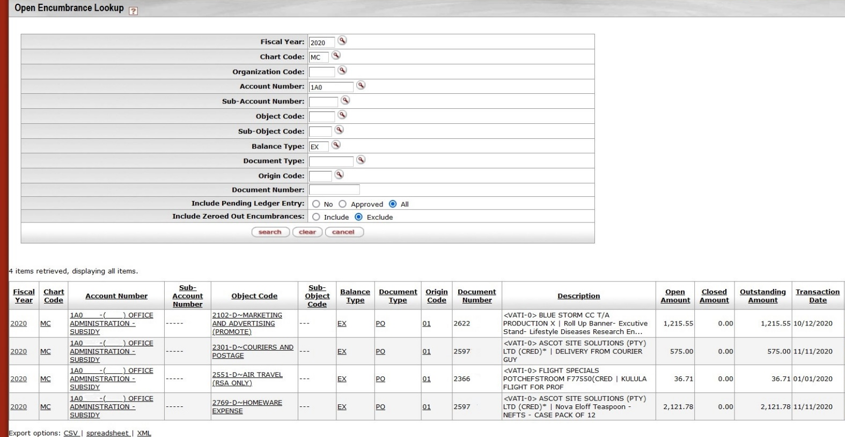
Figure 9
Actual balances:
  - Income and Expenses (Objects starting with a 2, 3, 5 or 6)
  - All Income and/or Expenses needs to be cleared. The DI (Distribution of Income and Expense) must be used for the purpose of moving income and/or expenses to the continuation Account. The same Object type (per amount) must be used in “From” and “To” – for example from an Income object in Account A, to an Income object in Account B.
  - Some object sub-types are not allowed to be used in the DI – please refer to the DI manual on the KFS website. For any objects (except for the Fund / Interest / Salary objects) that cannot be cleared via the DI, you must use the
    - RJV (Restricted Journal Voucher) or the
    - TF (Transfer of Funds) – for Internal Transfer objects.
      - The only time that the same object will be used in the FROM and TO sections of a Transfer of Funds, is when you are closing an account.

  - Assets (Objects starting with a 4…)
When a KFS account should be closed and capital expenditure (assets, 4-series objects) are reflected on the KFS Summary report during the current fiscal year, the following processes must be followed:

1. Determine to which account the assets must be transferred.
2. Extract both a KFS Summary (GLBI004) and Detail report (GLBI002) for the account from which the assets must be moved to identify the individual assets affected.
3. Determine the individual KFS asset numbers (all objects except 4210 and 4213) that are affected.
4. Should items have been purchased on objects 4210 and 4213, liaise with Lizette Williams to obtain the relevant KFS Asset numbers.

NB:
A GEC and a DI cannot be created to move the assets to the new KFS account as the GEC and DI does not generate GL entries for objects 4211 (Capitalization of Fixed Assets) nor the 7-series objects for the capitalization of the asset(s) that was purchased. Furthermore, the accumulated depreciation of the asset is not amended.

An Asset OU Transfer (AT) only amends the capitalization objects (7-series) and accumulated depreciation objects of assets, but not object 4211.

For all asset object codes except 4210 and 4213

1. Submit a JV to Marí van Bosch moving each asset individually by creating a new line for each asset’s respective amount as per the KFS Detail report.
The sum of all the accounting lines for that object must match the amount on the Summary report.

For this JV, use the “Journal Voucher - Finance” form available at http://services.nwu.ac.za/financial-systems/general-ledger-gl
under the heading “Administrative Transactions >> Financial Processing >> Journal Voucher”

Debit: New KFS account to which the assets must be moved
Credit: Current KFS account from which the assets must be moved

2. GRT-CAM will submit an Asset OU Transfer (AT) on KFS for each individual asset to correct the OU code of the assets.

In the case of assets moving across charts (e.g. MC to VC):

3. GRT-CAM will submit an additional JV to correct the chart capitalization for object 4211 per asset individually.

For asset object codes 4210 and 4213

1. Submit a JV to Marí van Bosch moving one amount per month according to the KFS Detail report.
Example:

Line 1: 895.00
Line 2: 20 084.75 – 327.47 = 19 757.28

The sum of all the accounting lines for that object must match the amount on the KFS Summary report.

Debit: New KFS account to which the assets must be moved
Credit: Current KFS account from which the assets must be moved

The VAT Indicator for the JV must be set to NO.

In the case of assets moving across charts (e.g. MC to VC):

2. GRT-CAM will submit an additional JV to correct the chart capitalization for object 4211 as well as the corresponding capitalization object (7-series) per asset individually.

3. GRT-CAM will correct the KFS asset totals via Manual Payments (MPAYS) (if the asset has already been created on KFS, if not – no MPAYS are required).

  - Salaries on Accounts (Objects starting with a 1…)
  - Actual amounts on the salary objects needs to be journalized to a continuation Account.
You need to complete the GL Payroll Journal Request form. The form is available at http://services.nwu.ac.za/kfs-module/general-ledger-gl under the heading “Administrative Transactions >> Financial Processing >> Journal Voucher”. After completion, please send the form to Corene Flemming via email.
  - Contact People and Culture (HR Admin) to update changes on the HR system – refer to page 16 “Transactions from sub-systems”

  - Balance Sheet transactions (Objects: 7701, 7703, 7501, 7982 and 9502)
  - Please note: If there is Balance Sheet transactions on the Account – the transactions need to be finalised on the specific Account; for example, debtors (7501), creditors (9502), staff prepayments (7701) and vendor prepayments (7703). These transactions cannot just be moved to a continuation Account. Others like petty cash (7982) can be moved, but you need to inform Belinda Bosch (x852617).
  - Balances on Fund Objects (Objects starting with an 8…)
  - ALL other objects must be cleared before you send the journal for clearing Fund objects.
  - You can transfer funds via the fund object (Reserves) on the “Transfers between Fund Objects (Type FB) (Fund Balances)” form available at http://services.nwu.ac.za/kfs-module/general-ledger-gl under the heading “Administrative Transactions >> Financial Processing >> Journal Voucher”
  - Send the journal form to Marí van Bosch.

  - Internal Interest on Accounts (Objects: 3551 & 5805 - Internal interest paid / received - NWU)
  - ALL other objects must be cleared before you send the journal for clearing Internal Interest.
  - You can transfer Internal Interest on the “Journal Voucher - Finance” form available at http://services.nwu.ac.za/kfs-module/general-ledger-gl under the heading “Administrative Transactions >> Financial Processing >> Journal Voucher”
  - Send the journal form to Marí van Bosch.

- Transactions from sub-systems

- When an Account needs to be closed that has any of the following types of transactions, you also need to inform the contact persons listed below to make the changes in the relevant systems – otherwise the transactions will keep being posted to the Account that needs to be closed and will cause continuous clearing of transactions.

    - Salaries
If there are still active salary payments on the account(s), send an e-mail to the following colleagues at People and Culture (HR Admin) to update the changes on the system:
    - Permanent Payroll to Supervisor Karen Coertzen and Quality Officer Sonja Nothnagel.
    - Temporary Payroll to Supervisor Nadia Botha and Quality Officer Mary Mphore.

- Request the closing of the Account
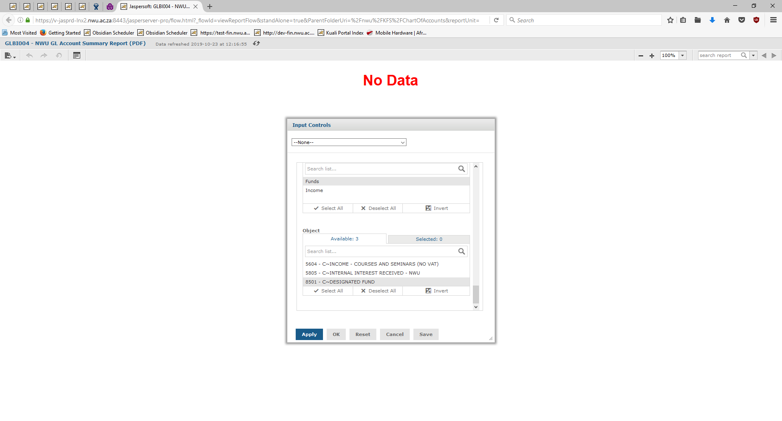
Figure 10
When all the objects for an Account have zero balances (GLBI004 = No Data / blank page - Figure 10 above):

- Please send an email to Chimoné Barends requesting her to close the Account.
- Provide the continuation Chart and Account number (the Account where the balances were journalized to).
- The Account and all its combinations will then be closed.

Lesson Summary
Having completed this lesson, you should be able to:
- Understand the process of closing Accounts
- Manage your Accounts more effectively

