AP Vendors

Document Summary
Product Owner | Frikkie Venter
Editor | Chimoné Barends
Date | 2014/12/01
Time | 10:00 AM
Template | Verbose

Lesson Objectives
On completion of this lesson you should be able to:

- Navigate to the Vendor (VND) in KFS
- Know the process to create a new Vendor
- Know how to create banks for Vendors in PDP
- Know how to change personal information of Vendor
- Know how to make a Vendor inactive
- Know how to create a division
- Know how to make an inquiry on a Vendor

Lesson Scenario
- As an existing staff member you will be able to create a Vendor.
- You will also be able to attach relevant documentation and be able to submit Vendor e-doc in order for it to route for final approval.

Lesson Prerequisites
- You need to be a NWU staff member that is registered on KFS as a user.

Table of Contents

- How to manage a Vendor
  - Business rules
- How to create a new Vendor
  - Navigation to Vendors
  - Create a new Vendor
  - General and Corporate Information
  - Vendor detail information
  - Vendors address information
  - Vendor contact information
  - Submit Vendor
  - Route log for Vendor Creation
  - Navigation to Pre-Disbursement Processor to create Banks
  - Payee ACH Lookup Screen
  - Create new bank information
  - Submit to create banking details
  - Search for existing bank details
- How to change personal information
  - Navigate to Vendor lookup
  - Old and new information for editing
- How to make a Vendor inactive
- How to create a division
- How to make an inquiry on a Vendor
- Frequent asked questions

How to Manage a Vendor

Business rules

- The KFS Vendor module allows users to create and maintain a Vendor table to track businesses or other entities your institution has done or plans to do business with. Each record in this table maintains all information pertinent to a vendor, including tax ID, addresses, contacts and other details required for the management of your institution's procurement process.
- The Vendor module also provides a lookup function that allows the Purchasing/Accounts Payable user to quickly identify vendor contracts by description, by vendor, and even by payment terms.
- Finally, this module provides maintenance e-docs that allow users to update the Vendor attributes used in Vendor records.
- End-users are allowed to initiate a Vendor, no KFS role needed.
- In case of Individuals birthday and Id number is compulsory.
- Employees are not created as Vendors but are created in the Administration Menu as persons where employee personal information is maintained.
- Disbursement Voucher and Prepayment Disbursement Voucher can be used to pay both a DV and a PO Vendor. In the case no Po number can be used.
- Purchase Orders can only be created against a Purchase Order Vendor and not against a Disbursement Voucher Vendor.

- How to create a new Vendor

  - Navigation to Vendors

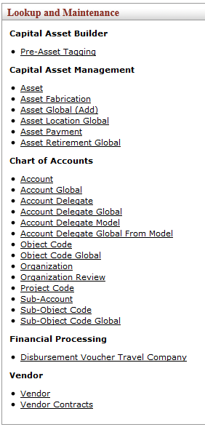
Figure 1

1. | KFS navigation: Main Menu > Lookup and Maintenance > Vendor
  - Create a new Vendor
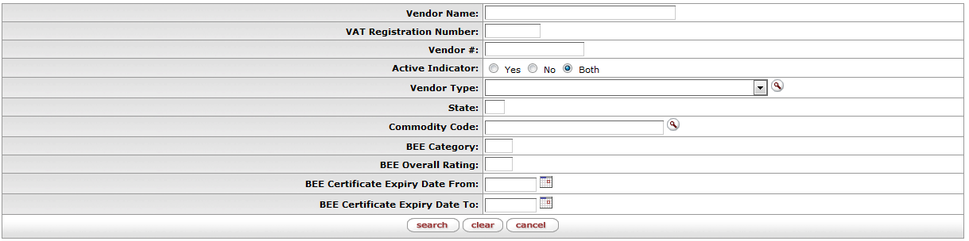
Figure 2

1. | Click on the button.

  - General and Corporate Information

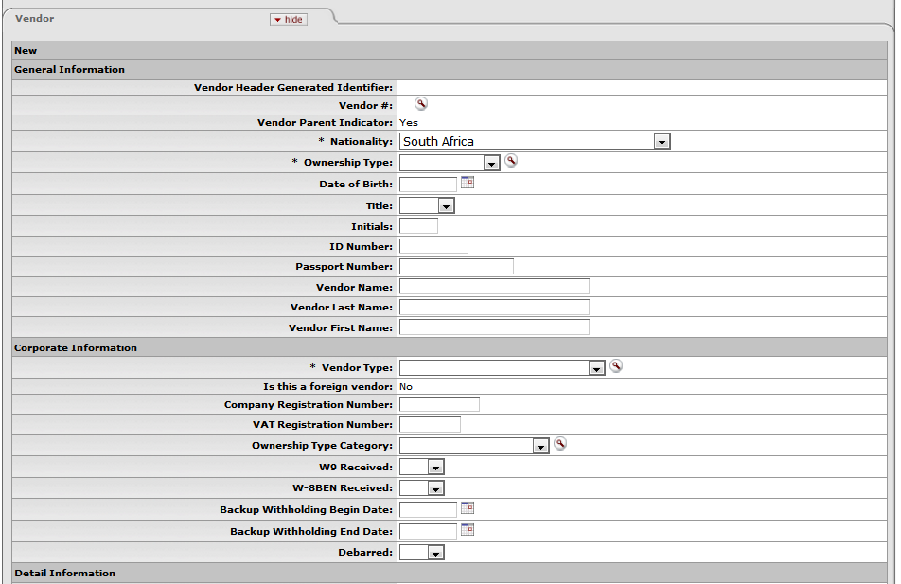
Figure 3

1. | No need to complete the Description field.
2. | Complete the Vendor Name field if it is a Company.
3. | Complete the Vendor Last & First Name field only if it is an Individual. In case an Individual Date of Birth, Title, Initials, Id Number must be completed.
4. | Navigate to Vendor Type and search or select the Vendor from the drop-down list for example PO - Purchase Order.
5. | Complete the VAT Registration Number if applicable-vat number will be validated for correctness, when the e-doc is submitted.
6. | Select the Ownership Type Category from the drop-down list for example Company.

  - Vendor Detail Information

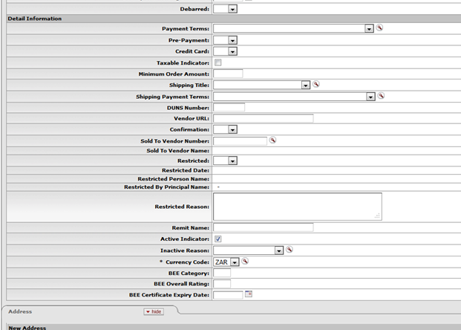
Figure 4

1. | Complete the Payment Terms field by selecting payment terms from the drop-down list.
2. | Taxable Indicator - the tick must be on if the Vat Registration nr is applicable.
3. | Complete the fields for BEE Category, BEE Overall Rating and BEE Certificate Expiry Date if applicable.

  - Vendor Address Information

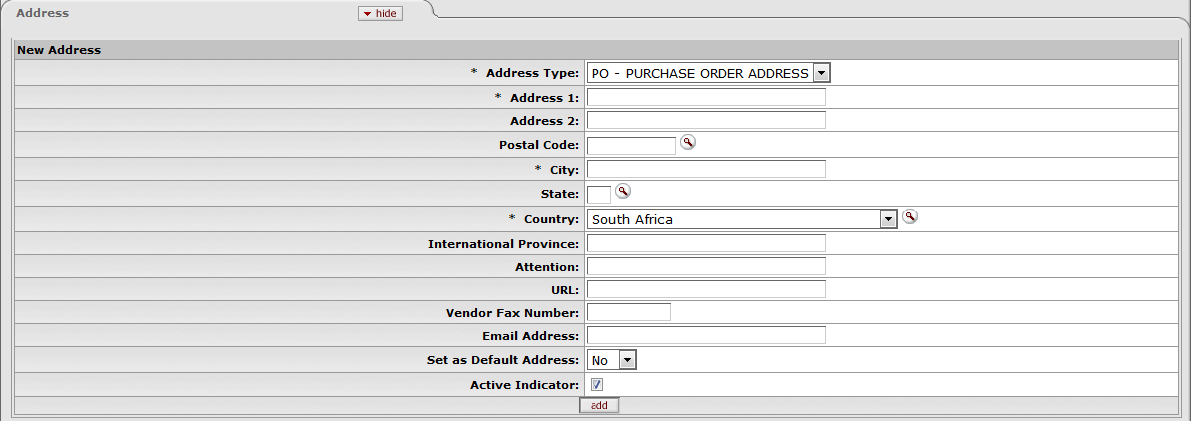
Figure 5

1. | Select Address Type from drop-down list, for example PO – PURCHASE ORDER ADDRESS.
2. | Complete Address 1.
3. | Select Postal Code from drop-down list, City and State must default automatically. The Country will default to South Africa.
4. | Complete Vendor Email Fax Number/Email Address and select yes from drop down list for default address.
5. | Click on add to add the address information.

  - Vendor contact information

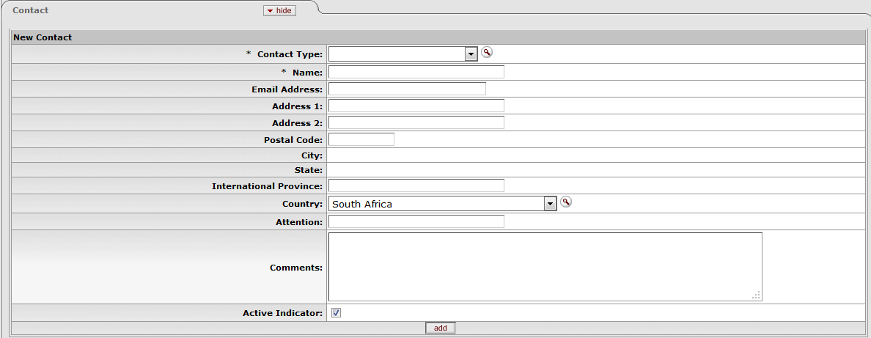
Figure 6

1. | Select Contact Type from the drop-down list.
2. | Complete the Name of the Contact Person and fields for Email Address, Address 1 and Postal Code.
3. | Click on add to add the contact information.
4. | The field for new phone number will open, complete the fields and click on add.
  - Submit Vendor
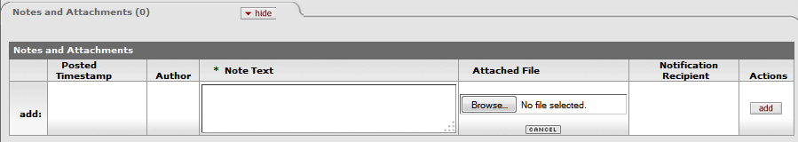
Figure 7

1. | Click on Notes and Attachments (0) to attach relevant documentation (banking details etc.) and then submit if all the fields are completed a message will appear – successfully submitted.

2.7.1 Creation of Vendor Number
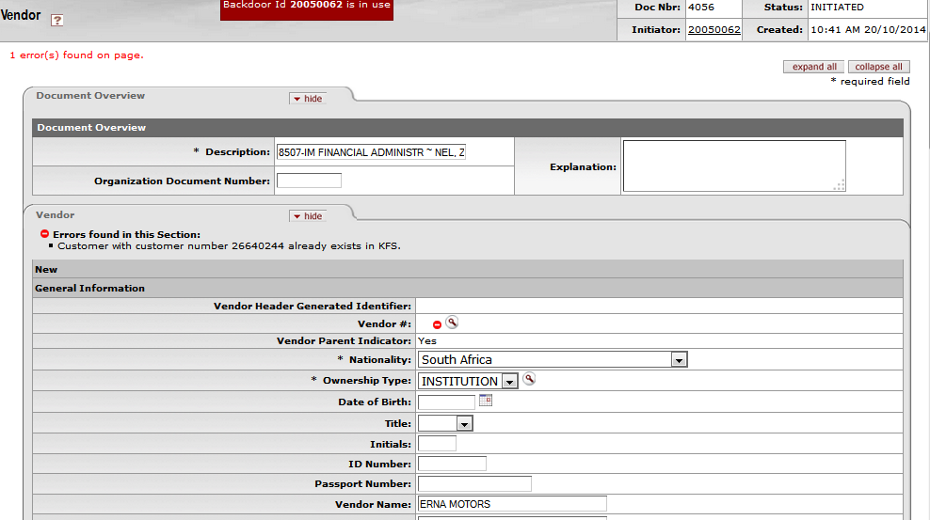
Figure 7.1

1. | If you click on submit and it is not an existing Vendor, a new number for the Vendor will be creates from Party. For example 26640244.
2. | If you click on submit and the Vendor already exist, you will receive the following error message: “Vendor with vendor number 26640244 already exist in KFS”.
3. | If Vendor already exists you will have the click on Vendor search button en chooses Vendor from list already exist.
4. | If you want to create a Vendor for an existing employee (10051945), it will allow you to return the record in order to create a Vendor with the same number (10051945-0).

  - Route log for Vendor creation

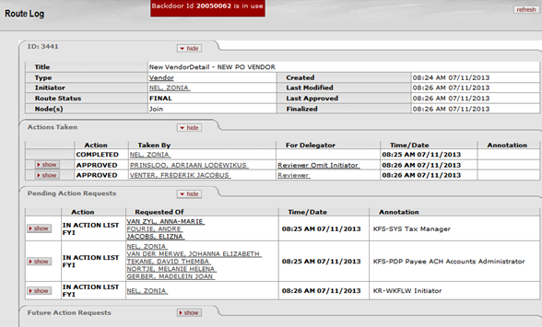
Figure 8

1. | - Click on show button for Route log to see the routing of this e-doc must route to Contract Manager and AP Manager for final approval if a PO Vendor is created In case of a DV Vendor status will change to final id submitted and AP Manager will only receive a FYI  - If the Vendor is registered for Vat, the Vendor E-doc will also route to the Tax Manager only to see (FYI).  - It will also route to Limited AP Manager to remind them to create banking details (FYI).  - It will also send (FYI) to initiator to inform that Vendor is created. Staff members who received a FYI will see it in their action list.  - They can open the e-docs in the action list and navigate to route log to see more detail regarding the FYI.  - If the AP Manager or Contract Manager disapproves the creation of the Vendor, an acknowledgement will be send to the initiator.

  - Navigation to Pre-Disbursement Processor to create Banks
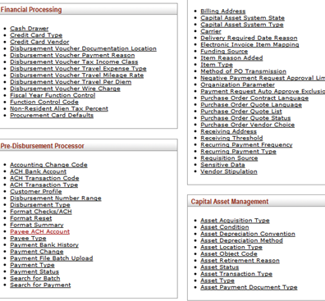
Figure 9

1. | AP Manager with role PDP Payee ACH Accounts Administrator navigates to Maintenance Menu Navigate to Pre-Disbursement Processor and click on Payee ACH Account.

  - Payee ACH Lookup Screen

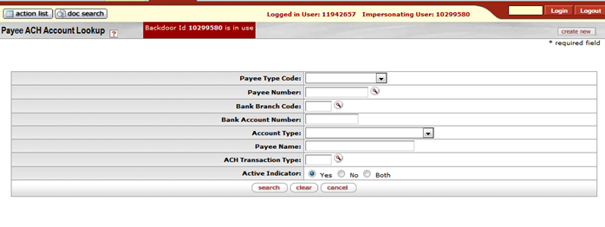
Figure 10

1. | Payee ACH Account Lookup will appear on screen click on button on the top right corner.

  - Create new Bank Information
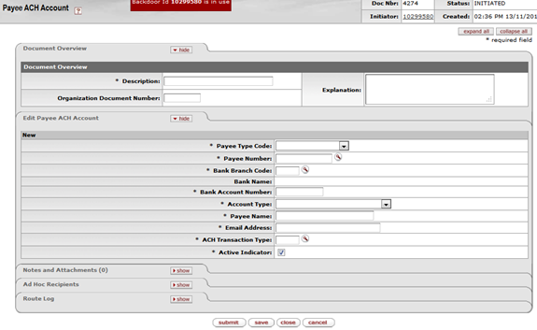
Figure 11

1. | Click on Description field and complete for Example Bank information Employee 10000666.
2. | Click on Payee Type Code and select from drop-down List - for example Employee ID.
3. | Click on Payee Number Search Button-Payee Lookup Screen will appear- Click on Person last name and fill in as follows: % Venter%. Click on search. In case of Vendor click on “Vendor Name”. Select relevant Employee and click on return value Button. Payee name will default from Payee number.
4. | Payee ACH Account screen will show again-complete Branch Code field or use search Button to find Branch code.
5. | Click on Bank Account Number and fill in relevant bank account number.
6. | Click on Account Type and select relevant type from Drop Down List.
7. | Click on E-mail Address and fill in e-mail address Vendor-e-mail address for remittance advices.
8. | Click on ACH Transaction Type and enter PRAP or click on search and then on return value.

  - Submit to Create banking details

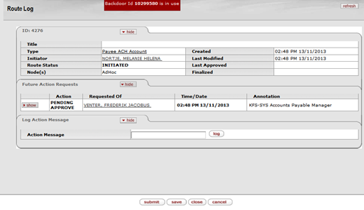
Figure 12

1. | Click on submit and if the document is successfully submitted, it will route to the AP Manager for final approval.

2.13 Search for existing bank details

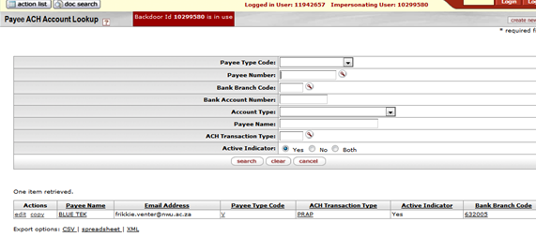
Figure 13

1. | Navigate too Pre-Disbursement Processor – Payee ACH account again.
2. | Click on search button if you want to see al payees with banks. If you are looking for a certain payee, click on payee number, to search for relevant Vendor or employee.

- How to Change Personal Information.
  - Navigate to Vendor Lookup
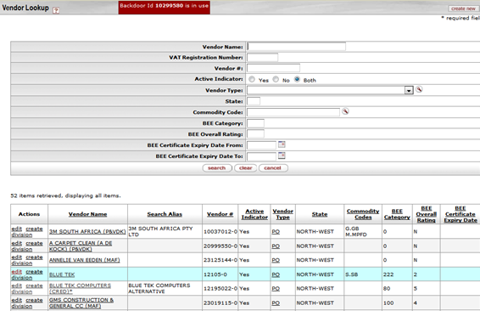
Figure 14

1. | Click on Main Menu then navigate to Lookup and Maintenance then click on Vendor.
2. | Then click Vendor name and put name in for example % Blue Tek% - then click on search.
3. | Information of Blue Tek will show on the screen-click on edit.

  - Old and new information for editing
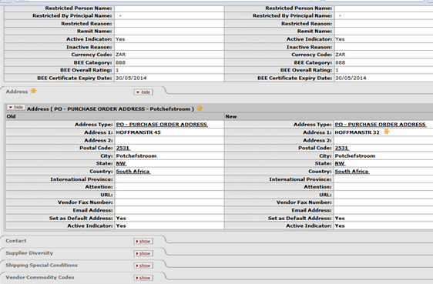
Figure 15

1. | Complete the Description field for example update address Blue Tek.
2. | Click on Address fields to change information to new address.
3. | Click on submit button-see message on top left Document was successfully submitted.
4. | Click on Route Log to see who must next approve and who is going to receive a FYI (For Your Information).
5. | The AP Manager and Purchase Manager must approve the change of information in their action lists.
6. | The Employees who received FYI’s in their action list must take notice of the changes.

- How to make a Vendor Inactive

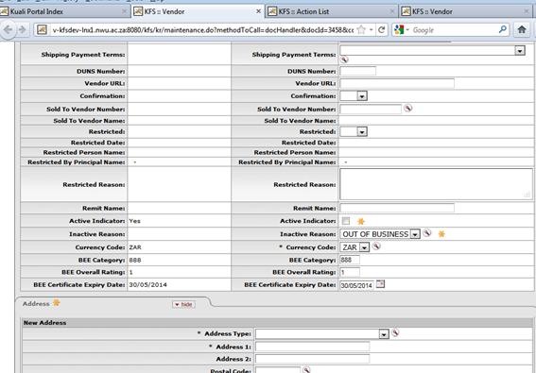
Figure 16

1. | Click on Main Menu > Lookup and Maintenance > Vendor
2. | Then click on Vendor Name and type for example %Blue Tek% and then click on search.
3. | Information of Blue Tek will be retrieved and click on edit. The Screen will reflect old information and new information.
5. | Complete the Description field.
6. | Remove the Active Indicator and select the Inactive Reason from drop-down list.
7. | Click on submit and if the document was successfully submitted it will reflect in the left top corner.
8. | Click on Route Log and the AP Manager and Purchase Manager must approve and a (FYI) is send to certain employees.

- How to Create a Vendor Division

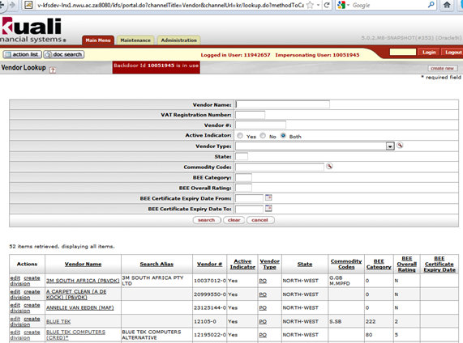
Figure 17

1. | Click on Main Menu > Lookup and Maintenance > Vendor
2. | Then click on Vendor Name and type for example %Blue Tek% and then click on search.
3. | Information of Blue Tek will be retrieved.
4. | Click on create division and follow the procedure to create a new Vendor with banking details as already explained. Remember to complete the field for currency code.
5. | Vendor Parent Indicator must be “NO” for division. 12105-0 is parent; division will be 12105-1. Option to create division will especially be used when Vendor is registered for Vat, because the Vat nr can only be used once.
6. | Creating of a Division must route to the AP Manager and Contract Manager (Purchase Manager) for final approval.

- How to make an inquiry on a Vendor
- Click on Main Menu; go to Look up and Maintenance-click on Vendor.
- Click on Vendor Name and put in the name of the Vendor you are looking for: % Waltons Stationery%.
- If the Vendor already exists on the system, the Information will appear on the screen.

- Frequent asked questions
  - What happens if the AP Manager or Contract Manager disapproves the creation of the Vendor?
- An acknowledgement will be send to the initiator’s action list. When the Initiator opens the e-doc it will show a message in notes and attachments indicating the reason for the disapproval.
- The AP Manager has the option to save the e-doc instead of disapprove it, especially if he/she just need for example the application form for the new creditor.
  - What happens if a Vendor is inactive? Will it still be possible to view the Vendor?
- When one search for an inactive Vendor, it will still be retrieved.
- It will only show inactive in the column for Active Indicator.
  - Is it possible to make an inactive Vendor active again?
- Yes it is possible, only click on edit and then tick the active indicator.
- The e-doc will again route to the AP Manager and Purchase Manager for approval, also a FYI
will be send to certain staff members according to the route log.
  - Must a Vendor Division also be approved?
- Yes, the same approvals applied to a Vendor Division as in the case of a new Vendor.

Lesson Summary
Having completed this lesson you should be able to:
- Navigate to the Vendor (VND) in KFS
- Know the process to create a new Vendor
- Know how to create banks for Vendors in PDP
- Know how to change personal information of Vendor
- Know how to make a Vendor inactive
- Know how to create a division
- Know how to make an inquiry on a Vendor

