Purchasing/Account Payable
Payment Request (PREQ)
Document Summary
Product Owner | Frikkie Venter
Editor | Chimoné Barends
Date | 2015/10/14
Time | 09:00 AM
Template | Verbose

Lesson Objectives
On completion of this lesson you should be able to:
- Navigate to the Payment Request (PREQ) in KFS
- Know the process to create a new Payment Request
- Know how to disapprove a Payment Request
- Know how to create a Vendor Credit Memo
- Know how to place a hold on a Payment Request/ Vendor Credit Memo
- Know how to request cancellation or cancel a Payment Request/Vendor Credit Memo.
- Know how to search for a Payment Request

Lesson Scenario
- As an existing staff member you will be able to create a Payment Request/Vendor Credit Memo for payments to Purchase Order Vendors by matching invoices/credit memos to Purchase Orders.
- You will also be able to attach relevant documentation and be able to submit the Payment Request/Vendor Credit Memo for it to route via approval levels to Financial Administration for payment.

Lesson Prerequisites
- You need to be a NWU staff member that is registered on KFS as a user.

Table of Contents

- Payment Request (PREQ) process
  - Business Rules
- How to create a Payment Request
  - KFS Navigation
  - Payment Request Initiation
  - Vendor Address and Vendor Info
  - Invoice info and PO Lines
  - Closing of PO
  - Attachment of Invoice and Calculation
  - Receiving not done
  - Action list if receiving is not done
  - Message in route log for receiving
  - Receiving
  - Line item receiving initiation
  - Line item receiving
  - The Action List AP processor
  - Message regarding receiving in Route Log for AP Processor
  - Item tab on saved payment Request
  - Calculate and submit Payment Request
  - Review GL Pending Entries on Payment Request
  - Route log for Approval of Payment Request.
- How to create a Vendor Credit Memo
3.1. Navigate to Vendor Credit Memo
3.2. Initiate Vendor Credit Memo
3.3. Process Tab on Vendor Credit Memo
3.4. Calculate and submit Vendor Credit Memo
3.5. General Ledger Pending Entries for Vendor Credit Memo.
3.6. Route Log for Vendor Credit Memo
- How to place a hold on a Payment Request/Vendor Credit Memo
4.1. Navigate to button for hold on Payment Request
4.2. Complete reason for hold screen.
- How to request cancellation or cancel a Payment Request / Vendor Credit Memo
5.1 Request cancel on Payment Request
5.2 Reason for request to cancel
5.3 Notification to recipient from Fiscal Officer
5.4 How to remove request to cancel
- Search for Payments
- Frequent asked questions

Payment Request (PREQ) Process

1.1 Business Rules

- Only the members of the AP Processors or AP Manager roles can initiate the Payment Request.
- Every payment request must be processed against a specific open PO document. This PO must be specified when the payment request is initiated.
- If the vendor number and invoice number match values previously processed, a warning notifies the initiator of the potential duplicate. Even so, the system allows the initiator to override the warning and continue. It also checks against DV for duplicates
- If the invoice amount and invoice date match values previously processed for this vendor, a warning notifies the initiator of the potential duplicate. Even so, the system allows the initiator to override the warning and continue. It also check against DV’s for duplicates
- Expired or closed accounts warnings are provided to the user according to parameters. The accounting line shows current accounts being used. Refer to either the notes or the original PO to see the original accounts.
- Whether the warning shows to an AP user is controlled by the parameter SHOW_CONTINUATION_ACCOUNT_WARNING_AP_USERS_IND.
- Whether the warning displays to the fiscal officer is controlled by the parameter SHOW_CONTINUATION_ACCOUNT_WARNING_FISCAL_OFFICERS_IND.)
- The user may process a payment request only on lines that have an available open quantity or if the items are non-quantity rand amounts remaining.
- Pay Date may not be a past date. If the pay date is more than 60 days in the future, a warning is received.
- Discounts applied from payment terms do not apply to freight or shipping and handling charges.
- Additional charges items that were not specifically funded on the purchase order are allocated to accounting lines in proportion to the item amounts on the purchase order.
- The calculate button must be pressed prior to submitting the payment request.
- Accounts Payable can close the PO during the processing of an invoice if the invoice will complete the order. This indicator box is available only on non-recurring orders.
- The following GL entries are created when the payment request is submitted.
- Debit entry: The expense accounts (full accounting string) on the payment request are debited in the G/L when the initiator submits the document. The GL entry is made in summary for each accounting string. Consequently, if three line items on a payment request use the same accounting string, only one debit (not three) is created in the G/L for that accounting string.)
- Credit entry: One offset to object code 9501 is created for each account/sub-account combination on a payment request.
- During fiscal officer approval routing of the PREQ, the fiscal officer/PREQ delegate may edit the accounts/subaccount/ object codes and amounts. The existing account string is reversed. The new account string debits the expense and credits object code 9501, the liability offset.
- After being cancelled, the G/L entries are reversed, any disencumbrance created from AP submission of the payment request is reversed, and the PO open quantities that were decremented from the creation of the payment request are increased. Only AP users may cancel a Payment Request document.
- Only AP users may modify a payment request's pay date, attachment flag, special handling instructions, and immediate pay flag and check stub notes. This action may be taken at any point following AP submit and preceding extract to PDP.
- Payment request searches are available to all users.
- A payment request that is Hold = 'yes' or is Request Cancel = 'yes' does not continue through workflow routing and cannot be paid until the hold or request cancel is removed.
- When receiving is not done on a Purchase order, the AP Processor will receive a message and has the option to send an acknowledgement to the Initiator of the Purchase requisition.
- A payment request may be put on hold any time between submit and the time it is extracted to the Pre-Disbursement Processor by the AP Department. The hold flag prevents a payment request from being extracted and paid.
- A Credit memo can also be put on hold from the time of AP submits until the time the credit extracts it to the Pre-Disbursement Processor. The process is the same as for the payment request. You only have to Navigate to Custom Document Searches-Purchasing Accounts Payables- Vendor Credit Memo’s.
- An approver who receives a payment request may choose to request cancellation or may remove the request cancellation of the payment request. The Fiscal Officer can request cancel or remove request cancel.
- After a payment request has received Fiscal Officer Approval as well as Final approval by AP Manager, it may still be cancelled by Accounts Payables (AP Processor / AP Manager) until it is extracted to the Pre-Disbursement Processor.
- The Fiscal Officer who originally requested cancellation may remove the cancellation request.

How to create a Payment Request

KFS navigation: Main Menu > Transactions > Purchasing/Accounts Payables > Payment Request
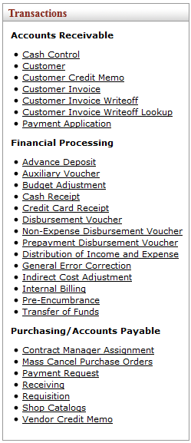
Figure 1

Payment Request Initiation

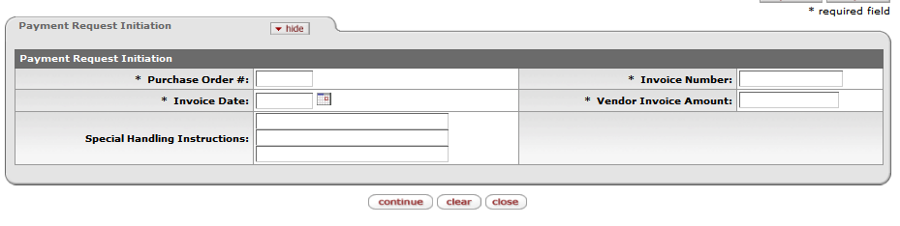

Figure 2

1. | Click on the Payment Request to open the Payment Request Initiation tab.
2. | Click on each field and complete the Purchase Order #, Invoice Number, Invoice Date and Vendor Invoice Amount.
3. | Click on to open the Payment Request e-doc.

Vendor Address and Vendor Info

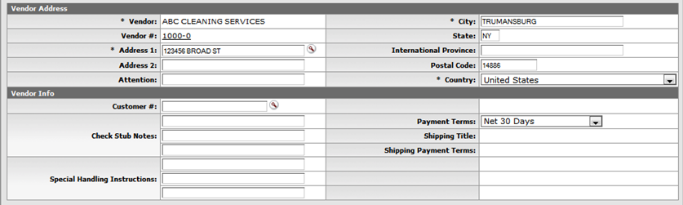
Figure 3

1. | Click on Vendor Address and then on Payment Terms and complete the fields.

Invoice Info and PO Lines

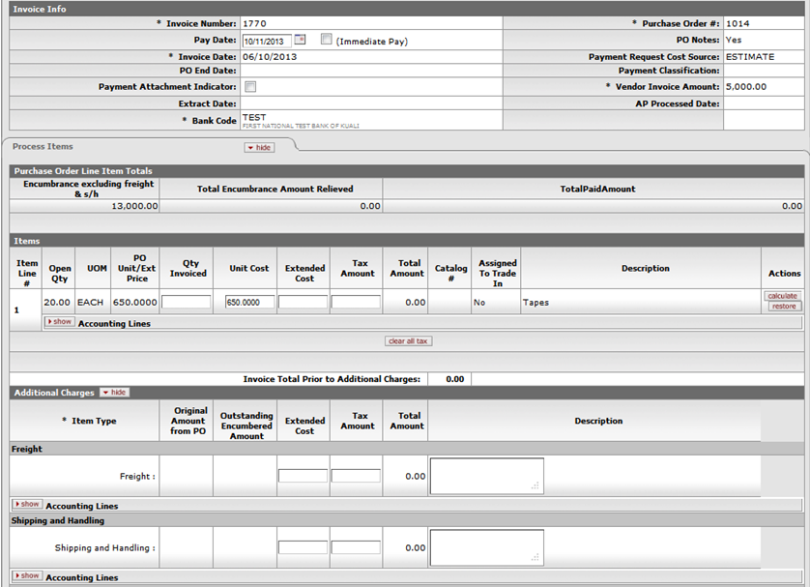

Figure 4

1. | - On the invoice tab the Pay Date is editable new pay date can be entered. Do not use tick box for Immediate Payments, only for emergency check payments. Parameter to change Pay date default: NUMBER_OF_DAYS_USED_TO_CALCULATE_DEFAULT_PAY_DATE
2. | - Navigate to the Process Items tab and then to Purchase Order Line Items and click on Qty Invoiced and enter the relevant quantity of the invoice. If the invoice amount is less than the PO amount, the unit cost on the item line can be changed for example 10 x R400 instead of 10 x R500.
3. | - Additional charges on the invoice (not part of PO) can be entered on the tab for Additional Charges. To see the accounting lines for the additional charges, click on accounting lines in the Additional Charges just beneath each item type for the charges. The miscellaneous line can be used in instances where the invoice amount is bigger than the Po amount if for example travel costs is add to the invoice. Otherwise the unit cost can be changed for example: R10 x R600 instead of R10 x R500.
4 | - If point 3 is applicable you should first navigate to Ad Hoc Recipients to add the head of Department/Director as Approver. The reason being to approve the additional amount to the Purchase Order.  - Click on the search button for Person to search for the relevant approver and then add the person.  - Then click on route log to open it and add a message in the Action Message field. Then click on submit.  - When you click on submit in this instance, the payment request will first of all route to the director/head of department for approval, before it take the normal routing to the fiscal officer. The director will see the payment request in his or her action list. When it is opened and the route log is opened/showed, the following message will be seen for example:

Closing of PO

Figure 5

1. | If all the line items is received and billed, click on close PO to disencumber any remaining encumbrance.

Attachment of Invoice and Calculation

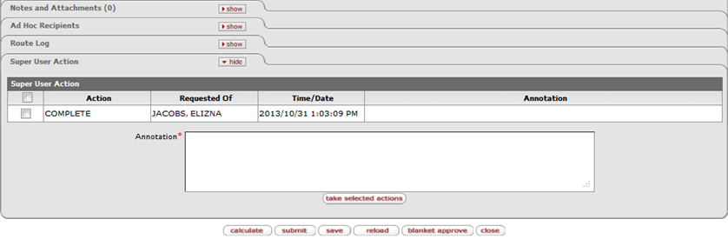
Figure 6

1. | Click on Notes and Attachment, browse for the invoice and attach invoice. Click on add.
2. | Click on and then on the submit button. Message will appear Document Successfully submitted if receiving is done on the PO. The next step will then be approval by the fiscal officer and AP Manager and status will change to final. The process if receiving is not done is explained further:

Receiving is not yet done

Figure 7

1. | If receiving is not done a message will display on the screen to indicate that the receiving is not done and you will be given the option to send an acknowledgement to the initiator of the PO requisition by clicking on yes or no. The status of the payment request will change to saved.

Action List if Receiving is not done

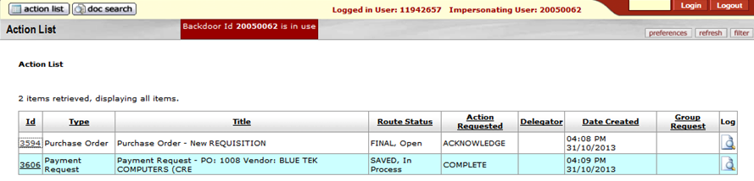
Figure 8

1. | If you have selected yes to send an acknowledgement, the relevant PO document will be send to the initiator of the PO requisition. He/she will see it in their action list.

Review message in Route Log for receiving

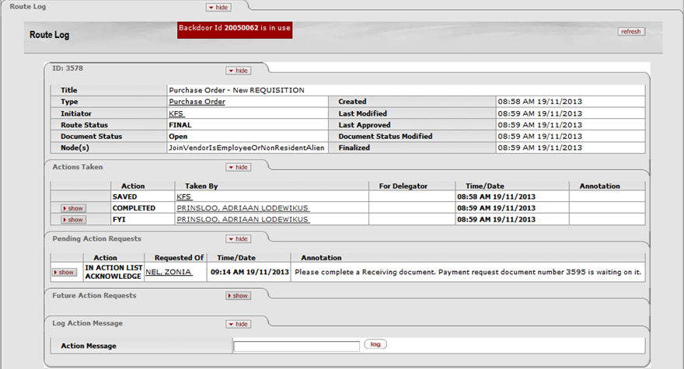
Figure 9

1. | Initiator of requisition must click on Purchase Order in the action list and then click on route log when the e-doc opens, to see message regarding receiving still to be done.

Receiving

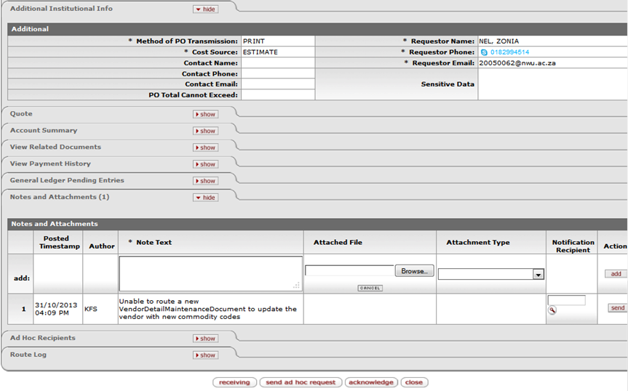
Figure 10
1. | The Initiator must open Purchase Order in Action List, click on the receiving button to do receiving and then go back to the action list.

Line item receiving initiation

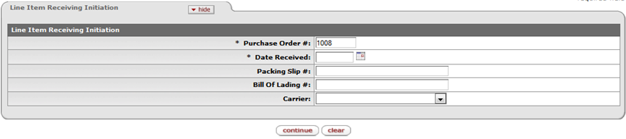
Figure 11

1. | Enter Purchase Order Number and Date Received and then click on the continue button.
2. | Click on Acknowledge to remove the Purchase e-doc out of the action list.

Line item receiving

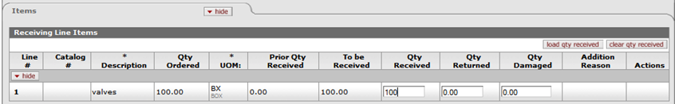
Figure 12

1. | Enter Qty Received and then submit.

Action list of AP Processor

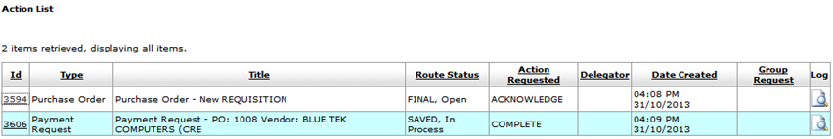
Figure 13

1. | The payment request will be send as a saved e-doc to the Action List of the AP Processor (1) who initially matched the relevant invoice to the PO and submit it.
2. | Click on Id to open Payment Request.
3. | Another AP Processor(2) can submit a saved Payment Request, regardless of the fact that the payment request is in AP Processor(1)’s action list. AP Processor (2) will receive a warning message that a payment request is already captured for the relevant Purchase Order. If the AP Processor(2) disregard the message and go on submitting the payment request, AP Processor (1) cannot submit the saved payment request in his/her action list. The item line to put in QTY invoiced will be hiding. AP Processor (1) should then cancel the saved Payment Request in his or her action list.

Message regarding receiving in Route Log for AP Processor

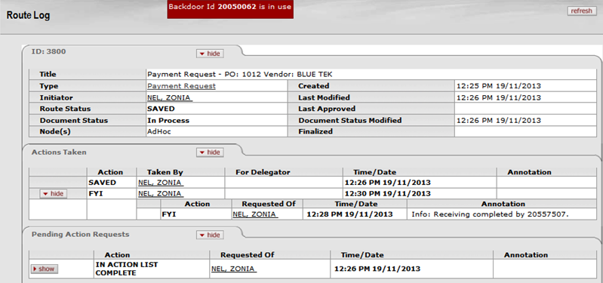
Figure 14

1. | The AP Processor can click on the Route Log to see the routing. The relevant payment request will be as a FYI in the action list and will have an annotation on the FYI reflecting info about the receiving.

Item tab on saved payment request

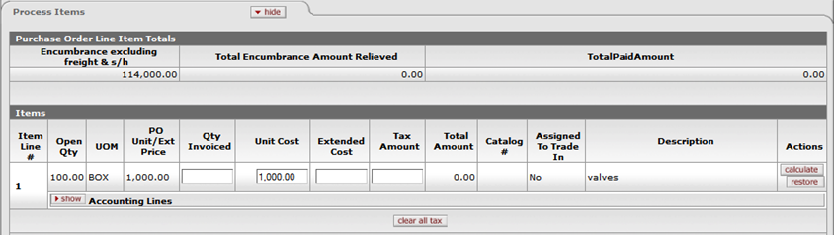
Figure 15

1. | If receiving is done, the AP Processor again can add the Qty Invoiced, on the Payment Request and click on calculate button to calculate the Vat.

Calculate and submit Payment Request

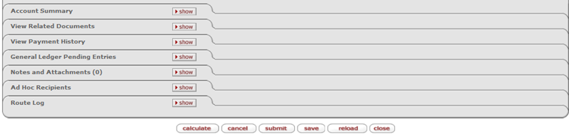
Figure 16

1. | The AP Processor must click on and submit to route the Payment Request to the Fiscal Officer and AP Manager for approval.

Review GL Pending Entries on the Payment Request

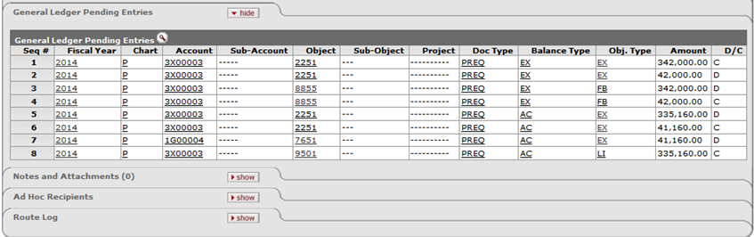
Figure 17

1. | The AP Processor must click on General Ledger Pending Entries to see the GL entries. When the Payment Request is submitted, the encumbrance will be lifted and the actual expenses will appear in the General Ledger after the following batch Jobs for the GL have run the nightly Out Job, scrubber Job and poster Job.

Route Log for approval of Payment Request

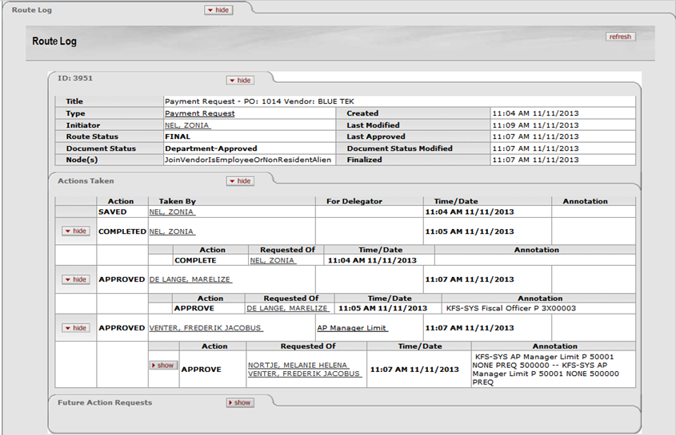
Figure 18

1. | The AP Processor can finally click on the Route Log to see the Payment Request’s routing for approval.

How to create a Vendor Credit Memo

KFS navigation: Main Menu > Transactions > Purchasing/Accounts Payables > Vendor Credit Memo
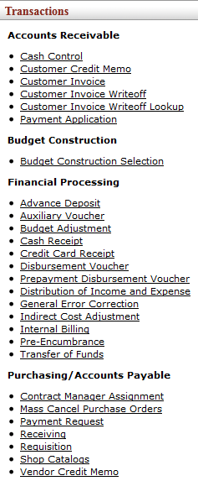
Figure 19

Initiate a Credit Memo

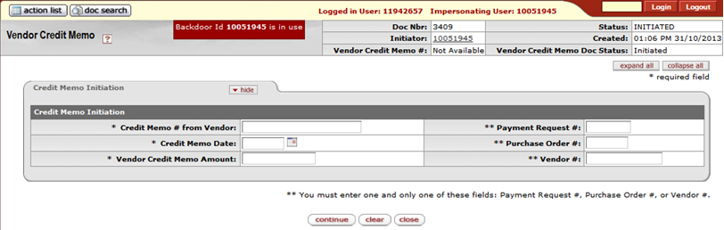
Figure 20

1. | Click on Vendor Credit Memo to open Vendor Credit Memo initiation tab.
2. | Click on Credit Memo number, Credit Memo Date, and Vendor Credit Memo Amount and enter information in fields.
3. | Click on one of the fields and enter information: Payment Request #, Purchase Order # or Vendor #.
4. | Click on the to open the Vendor Credit Memo e-doc.

Process tab on Credit Memo

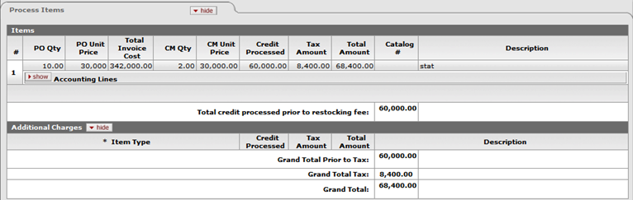
Figure 21

1. | Navigate to process items tab- if the Purchase Order field is entered on previous screen (credit memo is related to PO), click on CM Qty and enter the quantity. If you entered The Vendor or Payment Request field on previous screen, it means the Credit Memo is not related to a PO.
2. | In this instance you can click on Additional Charges in the Process Items tab and click on accounting lines beneath each item type to enter the relevant account and object.

Calculate and submit Vendor Credit Memo

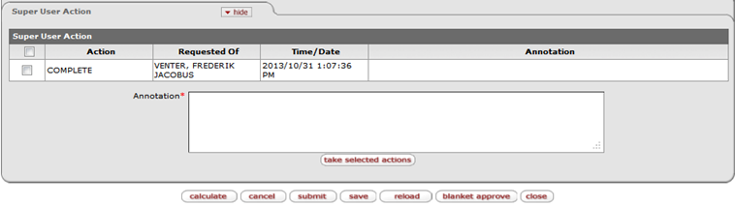
Figure 22

1. | Click on and then on .

Review General Ledger Pending Entries for Vendor Credit Memo

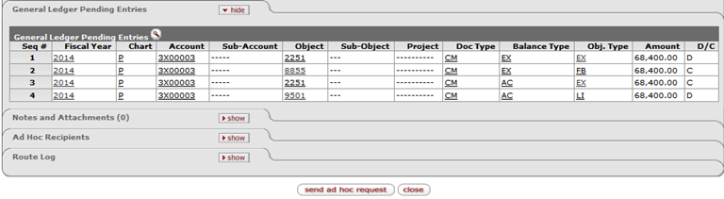
Figure 23

1. | Click on General Ledger Pending entries to see the GL-entries.

Review Route Log for Vendor Credit Memo

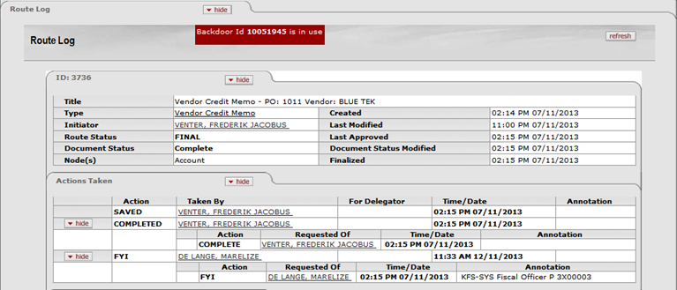
Figure 24

1. | Click on Route Log to see routing for Vendor Credit Memo.

How to place a hold on PREQ/Vendor Credit Memo

Navigate to button for hold on Payment Request

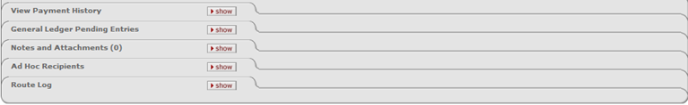
Figure 25

1. | Navigate to Main Menu- Custom Document Searches-Purchasing/Accounts Payables-Payment Request and search for payment requests not yet extracted to PDP.
2. | Navigate to the bottom of e-doc and click on (permission 286)

Complete reason for hold screen

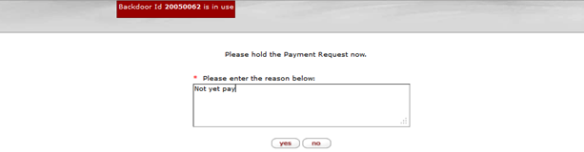
Figure 26

1. | Enter the reason for the hold and then click on . The payment request is marked hold and a large header will appear on the left top of the payment request indicating who placed the payment request on hold.
2. | To remove the hold follows the same procedure as placing a hold. Navigate to the bottom of the payment request a click on remove hold button. Again a window will be displayed to provide a reason for removing the hold. Enter the reason in the field and click on yes to remove the hold.

How to request cancellation or cancel a Payment Request/credit memo

Request cancel on Payment Request

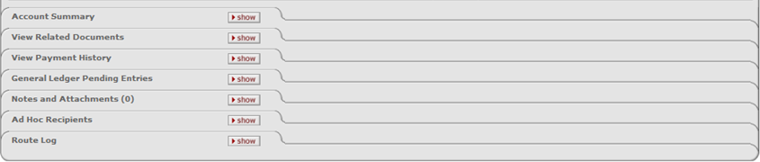
Figure 27

1. | A request to cancel may be made any time after the payment request has begun routing for approval and before it has received approval by the Fiscal Officer.
2. | Fiscal Officer must navigate to action list and open the relevant Payment Request.
3. | Click on the request cancel button on the bottom of the payment.

Reason for request to cancel
Figure 28

1. | A window will display on the screen with a field in which the reason for request to cancel must be provided.
2. | Click on the button to request cancel of the payment request.

Notification to recipient from the Fiscal Officer

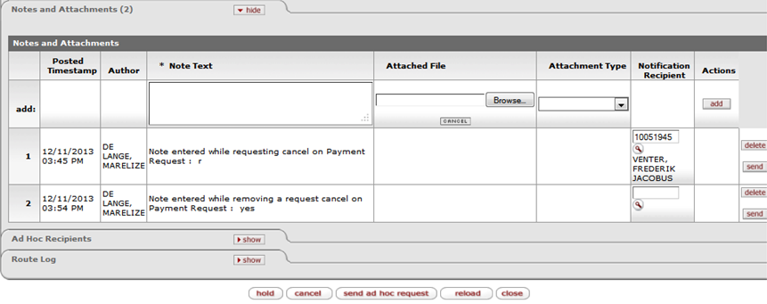
Figure 29

1. | Use the Notes and Attachments tab to send an ad hoc request to the recipient regarding the request to cancel.
2. | Cancellation of Payment Request: After a payment request has received fiscal officer approval as well as final approval by AP Manager, it may still be cancelled by Accounts Payables (AP Processor/AP Manager) until it is extracted to the Pre-Disbursement Processor.

How to remove request to cancel
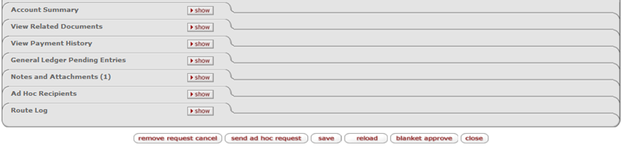
Figure 30

1. | The Fiscal Officer who originally requested cancellation may remove the cancellation request.
2. | Navigation to Main Menu – Custom Document Searches – Purchasing Account Payables. Click on Payment Requests – Document search will open.
3. | Enter information in relevant fields for example invoice nr, amount and PO number. Click on the search button and select the relevant payment request. Click on the yes button to request cancel of the payment request.
4. | When the payment request open, click on Remove request to cancel button. Again a window will appear on the screen which a field for the reason for removing the request to cancel. Enter the reason in the field.
5. | Click on the yes button. The request cancel is removed; the document retains the status it had before the request cancel flag was set.

Search for Payments
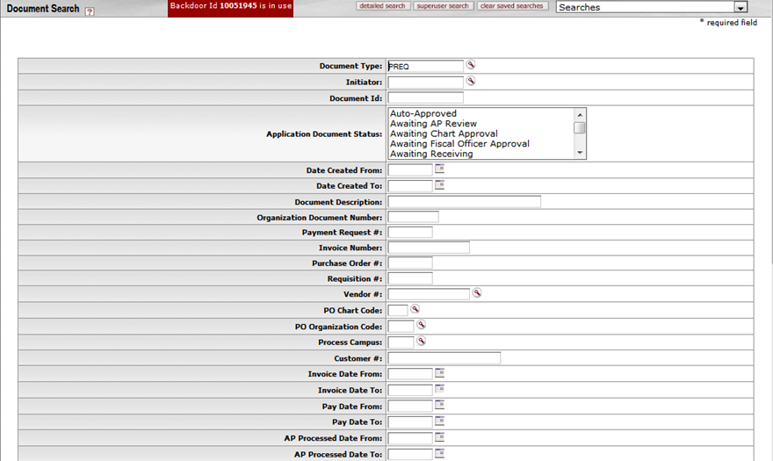
Figure 31

1. | Navigate to the Main Menu – Custom Document Searches – Purchasing Account Payables.
2. | Click on Payment Requests – Document search will open. Enter information in relevant fields for example invoice nr, amount and PO Number.
3. | Click on the search button and select the relevant payment request.

Useful information on the Payment Request:

- The Payment Request document is set up with a 5% tolerance. When you receive the totals do not balance, still submit and the attached screen will come up allowing you to Approve or Disapprove the amount. For example:
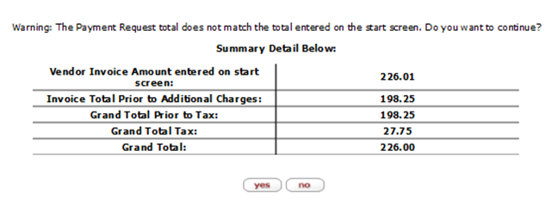

- It happens that Vendors which are registered for VAT sometimes has non Vatable items on their Invoices. To ensure that the Invoice amount and the Calculated amount on the Payment Request is the same, one must calculate a new unit price on the Payment Request as follows: Current Unit Price x 100/114 = New Unit Price.
- Then change the Unit Price to the new Unit Price on the Payment Request and click on the calculate button. The amount will then be the same on the Invoice and the Payment Request. The amount on the GL will also be correct. For example:
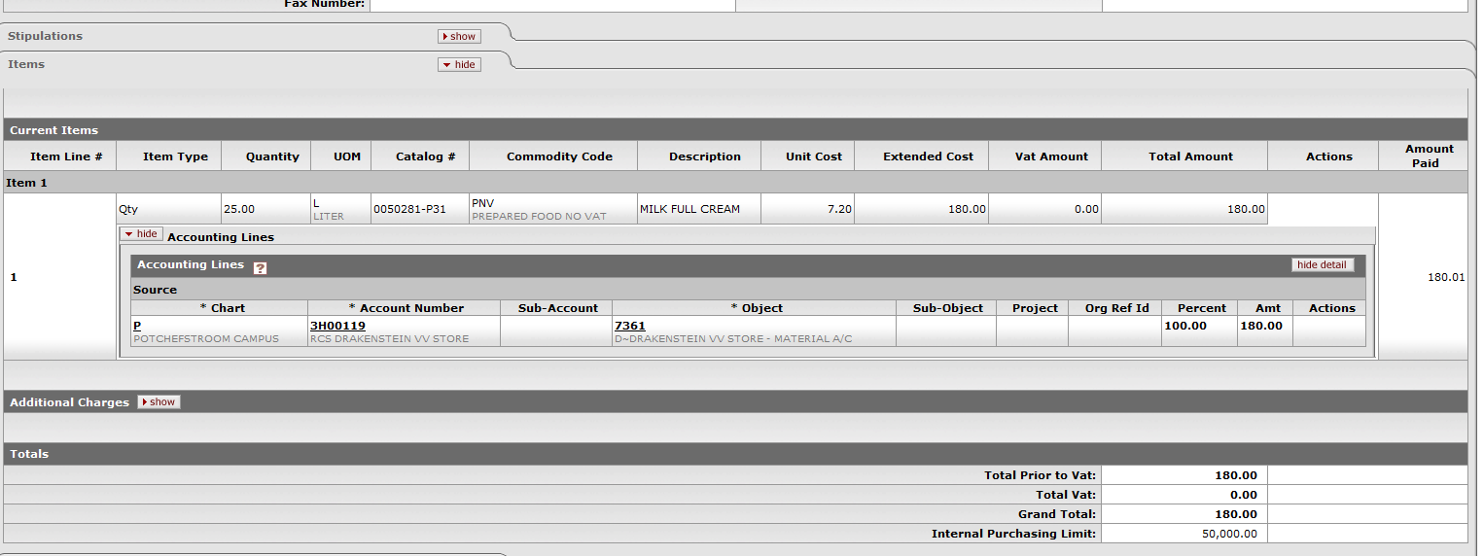
- Capturing of the Payment Request with attached invoice must be done by - The Initiator at the Department.
- Please Note: a Payment Request with status "Saved" will never be paid.

The short manual regarding the Payment Request:

- KFS Navigate: Main Menu > Purchasing/Accounts Payables > Payment Request
- On the first screen that opens complete the following fields: Purchase Order, invoice number, Invoice date, Vendor invoice amount and click on continue button.
- The next screen will open, click on Invoice QTY on the item lines to complete quantity as on invoice.
- Click on notes and attachments to add relevant invoice.
- Then click on calculate button at the left bottom of the document. The payment request will route to the Fiscal Officer for approval.
- I refer to point 3 on attach document to illustrate how to capture two or more invoices on the same Purchase order. Please remember you can't capture two invoices if the quantity is only 1.
- I refer to point 4 on the attach document to pay an invoice if the invoice amount is more than the Purchase Order amount.
  - A Vendor can add for example additional cost to invoice like travel. Then you can use the add charges option on the second screen of the Payment Request. Add the amount without vat in die first open field and the description in the last one.
  - If the invoice amount is less than the Purchase Order, you can change the unit price on the item line.
  - Click on calculate button, the relevant account and object for the additional charges will default. You can change the object/account and the click on calculate again.
  - In this instance the Fiscal officer should send an ad hoc routing to his manager to approve the additional amount.
- Stores: In the instance of stores a change in the number of decimals should solve the problem regarding 1 or 2c's difference between Purchase Orders and invoices.

7. Frequent asked questions

1. | What happens if I enter a duplicate Vendor and Invoice number?  If the invoice numbers already exist for the chosen Vendor, a warning message will be given with the option to go on capturing the duplicate invoice. Validation for duplicate invoice will be both done for Payment Requests and Disbursement Voucher.
2. | In what stage does the encumbrance become actuals? When a payment request is match to a PO and the Payment Request is submitted and approved.
3. | Can I pay a PO Vendor without a PO number? Yes, by using a Disbursement Voucher.
4. | What will happen if you submit a Payment Request if receiving is not done on PO? You will receive a warning message and the option to sent a request for receiving to the initiator of the PO.
5. | Can I Payment Request still be placed on hold or cancelled after it is finally approved?  A payment request may be put on hold or cancelled any time between submit and the time it is extracted to the Pre-Disbursement Processor by the AP Department. The hold /cancel flag prevents a payment request from being extracted and paid.

Lesson Summary
Having completed this lesson you should be able to:
- Navigate to the Payment Request (PREQ) in KFS
- Know the process to create a new Payment Request
- Know how to disapprove a Payment Request
- Know how to create a Vendor Credit Memo
- Know how to place a hold on a Payment Request/Vendor Credit Memo
- Know how to request cancellation or cancel a Payment Request/Vendor Credit Memo.
- Know how to search for a Payment Request

