Financial Processing
Non-Check Disbursement:
International Payments
Document Summary
Product Owner | Frikkie Venter
Editor | Chimoné Barends
Date | 2016/09/28
Time | 10:00 AM
Template | Verbose

Lesson Objectives
On completion of this lesson you should be able to:
- Navigate to the Non-Check Disbursement in KFS
- Know the process to create a new Non-Check Disbursement
- Know how to approve a Non-Check Disbursement
- Know how to correct a Non-Check Disbursement

Lesson Scenario
- As an existing staff member you will be able to create a Non-Check Disbursement for International/Foreign Payments and other direct payments/debits on bank statements.
- You will also be able to attach relevant documentation and be able to submit the Non-Check Disbursement in order for it to route via approval levels to Financial Administration for payment.

Lesson Prerequisites
- You need to be a NWU staff member that is registered on KFS as a user.

Table of Contents

- How to create a Non Check Disbursement
1.1 Document Overview
1.2 Handling of VAT
1.3 Notes and attachments
1.4 General Ledger Pending Entries

How to create a Non-Check Disbursement

KFS: Main Menu > Administrative Transactions > Financial Processing > Non-Check Disbursement
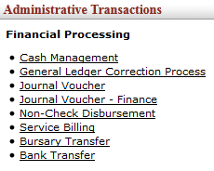
Figure 1

1.1 Document Overview tab

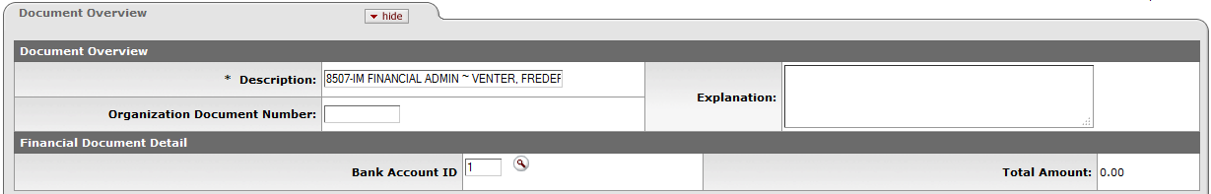

Figure 2

- No need to complete the Description field.

1.2 General Info & Accounting Lines tabs
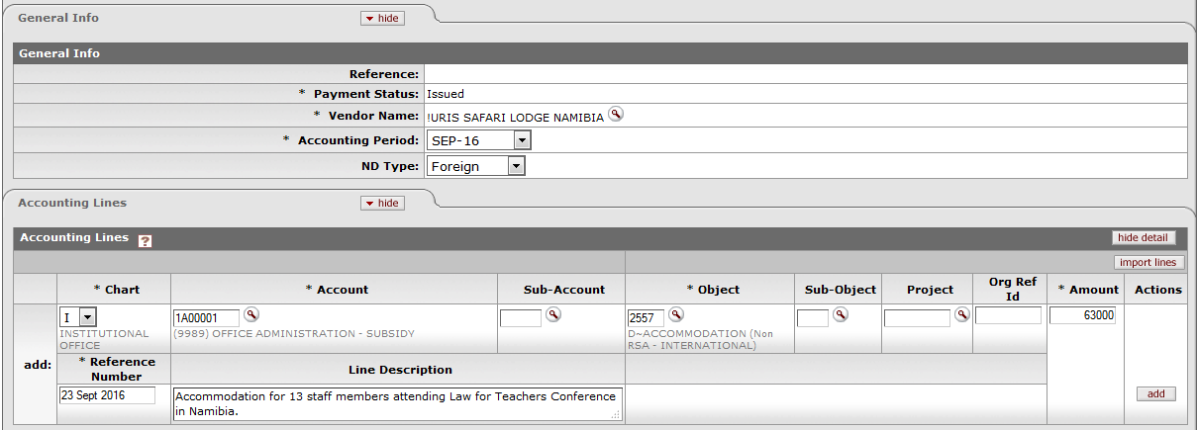
Figure 3

1. | Click on Vendor Name to search for relevant Foreign Vendor, for example:
2. | Click on Accounting Period and select the relevant period.
3. | Click on drop-down arrow and specify the ND Type:  - Petty Cash: To upload funds onto your Debit Cards issued by staff members.  - Foreign: To make payments to Foreign Vendors.  - Standard: For Central Finance use only.
4. | This ND Type will reflect on your Action List in the Title column, for example:
5. | Navigate to accounting lines, click on the drop-down list for Chart, Account and Object codes and search for relevant account and object. Also complete Amount, Reference Number (staff number/date) and Line Description for GL purposes.
6. | Please note that no VAT will be Calculated when a Foreign ND Type was selected.
7. | Click on add.

1.3 Notes and Attachments tab
Figure 4

The following information is very important:
- All supporting documentation should be attached.
- Complete the International Payment application form and attached to the Non-Check Disbursement. This form is also available on the http://www.nwu.ac.za/kfs website: For example:
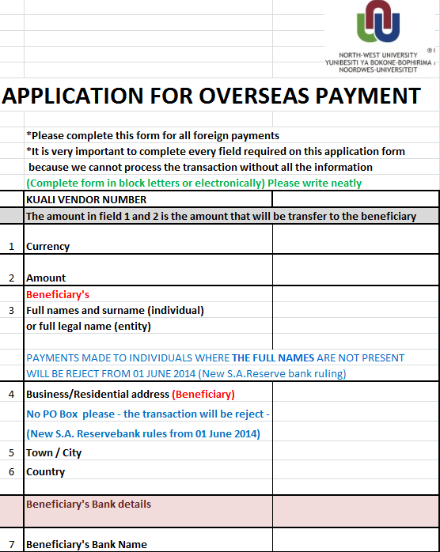
Figure 5
- No transaction will be done without this form.
- The form must be completed correctly and the amount to be transferred must be stated clearly, because we use this form to make the transfers.
- Make use of a “Currency Convertor” on Google to calculate the Rand amount.
- The amount in Rand must be used to complete the Non-Check Disbursement.
- As soon as we receive the final Rand amount from Absa, we will fill in the correct amount on the Non-Check Disbursement before we change its status to “Final”.
- Please take note that we need to give Absa 5 working days before we will receive a proof of payment.
1. | Click on Notes and Attachments and complete the Note Text field, click then on to attach the relevant documentation.
2. | Click on

1.4 The General Ledger Pending Entries tab

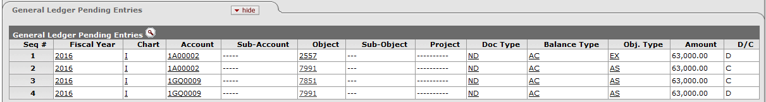
Figure 6

1. | Click on
2. | Click on the General Ledger Pending Entries to see the GL entries.
3. | The Actual expense 2557 *-* D~ACCOMMODATION (Non RSA - INTERNATIONAL) will be Debited (D) and the Relevant Cash Account (bank) 7851 *-* D~ABSA MAIN BANK A/C CASH will be Credited (C).
4. | Click on

Lesson Summary
Having completed this lesson you should be able to:
- Navigate to the Non-Check Disbursement in KFS
- Know the process to create a new Non-Check Disbursement
- Know how to approve a Non-Check Disbursement
- Know how to correct a Non-Check Disbursement

