Innovation Bridge 4 - 6 December, CSIR ICC

The Innovation Bridge (IB) Technology Matchmaking and Showcasing Event and Science Forum South Africa (SFSA), previously separate events, have joined forces to serve the South African innovation ecosystem. For the first time ever the IB and the SFSA have taken place at the same time and at the same venue. The 2019 joint event under the theme:

Igniting Conversations About Science For Innovation With Impact, has taken place at the CSIR International Convention Centre from the 4th to 6th December 2019. Both events were initiatives of the Department of Science and Innovation (DSI).

Here are some photos of the Event:

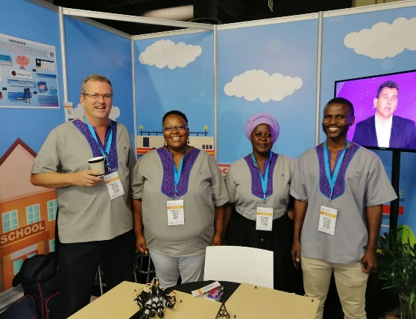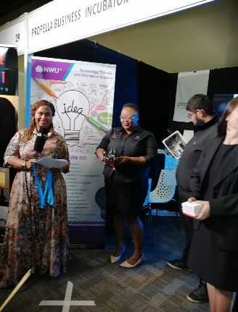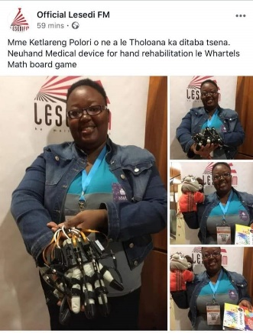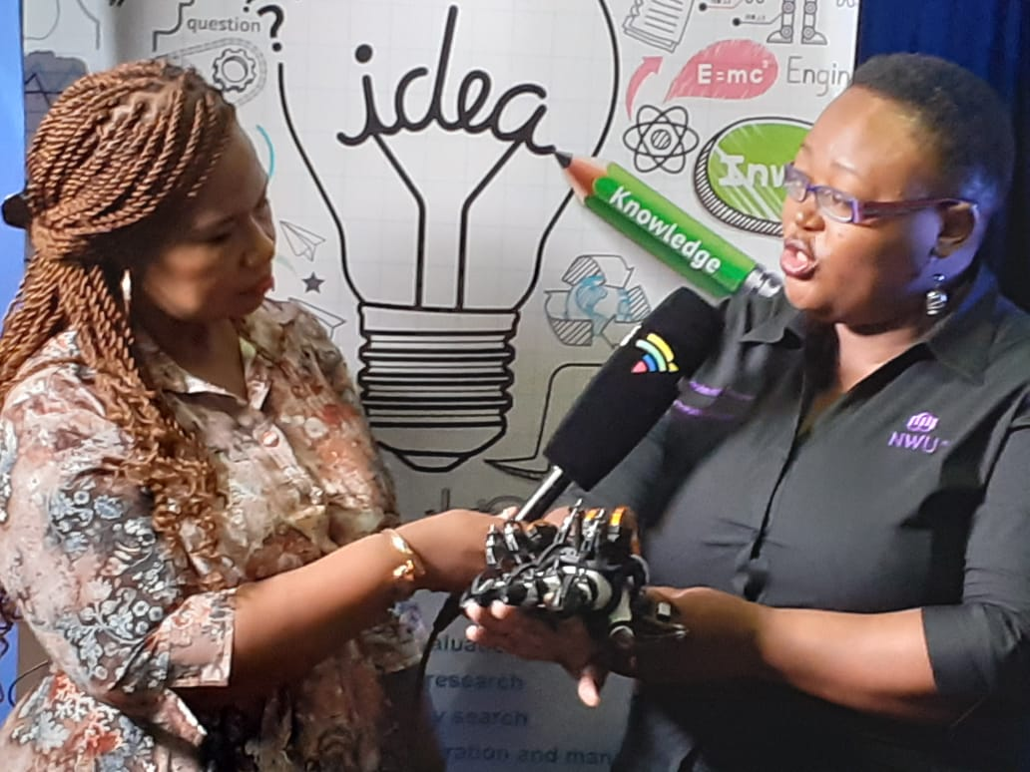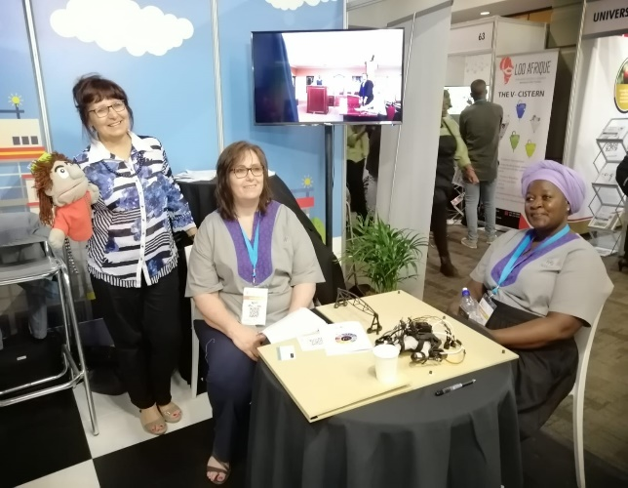

The "Innovation Bridge/Science Forum South Africa" was held at the CSIR International Convention in Pretoria between 4 and 6 December 2019. This is a flagship event, jointly hosted by the Department of Science and Innovation and the National Intellectual Property Management Office (NIPMO) and attended by leading scientists, researchers, funding agencies, policy makers, science and media and the general public. The NWU was represented by its Research Support and Technology Transfer and Innovation Support (TTIS) Offices.

Team NWU consisted of Mrs KT Polori, Mr Hannes Malan and Dr Mesuli Mbanjwa, Ms MPE Meintjes and Ms Funani Lavhelani.

The selected NWU technologies, which were selected by theme, included Whartels®, NeuHand and the Walking Irrigation Pivot. The NWU exhibition stand received a very positive interaction from the delegates and other stakeholders. Amongst the interactions received representatives from government, media, researchers, students and potential technology partners.

Whartels® in an innovative board game designed for pre-primary and primary learners for improving children’s maths achievement by focusing on cognitive aspects (maths concepts, metacognition and information processing) and psychological facets (executive functioning, study orientation in maths, maths anxiety, maths resilience, motivation, etc). The game is designed to facilitate self-directed learning and includes principles used in play therapy (art, bibliotherapy, board games, and puppets). The game also has an app format. Its inventor is Dr Petro Erasmus of the Department of Psychology at our Mahikeng Campus.

NeuHand is a low-cost, hand-wearable robotic device for supplementing rehabilitation therapy for stroke patients. The device provides a series of hand movement exercises which can be tailored to suit a wide range of patient needs. The lightweight frame and portability of the device allow for flexibility and choice of when and where to use the device. The NWU proprietary invention is the built-in connectivity platform which links to external devices for remote controlling, better monitoring of patient progress. The device is being developed by a team of electronic engineers under Prof Leenta Grobler from our Faculty of Engineering at the Potchefstroom Campus.

The Walking Pivot is an irrigation pivot which “walks” in half circles along a feeder water line, as opposed to the full circle of a traditional centre pivot. The walkabout motion enables a number of benefits, including larger area coverage, passing under Eskom power lines, and irrigating around physical obstacles like hills, farm houses and roads. It is the invention of a farmer from the Potchefstroom district, Mr Eric Schoeman, and the NWU is a supporting shareholder through its virtual incubator, Innovation Highway.

Another of the Innovation Highway projects, Moonshine, received a “wild card” invitation by the DSI to showcase its invention, a reflective spray paint for stray donkeys and live stock in rural villages, to avoid car accidents at night.

One of our highlights of the event was the live interview on SABC Morning Live about NeuHand and the medical devices development at NWU, where Mrs KT Polori was interviewed. Further interviews were give on Lesedi FM (SABC radio channel for Sesotho listeners) on Whartels and NeuHand.

Further highlights included a very informative panel discussion with the partners at venture capital firm Stocks and Strauss, and a spirited presentation by the Ambassador of China, Mr Lin Songtian, about collaboration possibilities between our countries in the fields of science and technology.

